Embed Inclusion Into the Organization’s Culture Executive Briefing

Summary
The positive impacts of workforce diversity have resulted in diversity, equity, and inclusion (DEI) becoming a strategic priority for competitive organizations. However, organizations often concentrate their efforts on increasing diversity, missing the full benefits that cannot be realized without an inclusive culture.

Our Recommendation
- Conduct an assessment to understand the current state of inclusion.
- Embed inclusion into organizational values and adapt competencies to promote accountability at the individual level.
- Use inclusive design principles to modify organizational work practices to demonstrate a more inclusive culture.

Client Challenge
- Although inclusion is key to the success of a DEI strategy, the complexity of the concept makes it a daunting pursuit.
- An individual employee has many diversity dimensions that cannot be categorized, meaning that narrowly defined inclusion efforts won’t be enough.
- This is further complicated by the fact that creating inclusion is not a one-and-done exercise. Rather, it requires the ongoing commitment of employees at all levels to drive a cultural shift.

Critical Insight
- Realize the benefits of a diverse workforce by embedding inclusion into work practices, behaviors, and values, ensuring accountability throughout the organization.

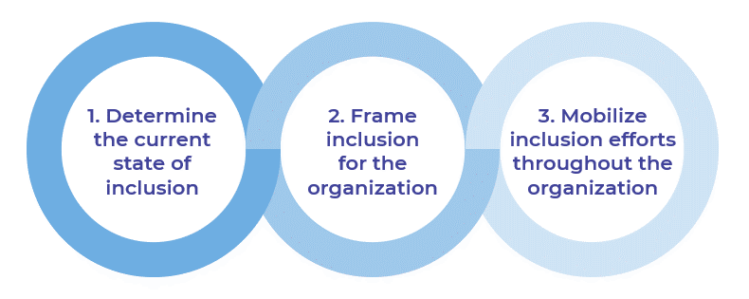
Get to Action
1. Create the vision for the change and understand the impact | - Communicate inclusion as a priority.  - Collect quantitative and qualitative data to assess the current state of inclusion.  - Analyze data to identify shared challenges.  Deliverables:  - Standard Internal Communications Plan  - Standard Focus Group Guide  - Diversity & Inclusion Strategy Template
2. Communicate the change | - Envision the future state of inclusion.  - Ingrain inclusion into organizational values and competency model.  - Assist executives in reflecting on their current behaviors.  Deliverables:  - Diversity & Inclusion Strategy Template  - HR Metrics Library  - Diversity and Inclusion Metric Tracking Tool  - Executive Reflection Template
3. Involve the managers and develop the change action plan | - Communicate the inclusion competency and expectations to managers.  - Incorporate employee learning opportunities to shift mindsets towards inclusion.  - Launch an examination of work practices using inclusive design principles.  Deliverables:  - Inclusive Work Practices Template  - Inclusive HR Work Practices Examples

__________________________________________________

For acceptable use of this template, refer to McLean & Company's Terms of Use. These documents are intended to supply general information only, not specific professional, personal, legal, or accounting advice, and are not intended to be used as a substitute for any kind of professional advice. Use this document either in whole or in part as a basis and guide for document creation. To customize this document with corporate marks and titles, simply replace the McLean & Company information in the Header and Footer fields of this document.

