Redesign Your HR Structure Executive Briefing

Summary
HR’s structure underpins how an HR function operates. HR needs to be structured in a way that enables it to operate efficiently and effectively.

Our Recommendation
- Design a fit-for-purpose HR structure rather than replicating or copying another.
- Design for the future, aligning HR structure and HR functional capabilities with organizational and line of business strategic objectives.

Client Challenge

There is no one-size-fits-all HR structure, as no two HR functions are the same – they have different strategic objectives, clients, employee value propositions, etc.

Designing an HR structure is complicated and often doesn’t produce the desired results (e.g. misalignment with talent and/or organizational strategy, priority work units buried within the structure, etc.).

An improperly structured HR function impacts the larger organization, as it can result in bottlenecks and delays in meeting client needs or misalignment between priority HR capabilities and HR resource allocation.

Critical Insight
- There is no one-size-fits-all structure. Design a fit-for-purpose HR structure rather than replicating or copying another.

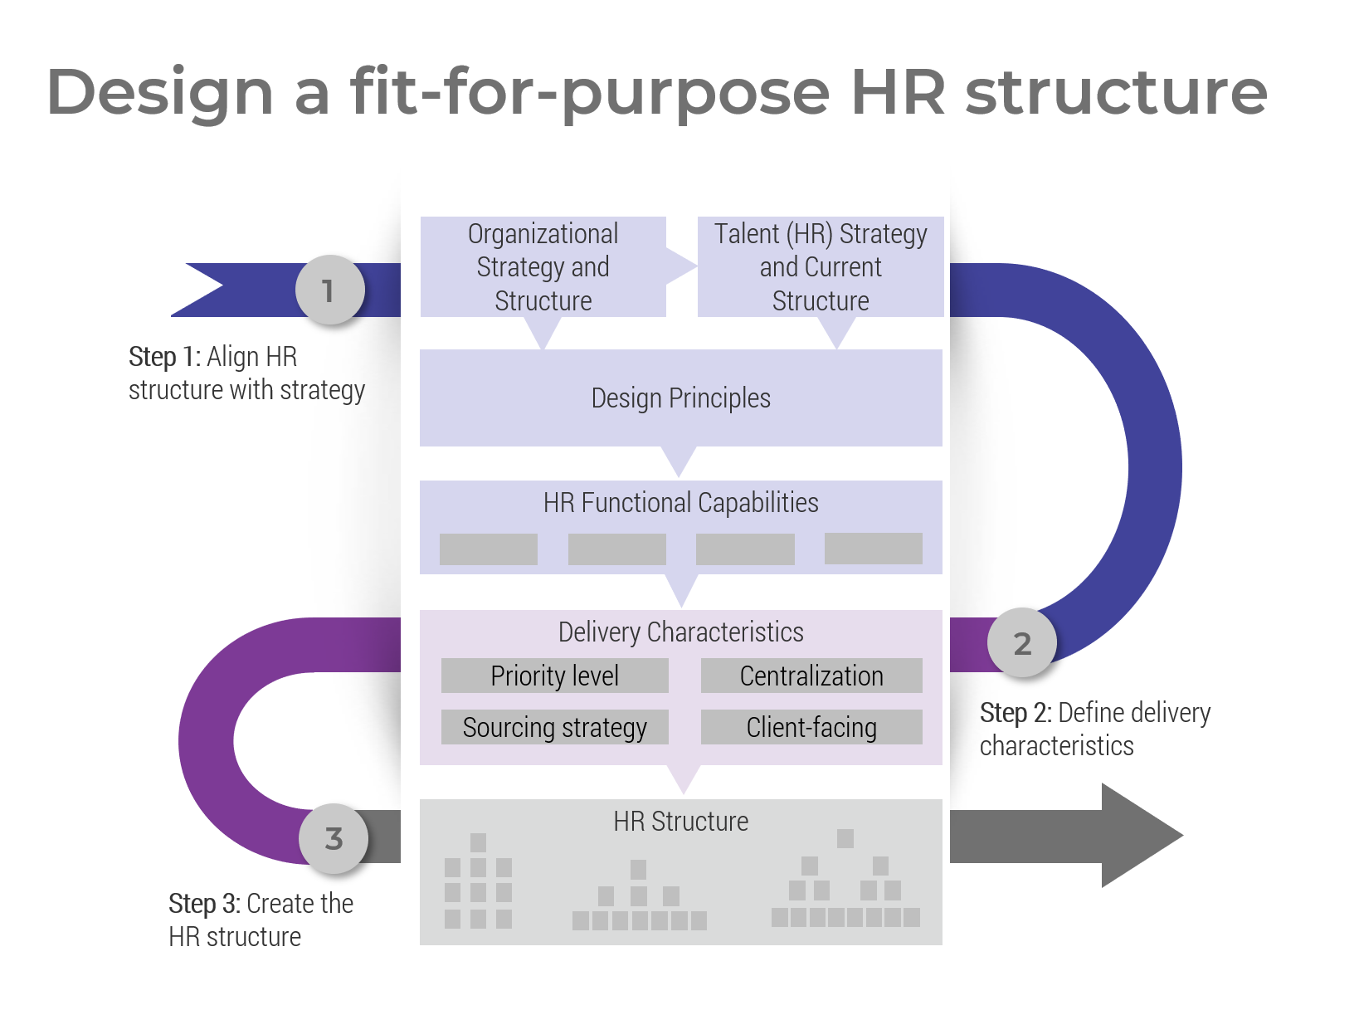

Get to Action

1. Align HR structure with strategy | - Review the current state and desired outcomes.  - Create design principles.  - Identify HR functional capabilities.  Deliverables:  - HR Structure Workbook  - HR Metrics Library  - HR Functional Capability Framework  - Case Studies: Redesign Your HR Structure
2. Define delivery characteristics | - Determine the priority level of each capability.  - Identify whether each capability will be mostly centralized or decentralized.  - Select capabilities to investigate co/outsourcing.  - Identify client-facing capabilities and their mode of delivery (i.e. face-to-face vs. technology-enabled).  Deliverables:  - HR Structure Workbook
3. Create the new HR structure | - Create work units for each capability.  - Identify work unit accountabilities and responsibilities.  - Create mandates for each work unit.  - Identify roles within each work unit.  - Finalize the new HR structure.  Deliverables:  - HR Structure Workbook  - HR Structure Presentation Template  - Workshop: Redesign Your HR Structure

__________________________________________________

For acceptable use of this template, refer to McLean & Company’s Terms of Use. These documents are intended to supply general information only, not specific professional, personal, legal, or accounting advice, and are not intended to be used as a substitute for any kind of professional advice. Use this document either in whole or in part as a basis and guide for document creation. To customize this document with corporate marks and titles, simply replace the McLean & Company information in the Header and Footer fields of this document.

