Design the Employee Experience Executive Briefing

Summary
Employees’ expectations of their experiences at work are evolving. Similar to their customer experiences, they want an overall employee experience that fits more seamlessly into their lives. Organizations not only have to compete with each other for talent, but they must also compete with alternative approaches to employment, like the gig economy. Candidates and employees have more choices, and they know it.

Our Recommendation
- Start with the employee lifecycle and identify moments that matter – where the employee and employer needs are most aligned.
- Use a design thinking approach to engage employees in the process of designing a best-fit solution for a positive employee experience. Improve attraction, retention, engagement, and productivity.
- Get comfortable with being uncomfortable; an employee experience design can be a big change. Leverage employee feedback and be prepared to iterate to find the best possible solution.

Client Challenge
- Employees have more choices in today’s marketplace, and they know it. Competition is fierce, so enhancing the employee experience is more critical than ever to attract and retain the right talent.
- Employees’ expectations of their work experiences are evolving.
- Organizations have few formalized efforts to address employee experience, and where they exist, efforts are siloed or lack resourcing to address the end-to-end experience.
- Employee experience isn’t limited to areas where HR has direct control.

Critical Insight
- In the past, organizations have focused on their own priorities as an employer, but that pendulum has swung toward a more balanced approach. The sweet spot is where employee needs and organizational strategy meet.

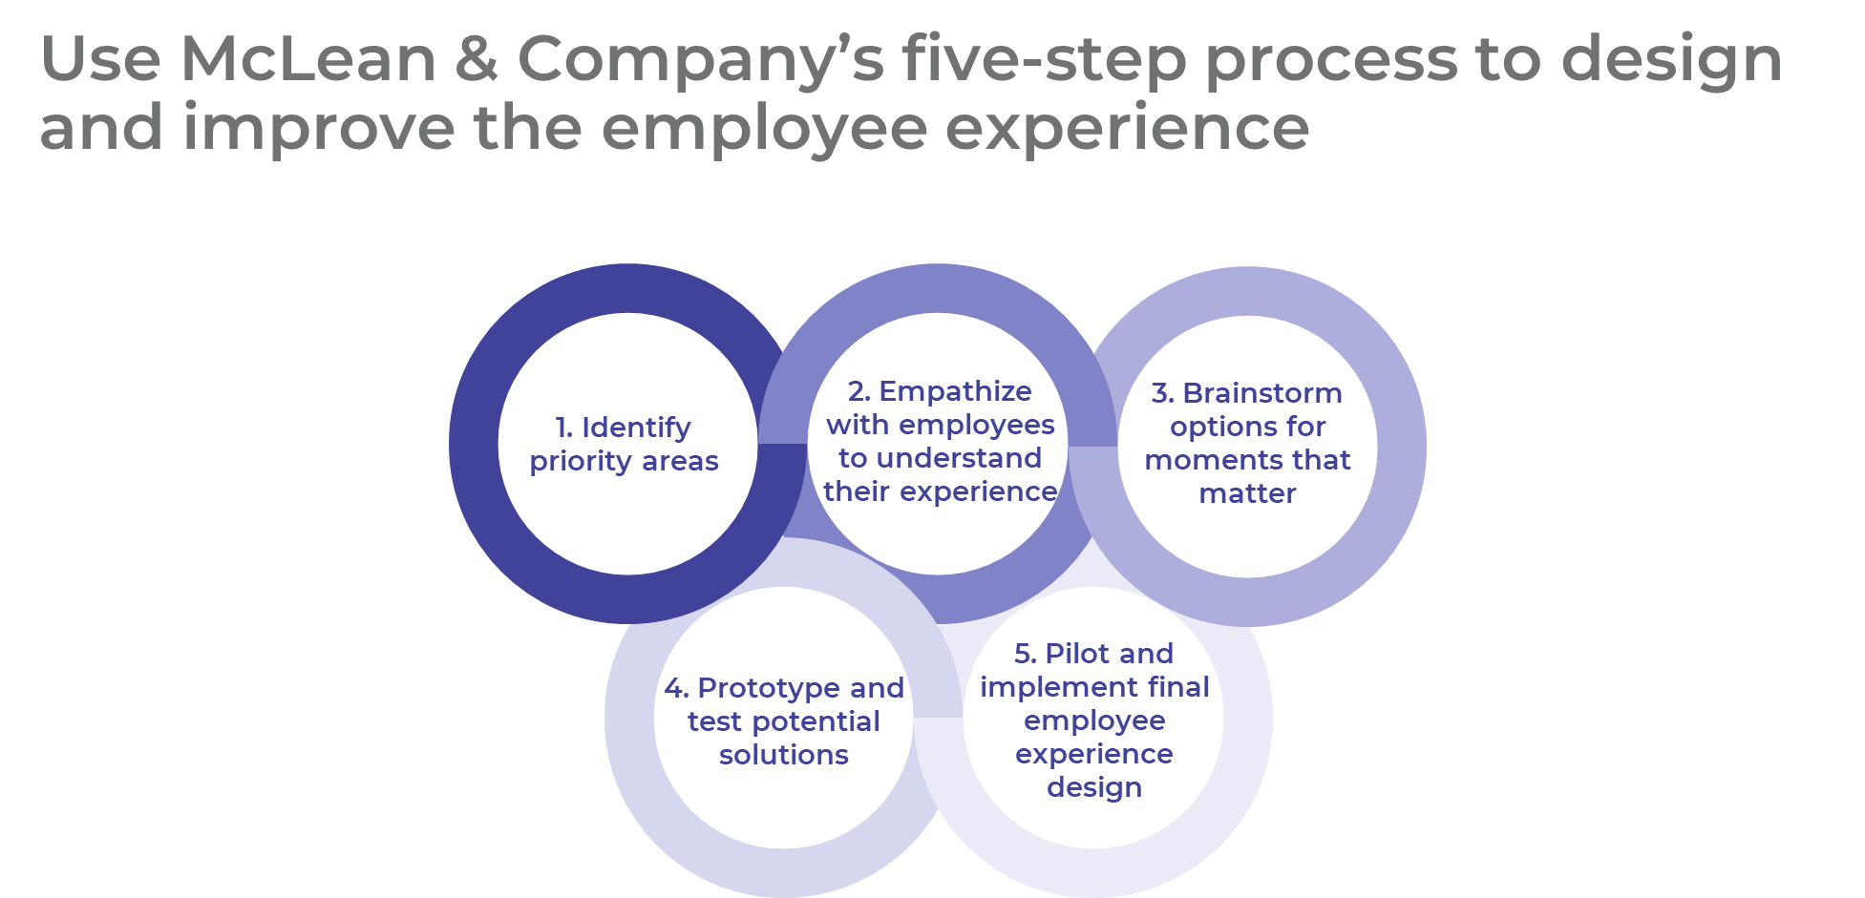

Get to Action
1. Identify Priority Areas | - Determine which segment of the employee lifecycle to prioritize based on organizational data.  - Select a project team.  - Outline the current business process to determine key business deliverables required from the process.  Deliverables:  - Design Thinking Primer  - Employee Experience Workbook  - Employee Experience Project Planning Template  - HR Process Mapping Template  - Project Roadmap Tool
2. Empathize With Employees to Understand Their Experience | - Select and interview employees.  - Complete an empathy map and analyze and interpret employees’ thoughts and feelings.  - Complete a journey map to identify and understand the moments that matter to employees.  - Review the employer and employee wants and needs and draft the problem statement.  Deliverables:  - Discovery Interview Guide  - Empathy Map Template  - Journey Map Template  - Employee Experience Project Planning Template
3. Brainstorm Options for Moments That Matter | - Create “How might we” statements from the problem statement to start the brainstorming process.  - Review and select a brainstorming option.  - Complete the brainstorming session and record key potential solutions.
4. Prototype and Test Potential Solutions | - Select potential solutions to prototype.  - Create prototypes and test them.  - Determine to either move a prototype forward to pilot or circle back to revise.  Deliverables:  - Employee Experience Workbook  - HR Process Mapping Template  - Storyboarding Guide  - Employee Experience Test Session Guide
5. Pilot Solution and Prepare for Implementation | - Prepare for and pilot the potential solution.  - Determine success of pilot to move forward with full-scale implementation.  - Implement employee experience solution.  - Prepare to assess measurements.  Deliverables:  - Project Roadmap Tool
__________________________________________________

For acceptable use of this template, refer to McLean & Company's Terms of Use. These documents are intended to supply general information only, not specific professional, personal, legal, or accounting advice, and are not intended to be used as a substitute for any kind of professional advice. Use this document either in whole or in part as a basis and guide for document creation. To customize this document with corporate marks and titles, simply replace the McLean & Company information in the Header and Footer fields of this document.

