Customize HR Programs for a Global Workforce Executive Briefing

Summary
As organizations are increasingly working across regions and workforce needs vary, one-size-fits-all HR programs lose their effectiveness. Strategically customizing HR programs to align with organizational objectives and regional requirements enables HR to provide targeted and relevant solutions, optimize resource allocation, and ensure meaningful employee experiences are shared by all.

Our Recommendation
- Identify where HR program customization will be most impactful, using insights from an environmental scan of external factors and an internal review of diverse employee perspectives across regions.
- Modify selected HR programs, using standardization where useful and customization where required, to ensure alignment with organizational objectives and regional needs.
- Implement customized HR programs, accounting for nuances affecting change management at the regional level.

Client Challenge
- While benefits exist for both the standardization and customization of HR programs, HR must find a balance that ensures alignment with organizational objectives and regional needs.
- When HR programs are misaligned, there is a risk of long-term organizational and people impacts, such as inefficient use of resources, failure to meet organizational goals, and employee disengagement.

Critical Insight
- Workforce needs are not universal across regions. Strategically customizing HR programs to align with organizational objectives and regional requirements ensures meaningful employee experiences are shared by all.

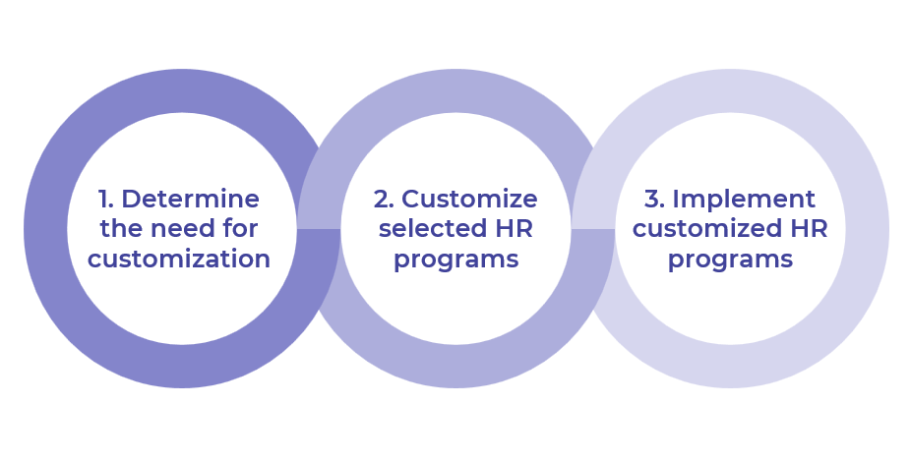

Get to Action

1. Determine the need for customization | - Determine guiding principles.  - Identify key players to participate in program customization.  - Inventory HR programs and create a shortlist of programs for customization.  - Conduct an environmental scan.  - Identify the degree and anticipated impact of customization.  - Select HR programs where customization will be most impactful and finalize move-forward decisions.  Deliverables:  - Customize HR Programs Workbook  - PESTLE Analysis Template  - Standard Focus Group Guide  - Customize HR Programs Presentation Template
2. Customize selected HR programs | - Explore common factors that apply to HR program customization.  - Review implications for customized HR program design.  - Prepare to customize selected programs.  Deliverables:  - Standard Project Charter  - Project Roadmap Tool  - Customized HR Programs Tracking Tool
3. Implement customized HR programs | - Review regional nuances of change management.  - Determine the appropriate rollout approach and craft a communication plan for each customized HR program.  - Plan to evaluate each customized HR program and iterate as needed.  Deliverables:  - Customized HR Programs Tracking Tool

__________________________________________________

For acceptable use of this template, refer to McLean & Company's Terms of Use. These documents are intended to supply general information only, not specific professional, personal, legal, or accounting advice, and are not intended to be used as a substitute for any kind of professional advice. Use this document either in whole or in part as a basis and guide for document creation. To customize this document with corporate marks and titles, simply replace the McLean & Company information in the Header and Footer fields of this document.

