Address the Talent Gap Driven by Generative AI: Executive Briefing

Summary
Generative AI can automate tasks, which will disrupt organizations by reshaping roles, shifting talent requirements, and impacting workforce composition. Address the talent gap by adjusting or developing strategic HR initiatives to build, buy, borrow, redeploy, or reduce talent.

Our Recommendation
- Organizations must first determine how generative AI use supports the organization’s strategic objectives to uncover its impact on the workforce, and in turn, the talent demand, supply, and gap.
- HR can address the talent gap driven by generative AI by adjusting or developing strategic HR initiatives to build, buy, borrow, redeploy, or reduce talent.

Client Challenge
- Task automation through generative AI can disrupt organizations by changing the work that makes up existing roles, shifting skill requirements, and affecting workforce composition.
- This will change the critical talent needed to achieve strategic objectives (the talent demand) and how prepared the organization is to meet the talent demand (the talent supply), revealing the talent gap driven by generative AI.

Critical Insight
- Generative AI has the potential to disrupt organizations by automating tasks, reshaping roles, and shifting talent requirements. The success of organizations in leveraging generative AI to drive organizational objectives hinges on HR addressing the underlying impacts on talent.
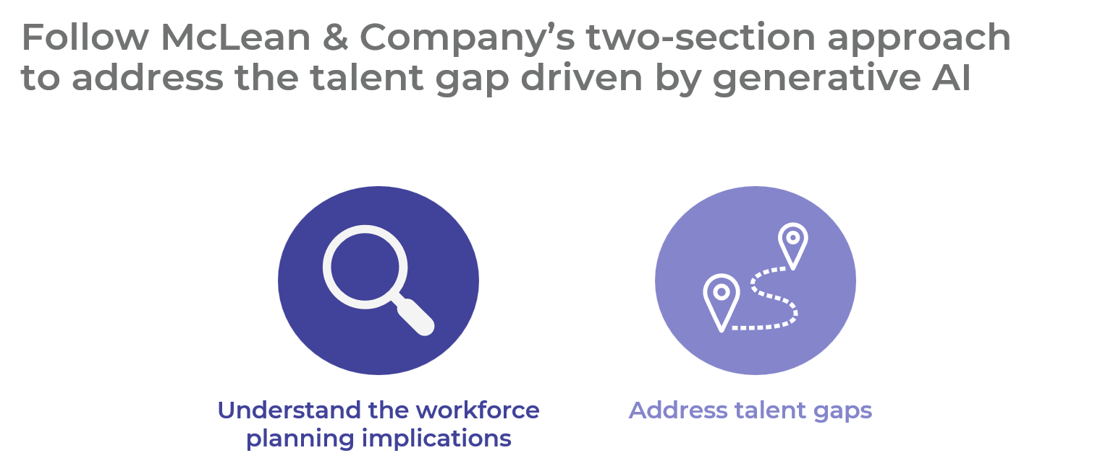

Get to Action

1. Understand the workforce planning implications | - As generative AI impacts tasks, roles will change across organizations.  - Exposure to generative AI automation determines the degree to which roles will change.  - As roles change or disappear, the demand for non-technical skills will increase.  - There will also be a growing need for technical skills related to generative AI in the workforce.  - Generative AI will widen the digital divide and disproportionately affect certain populations.  Deliverables:  - Generative AI Workforce Planning Implications Tool  - Generative AI Task Automation Tool
2. Address talent gaps | - Plan to address workforce planning implications through HR initiatives.  - Build talent within the organization to fill talent gaps.  - Recruit talent from outside of the organization to fill gaps.  - Borrow talent to temporarily fill the generative AI talent shortage.  - Redeploy talent to other areas of the organization to fill talent shortages internally.  - Reduce talent where necessary to address talent surpluses.  - Determine next steps.  Deliverables:  - Generative AI Workforce Planning Implications Tool

__________________________________________________

For acceptable use of this template, refer to McLean & Company's Terms of Use. These documents are intended to supply general information only, not specific professional, personal, legal, or accounting advice, and are not intended to be used as a substitute for any kind of professional advice. Use this document either in whole or in part as a basis and guide for document creation. To customize this document with corporate marks and titles, simply replace the McLean & Company information in the Header and Footer fields of this document.

