Establish Data Governance for HR: Executive Briefing

Summary
HR must enhance data governance practices to generate valuable insights to drive innovation, improve decision making, and gain a competitive advantage. Download our research to address HR’s urgent governance needs with practical people, process, and technology solutions and establish a formal HR data governance framework.

Our Recommendation
- Implement HR data governance practices to ensure data is available, accurate, standardized, and complete to enable HR to develop data-driven recommendations based on high-quality data.
- Use a phased approach to address HR’s urgent data governance needs with practical people, process, and technology solutions and establish a formal HR data governance framework to support a proactive and strategic approach to data governance in the long term.

Client Challenge
- HR data governance is often inadequate due to a lack of formal data governance practices and low levels of data literacy. Without data governance practices, HR risks sharing inaccurate information, resulting in key individuals lacking trust in HR data. This stifles cross-functional collaboration and the ability to generate valuable insights to drive innovation, improve decision making, and gain a competitive advantage.
- HR often has urgent pain points to address; however, formal data governance frameworks are not a quick solution and typically take years to implement fully.

Critical Insight
- Accurate and reliable data are essential components of data-driven HR. Developing data governance practices helps ensure that data is high quality and builds a solid foundation on which HR can create a data-driven culture.

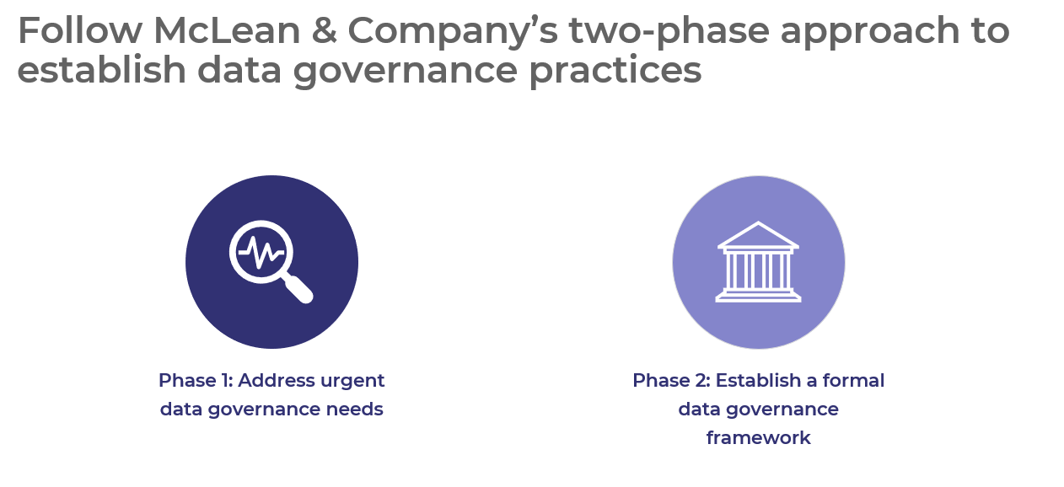

Get to Action

1. Address urgent data governance needs | - Define the driving need for data governance in HR.  - Partner with key individuals.  - Understand the current state of data governance and identify pain points.  - Prepare to create a data inventory.  - Complete the data inventory and assess data quality.  - Select people, process, and technology solutions to address pain points.  - Create an action plan to implement people, process, and technology solutions.  - Establish metrics to monitor pain point solutions.  - Determine if a formal HR data governance framework is the next step.  Deliverables:  - Data Governance Workbook: Phase 1  - HR Action and Communication Plan
2. Establish a formal data governance framework | - Document existing elements of each component.  - Define the purpose, scope, and impact of data governance within HR.  - Determine the approach to a data governance committee.  - Select participants and outline data governance roles and responsibilities.  - Establish data governance goals and use metrics to evaluate results.  - Identify regulatory and ethical standards.  - Create guidelines to align with regulatory and ethical standards.  - Draft policy statements to uncover data quality, access, usage, and security requirements.  - Create a data dictionary to improve standardization and consistency.  - Document the data governance framework.  - Build a training and communication plan to communicate data governance.  Deliverables:  - Data Governance Workbook: Phase 2  - Data Governance Framework Template  - Data Dictionary Template  - Additional policy templates:  - Data Retention Policy Template  - File Storage and Sharing Policy Template  - Data Protection Policy Template

__________________________________________________

For acceptable use of this template, refer to McLean & Company's Terms of Use. These documents are intended to supply general information only, not specific professional, personal, legal, or accounting advice, and are not intended to be used as a substitute for any kind of professional advice. Use this document either in whole or in part as a basis and guide for document creation. To customize this document with corporate marks and titles, simply replace the McLean & Company information in the Header and Footer fields of this document.

