Return-to-Office Playbook Executive Briefing

Summary
Use this research to create a flexible return-to-office policy that balances employee and organizational needs.

Our Recommendation
- Gather and assess organizational and employee data to identify valid reasons for returning employees to the office.
- Create and roll out a flexible RTO policy that balances organizational and employee needs.
- Support employees through the challenges of returning to the office by identifying supports that are feasible for the organization to offer.

Client Challenge
- Many organizations are mandating that employees return to the office despite the popularity of remote and hybrid work.
- Employees do see the benefits of working from the office some of the time but are facing challenges with returning to the office (e.g. long commutes).
- Organizations that mandate RTO often fail to do their due diligence with identifying and communicating a rationale for RTO, leading to employee backlash and numerous negative consequences for the organization (e.g. decreased engagement).
- In addition, RTO mandates are often a one-size-fits-all approach that lacks flexibility and fails to consider unique employee needs and challenges, leading to rising frustration among employees.

Critical Insight
- Despite the popularity of work-from-home among employees, organizations and employees recognize there are benefits to occasionally working from the office. The key to implementing a successful RTO policy is understanding organizational and employee needs and rolling out a policy that is intentionally flexible.
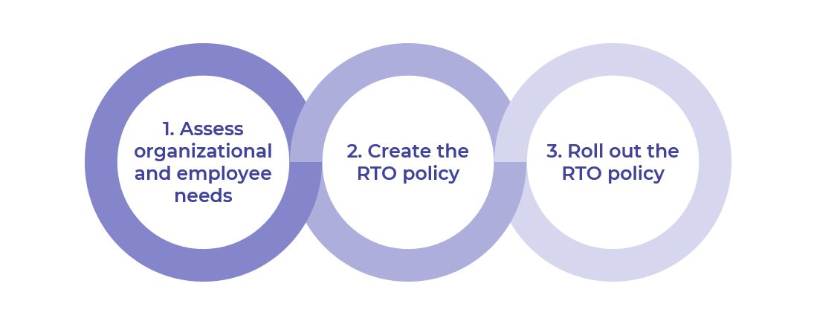

Get to Action

1. Assess organizational and employee needs | - Review key players’ responsibilities in the RTO process.  - Examine strategic documents to determine how RTO supports the organization’s strategic direction.  - Gather existing data to identify insights about RTO.  - Conduct focus groups with leaders to identify the rationale for RTO.  - Launch a survey to gather the employee perspective on RTO.  - Categorize the insights gathered to identify reasons for RTO, misconceptions, etc.  Deliverables:  - Return-to-Office Workbook  - Metrics and Analytics Selection Guide  - HR Metrics Library  - Return-to-Office Sample Survey Questions List
2. Create the RTO policy | - Create a planning committee.  - Assess logistics of the organization’s office space.  - Identify supports and incentives that are feasible to offer employees returning to the office.  - Identify employee exemptions to include in the RTO policy.  - Formulate the guiding principles for the RTO policy.  - Draft the RTO policy and present it to executives for approval.  Deliverables:  - Return-to-Office Workbook  - Return-to-Office Policy Template
3. Roll out the RTO policy | - Create an action plan to roll out the RTO policy.  - Create a plan to communicate the RTO policy.  - Share the RTO policy with people leaders and employees.  - Equip people leaders with tools to help them implement the RTO policy within their teams.  - Align the RTO policy with existing HR programs.  - Devise an approach for evaluating the RTO policy.  Deliverables:  - Project Roadmap Tool  - Return-to-Office Workbook  - Standard Internal Communications Plan  - Return-to-Office Manager FAQ Template  - Return-to-Office Employee FAQ Template

__________________________________________________

For acceptable use of this template, refer to McLean & Company's Terms of Use. These documents are intended to supply general information only, not specific professional, personal, legal, or accounting advice, and are not intended to be used as a substitute for any kind of professional advice. Use this document either in whole or in part as a basis and guide for document creation. To customize this document with corporate marks and titles, simply replace the McLean & Company information in the Header and Footer fields of this document.

