Adapt Performance Management for Teams Executive Briefing

Summary
Teams are becoming more prevalent in today’s workplaces, as they improve productivity, performance, and employee engagement. As the prevalence of teams increases, how work is accomplished is shifting toward more collaboration and interdependencies among employees. Performance management processes must align with how work is done to be effective.

Our Recommendation
- Determine where team-based performance management is appropriate by identifying eligible teams.
- Adapt the existing performance management process for eligible teams by customizing the following building blocks to meet their needs: overall process, goal setting, competencies, feedback and coaching, crowd-sourced feedback, and ratings.

Client Challenge
- Many performance management processes are not designed for teams. Organizations continue to focus on individuals for performance evaluation, rewards, and recognition, regardless of how work is carried out and whether teams exist.
- Misalignment between how work is done and how it is evaluated leads to poor employee performance, decreased engagement, and ineffective overall performance management.

Critical Insight
- Work today requires more collaboration and teams are becoming more prevalent, yet performance management is failing to keep up. Performance management processes need to align with how work is carried out, otherwise organizations are at risk of decreased performance and engagement within their teams.

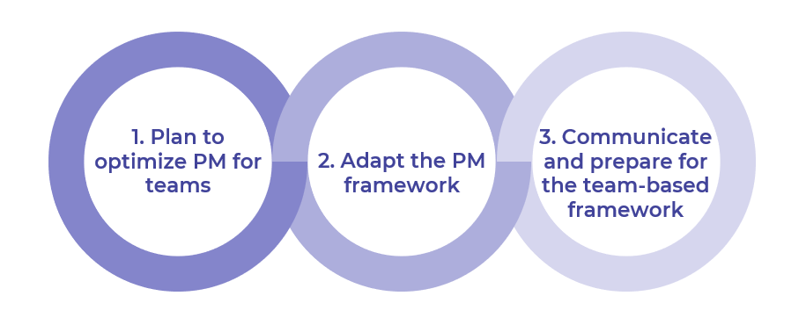

Get to Action

1. Plan to optimize performance management for teams | - Determine which teams will be using team-based PM.  - Establish the key attributes of eligible teams.  - Identify the susceptibility of eligible teams to common challenges of team-based PM.  - Set goals and metrics for success.  Deliverables:  - Team-Based PM Workbook  - HR Metrics Library  - Case Studies: Adapt Performance Management for Teams
2. Adapt the performance management framework | - Customize the PM building blocks for each eligible team.  - Align rewards and recognition programs with the team-based PM framework, if appropriate.  - Obtain stakeholder buy-in to proceed.  Deliverables:  - Team-Based PM Workbook  - Team-Based PM Guide  - Team-Based Total Rewards Job Aid
3. Involve the managers and develop the change action plan | - Outline accountabilities for HR, team leaders, team members, and reporting managers.  - Prepare to address pushback.  - Develop an action and communication plan.  - Customize a guide to support the communication of the team-based framework.  Deliverables:  - HR Action and Communication Plan  - Team-Based PM Guide

__________________________________________________

For acceptable use of this template, refer to McLean & Company's Terms of Use. These documents are intended to supply general information only, not specific professional, personal, legal, or accounting advice, and are not intended to be used as a substitute for any kind of professional advice. Use this document either in whole or in part as a basis and guide for document creation. To customize this document with corporate marks and titles, simply replace the McLean & Company information in the Header and Footer fields of this document.

