Catalyze Cross-Functional Collaboration Executive Briefing

Summary
Increasing complexity, both inside organizations and in the external environment, is resulting in more challenging problems. To address these, different types of specializations and knowledge need to be brought together to create effective solutions. This makes cross-functional collaboration a crucial organizational capability today.

Our Recommendation
- Identify an organizational need that leaders will rally around as a common purpose for collaboration.
- Take time to understand the root causes of poor collaboration between departments or functions.
- Select and implement targeted solutions that drive cross-functional collaboration.

Client Challenge
- Traditional solutions, such as restructuring and changing the culture, require significant resources and take years to successfully implement (if ever!).
- It can be difficult for HR to get enough buy-in from leaders to change siloed behaviors.
- The root causes of poor collaboration in the workplace are difficult to assess.

Critical Insight
- HR can take ownership of fostering cross-functional collaboration by initiating targeted changes within its sphere of control that have a ripple effect across the organization’s culture.

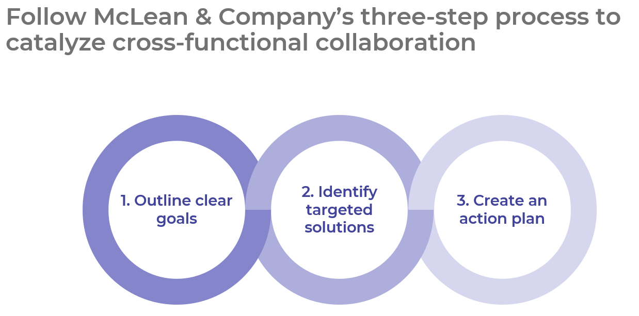

Get to Action
- Outline clear goals | - Identify which functions are struggling to collaborate.  - Meet with key stakeholders and identify a common need for cross-functional collaboration.  - Examine the existing network of relationships between key functions.  Deliverables:  - Collaboration Worksheet  - Personal Network Analysis Tool
- Identify targeted solutions | - Conduct focus groups to identify the root causes of poor collaboration, along with success stories from the organization.  - Determine which solutions are best aligned with resolving the root causes.  Deliverables:  - Collaboration Worksheet  - Collaboration Ideas Catalog  - Personal Network Analysis Tool  - Training Deck: Activate Networks to Enable Collaboration  - Collaboration & Networking: Self-Assessment  - Network Activation Action Plan  - Standard Focus Group Guide  - Standard Project Charter  - Samples of Collaboration Technology Maps
- Create an action plan | - Create a detailed change and communication plan.  - Outline a process for iteration and updates to solutions based on realized outcomes.  Deliverables:  - HR Action and Communication Plan

_____________________________________________________

For acceptable use of this template, refer to McLean & Company's Terms of Use. These documents are intended to supply general information only, not specific professional, personal, legal, or accounting advice, and are not intended to be used as a substitute for any kind of professional advice. Use this document either in whole or in part as a basis and guide for document creation. To customize this document with corporate marks and titles, simply replace the McLean & Company information in the Header and Footer fields of this document.

