Conduct a Salary Assessment Executive Briefing

Summary
Pay structure assessments help prevent and address salary inequities. Download our research to learn the critical elements of a successful salary assessment.

Our Recommendation
- Adopt a proactive mindset by assigning an annual cadence to salary assessments, at a minimum, and conducting more frequent assessments based on need (e.g. roles or departments critical to operational continuity), to ensure internal and external equity.
- Assess pay gaps for signs of systemic patterns of inequity and investigate organizational practices across the employee lifecycle to identify root causes.
- Avoid losing traction; understand that internal and external pay equity requires sustained focus and commitment.

Client Challenge
- Organizations are facing difficulties keeping salaries up to date with the rapidly changing labor market. Employees often do not perceive their salaries as competitive and look for higher paying jobs at other organizations.
- As employees are becoming increasingly comfortable discussing pay with colleagues, they are finding out about internal pay gaps through informal mediums. This frequently results in lower levels of engagement, mistrust, and turnover.
- By the time organizations decide to conduct a salary review, pain points have cumulated to be significant, making the process and implementation of salary adjustments a larger task than it could have been if it was prioritized proactively.

Critical Insight
- Haphazardly delving into a salary assessment without ensuring that the foundational elements (e.g. job descriptions, market positioning strategy) are in order will not yield results.
- Implementing remedial salary adjustments without having addressed the systemic issues causing the pay gaps only perpetuates the problem.
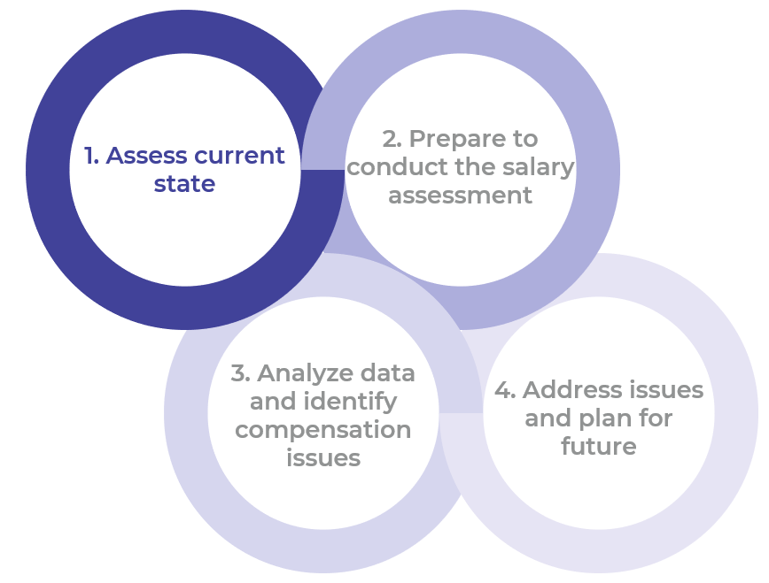

Get to Action

1. Assess current state | - Gather data and employee feedback to identify pain points that are potentially caused by salary issues.  - Determine the scope of the assessment.  - Set goals and metrics to measure the success of the salary assessment.  - Establish the appropriate level of transparency for the project.  Deliverables:  - Salary Assessment Tool  - HR Metrics Library
2. Prepare to conduct the salary assessment | - Conduct due diligence on job descriptions.  - Revisit job evaluation outcomes.  - Confirm organizational market positioning strategy.  - Collect market data and assess external equity.  - Leverage updated market data to adjust salary ranges.  - Select the approach to salary assessment.  Deliverables:  - Salary Assessment Tool  - Market Data Sources by Industry
3. Analyze data and identify compensation issues | - Gain familiarity with foundational metrics used in salary assessments.  - Conduct a cohort analysis across the organization.  - Determine salary adjustments and calculate the total cost of remediation.  - Determine the remediation approach and make prioritization decisions.  Deliverables:  - Salary Assessment Tool
4. Address issues and plan for future | - Secure leadership alignment on the budget, approach, and timeline of the remediation plan.  - Develop a communication plan.  - Adjust salaries.  - Investigate pay gaps for patterns of systemic inequity and identify their root causes.  - Revisit and improve salary administration guidelines.  - Prepare for the next salary assessment.  Deliverables:  - Pay Equity Report Sample  - Salary Assessment Tool  - Salary Administration Guidelines

__________________________________________________

For acceptable use of this template, refer to McLean & Company's Terms of Use. These documents are intended to supply general information only, not specific professional, personal, legal, or accounting advice, and are not intended to be used as a substitute for any kind of professional advice. Use this document either in whole or in part as a basis and guide for document creation. To customize this document with corporate marks and titles, simply replace the McLean & Company information in the Header and Footer fields of this document.

