Craft an Internal Communications Strategy Executive Briefing

Summary
Strategic internal communications are vital to organizational success. Organizations with effective internal communications benefit from fewer misunderstandings, improved productivity, increased collaboration and knowledge sharing, better morale, better performance, and higher employee satisfaction (Kunsman, 2022).

Recommendation
- Craft an effective internal communications strategy with the main purpose of enabling the organization to its meet strategic goals.
- Execute the communications strategy by empowering everyone in the organization to communicate effectively. Provide them with the tools, tactics, and messages to drive strategic internal communication.

Client Challenge
- Communicating effectively is even more challenging in today's operating environment. Business ‒ and the world of work ‒ is in a state of flux, and cutting through the noise is increasingly difficult.
- While internal communications are considered critical, efforts are not always strategic. Without effective communication channels, employees report higher dissatisfaction and lower engagement (Gallagher, 2022).

Critical Insight
- Choose communications empowerment over ownership to enable organizational strategy. Empowerment starts with the clarity, tools, and capability to communicate effectively and guarantees an exchange downwards and upwards.

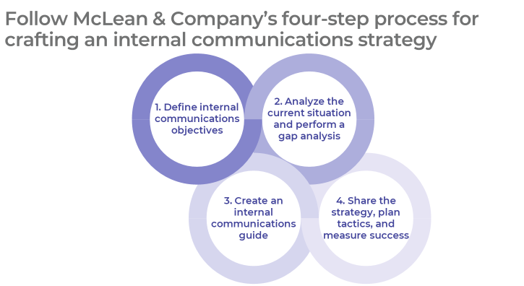

Get to Action

1. Define internal communications objectives | - Confirm the organization’s strategic direction.  - Establish internal communications objectives to support organizational goals.  - Determine key results and set metrics to track them.  Deliverables:  - Case Studies: Craft an Internal Communications Strategy  - Strategy Discovery Tool  - Strategy Exploration Guide  - Internal Communications Strategy Template  - HR Metrics Library
2. Analyze the current situation and perform a gap analysis | - Evaluate quantitative and qualitative data to identify trends, themes, and insights related to internal communications.  - Conduct an internal communications audit and SWOT analysis.  - Segment and profile your target audiences.  - Establish the current state and identify critical gaps.  Deliverables:  - Internal Communications Audit  - Standard SWOT Analysis Template  - Audience Profile Template  - Internal Communications Strategy Template
3. Create an internal communications guide | - Review all components of McLean & Company’s Internal Communications Guide Template.  - Customize McLean & Company’s Internal Communications Guide Template with information relevant to your organization.  Deliverables:  - Internal Communications Guide Template
4. Share the strategy, plan tactics, and measure success | - Establish appropriate feedback mechanisms for upwards communication.  - Customize McLean & Company’s Standard Internal Communications Plan for widespread organizational use.  - Plan for the rollout of the internal communications strategy and ongoing support for communicators.  Deliverables:  - Standard Internal Communications Plan  - HR Action and Communication Plan  - Training Deck: Train Managers to Communicate Effectively Across Channels, Cultures, Continents and Generations  - Workshop: Craft an Internal Communications Strategy

_____________________________________________________

For acceptable use of this template, refer to McLean & Company's Terms of Use. These documents are intended to supply general information only, not specific professional, personal, legal, or accounting advice, and are not intended to be used as a substitute for any kind of professional advice. Use this document either in whole or in part as a basis and guide for document creation. To customize this document with corporate marks and titles, simply replace the McLean & Company information in the Header and Footer fields of this document.

