Create a People Strategy Executive Briefing

Summary
People are increasingly accepted as the key factor enabling organizational competitive advantage. HR needs to act to identify and improve the critical aspects of talent that will determine the success of organizations.

Our Recommendation
- Identifying the key talent implications required to achieve the organization’s goals enables the creation of targeted HR initiatives.
- Reviewing existing initiatives and reallocating resources to strategically aligned activities will make the most out of limited resources, while helping to build the case for additional resources.

Client Challenge
- Truly understanding organizational goals, sources of competitive advantage, and critical capabilities requires a different skill set and approach than HR may be accustomed to.
- Limited resources for strategic initiatives and an ongoing commitment to deliver core HR services restrict HR’s ability to create value for organizations.

Critical Insight
- Senior leaders are demanding more strategic value from their HR departments but are not changing the level of resources available to them.
- This means that while there are myriad effective HR programs and processes that will benefit organizations, there are not enough resources to execute even half of them well. HR leaders must prioritize aspects of the workforce that are critical to executing the strategy and identify HR initiatives that will best support them.

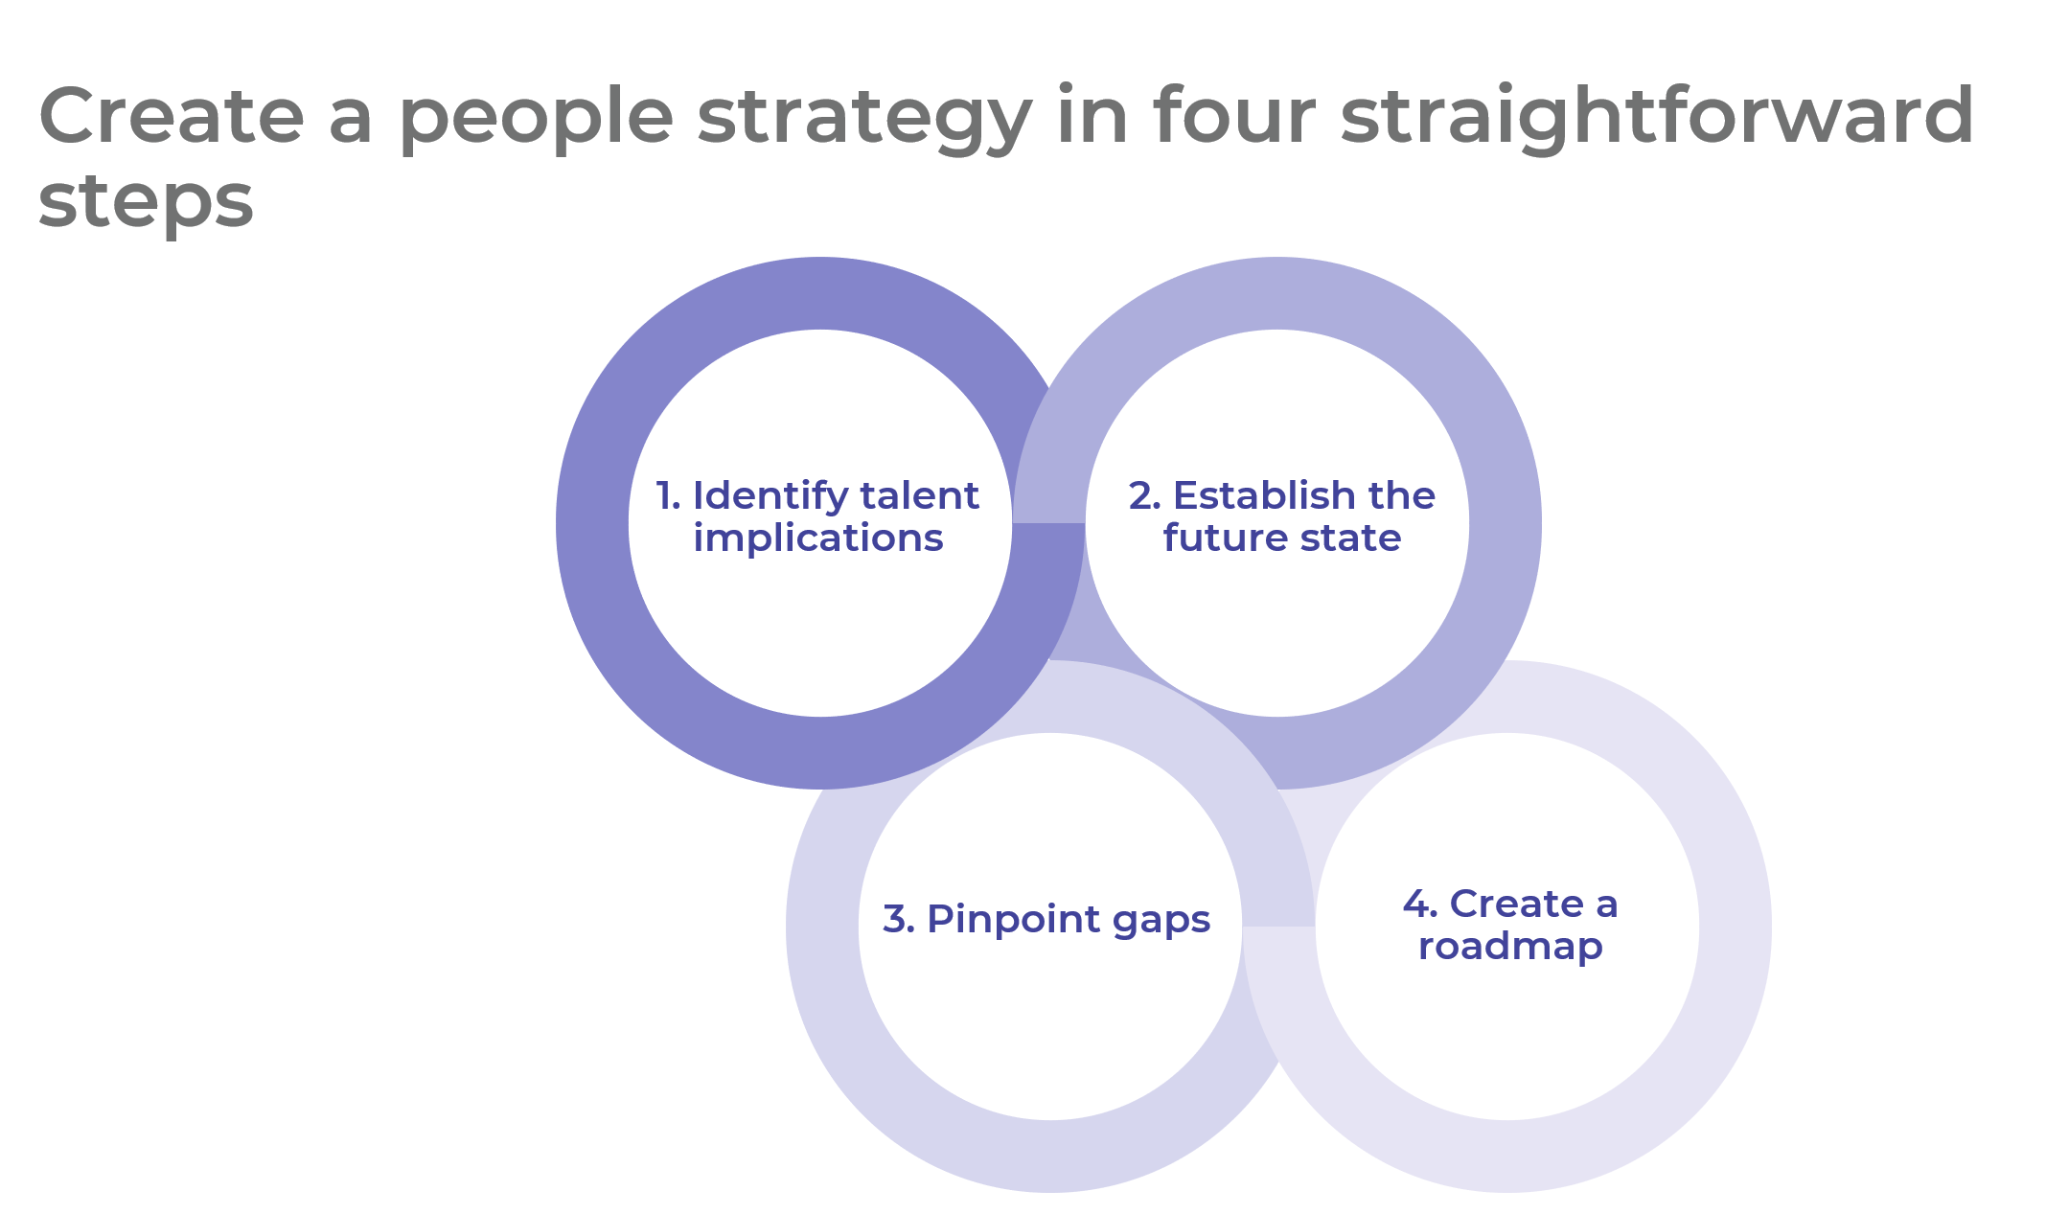

Make it Happen
1. Identify talent implications | - Derive key insights from the organizational strategy.  - Determine the scope of the people strategy.  - Identify talent implications that will inform the people strategy.  Deliverables:  - Talent Implications Checklist  - Strategy Discovery Tool  - Strategy Exploration Guide  - People Strategy Presentation Template  - Standard SWOT Analysis Template  - Standard PESTLE Analysis Template
2. Establish the future state | - Prioritize talent implications.  - Create strategic pillars.  - Identify HR outcomes.  Deliverables:  - People Strategy Workbook
3. Pinpoint gaps | - Analyze the current state of HR.  - Identify gaps between current abilities and HR outcomes.  - Create HR initiatives to close the gaps.
4. Create a roadmap | - Identify surplus resources.  - Prioritize initiatives.  - Create an action plan.  - Communicate the final people strategy.  Deliverables:  - Standard HR Scorecard

__________________________________________________

For acceptable use of this template, refer to McLean & Company's Terms of Use. These documents are intended to supply general information only, not specific professional, personal, legal, or accounting advice, and are not intended to be used as a substitute for any kind of professional advice. Use this document either in whole or in part as a basis and guide for document creation. To customize this document with corporate marks and titles, simply replace the McLean & Company information in the Header and Footer fields of this document.

