Ingrain and Sustain Employee Recognition Executive Briefing

Summary
Many organizations have a recognition program of some kind, but the majority focus on recognizing tenure. This form of recognition is a dated way of recognizing employees and has less of an impact on organizational performance (Apollo Technical, 2022). Additionally, 81% of organizational leaders do not see recognition as a strategic priority. However, studies show that companies can save up to $16.1M in turnover when recognition is prioritized (Workhuman, 2022). Employees who report high recognition are 2.9x more likely to be engaged than those who report low recognition (McLean & Company Engagement Survey Database, 2022, N = 129,919 responses, 181 organizations).

Our Recommendation
- Design a recognition program with the three keys to recognition in mind: customization, alignment, and transparency.
- Ask employees how they want to be recognized. Customization will make the program more impactful.
- Discover key strategic and cultural behaviors that the organization wants to drive and align recognition criteria with these behaviors.
- Create transparency with a fair, open recognition selection process.

Client Challenge
- Expectations are rapidly changing about how, and how often, employees should be recognized.
- Rewards and recognition programs are often too focused on the tangible reward element, ignoring the more important, but intangible, recognition element.
- Recognition programs are created in an ad hoc manner that does not align with organizational or individual needs.

Critical Insight
- Recognition is impactful independent of rewards (i.e. items with a monetary value), but rewarding employees without proper recognition can be counterproductive. Put recognition first and use rewards as a way to amplify its effectiveness.

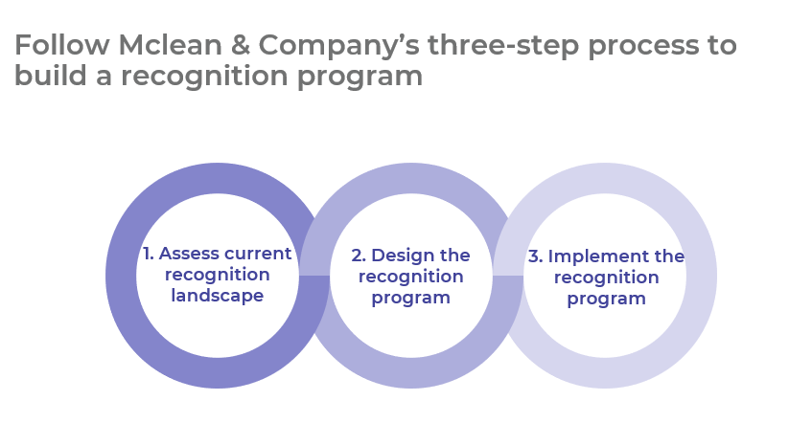
Get to Action

1. Assess the current recognition landscape | - Gather data on employee preferences and perceptions of recognition.  - Conduct focus groups to drill down into recognition feedback.  - Select key recognition criteria.  Deliverables:  - Employee Recognition Survey Questions  - Focus Group Guide
2. Design the recognition program | - Identify the budget for recognition.  - Decide if the program will include both formal and day-to-day recognition.  - Design formal recognition initiatives.  - Create day-to-day recognition initiatives.  Deliverables:  - Recognition Program Guide  - Employee Recognition Nomination Form  - Recognition Ideas Catalog
3. Implement the recognition program | - Select metrics to measure the impact of the recognition program.  - Design an action and communication plan to implement the recognition program.  - Train managers on how to effectively recognize others.  - Ingrain and sustain the recognition program.  Deliverables:  - HR Action and Communication Plan  - Recognition Program Guide  - Manager Training: Reinforce Behavior With Recognition

_____________________________________________________

For acceptable use of this template, refer to McLean & Company's Terms of Use. These documents are intended to supply general information only, not specific professional, personal, legal, or accounting advice, and are not intended to be used as a substitute for any kind of professional advice. Use this document either in whole or in part as a basis and guide for document creation. To customize this document with corporate marks and titles, simply replace the McLean & Company information in the Header and Footer fields of this document.

