Uncover and Market Internal Career Path Opportunities

Executive Briefing

Summary
Having demonstrable career opportunities helps organizations attract and retain talent. Two of the top five reasons employees leave their organizations are directly related to careers (McLean & Company, Exit Survey database 2021; N=19455 to 27495 responses). Providing visible career path opportunities can alleviate the organizational costs associated with recruitment, training, productivity loss, and poor engagement.

Our Recommendation
- Employees now need to chart their career paths, in the face of constantly changing skills. Build a program that empowers employees to drive their own careers and provides them with the tools to do so.
- In a VUCA environment, career paths offer a double benefit. Employees acquire a wide range of skills and explore interests, and organizations see increased engagement, bench strength, and retention.

Client Challenge
- A VUCA (volatile, uncertain, complex, ambiguous) environment makes it increasingly difficult for organizations to predict the skills required or positions available in the future.
- The talent economy is increasingly fluid and flexible, and perceptions of “career” are evolving as a result.

Critical Insight
- Career path programs are not outdated, but they need to be approached differently; it’s less about creating a prescribed framework and more about creating visible opportunities.
- Amidst an increasingly fluid and flexible talent economy and a broadening definition of “career,” employees must drive their career development and the organization must provide support to get them there.

Use McLean & Company’s three-step approach to create an effective career path program

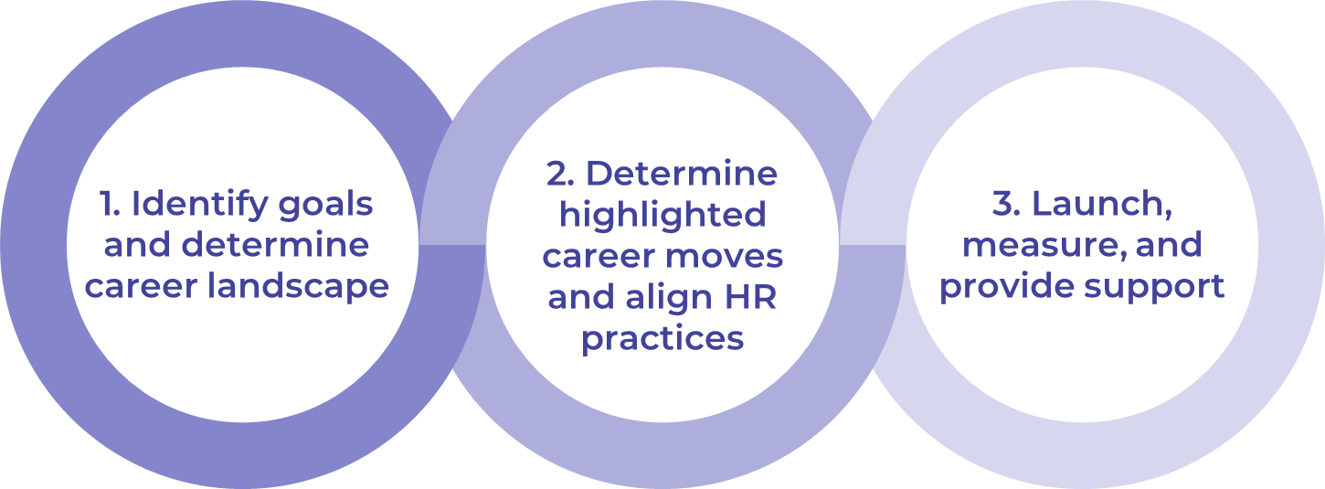

Get to Action

1. Identify goals and determine career landscape | - Establish a project team.  - Examine data and assess the organization’s current state.  - Determine goals and select metrics.  Deliverables:  - Career Path Program Planning Template  - HR Metrics Library
2. Determine highlighted career moves and align HR practices | - Determine the types of career moves to highlight in your organization.  - Assess alignment of supporting HR practices to each highlighted career move.  - Create an action plan.  - Develop collateral and resources to support employee-driven career paths.  Deliverables:  - Career Path Assessment, Action, and Communication Plan  - Traditional Career Ladder Tool  - Career Path Program Marketing Guide  - Employee Career Development Workbook
3. Launch, measure, and provide support | - Provide managers with the necessary resources to support the program.  - Determine a communication and launch plan.  - Define a plan to maintain and refresh the program.  Deliverables:  - Manager Career Conversation Guide  - Career Path Assessment, Action, and Communication Plan

__________________________________________________

For acceptable use of this template, refer to McLean & Company's Terms of Use. These documents are intended to supply general information only, not specific professional, personal, legal, or accounting advice, and are not intended to be used as a substitute for any kind of professional advice. Use this document either in whole or in part as a basis and guide for document creation. To customize this document with corporate marks and titles, simply replace the McLean & Company information in the Header and Footer fields of this document.

