Activate Frontline Managers in Change Management Executive Briefing

Summary
Given their proximity and daily interactions with employees, frontline managers are best suited to support employees through change. Despite being in the prime position to influence employees to adopt change, managers’ knowledge of and expertise in their teams and functions are left untapped. Equip frontline managers with the tools to successfully lead through change.

Our Recommendation
- Create a standard plan to involve frontline managers at all stages of change, communicating key change messages, consulting on key decisions, and participating in training to be effective leaders of change.
- Evaluate frontline managers on key change abilities and curate a resource toolkit for frontline managers to address gaps and facilitate successful implementation and sustainment of change in the front lines.
- Monitor the effectiveness of the toolkit and establish a regular cadence to update the toolkit.
Client Challenge
- Frontline managers are often informed of the change at the same time as the broader workforce and are rarely consulted before key decisions impacting their teams are made.
- Despite being in the prime position to influence employees to adopt change, managers’ knowledge of and expertise in their teams and functions are left untapped. Managers are also not provided with the necessary support or training to be effective leaders of change.

Critical Insight
- Given their proximity and daily interactions with employees, frontline managers are best suited to support, influence, and lead employees through change. Equip frontline managers with the training and tools necessary to effectively navigate their dual role as both the recipients and leaders of change.

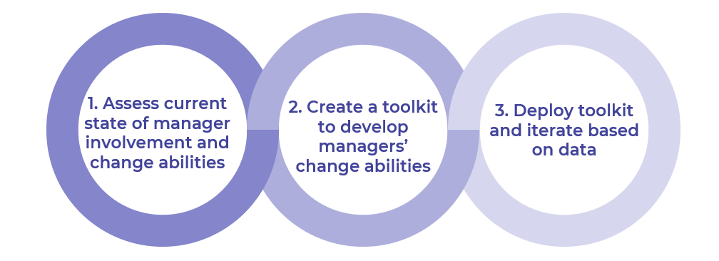
Get to Action

1. Assess current state of manager involvement and change abilities | - Assess the organization’s current change management approach.  - Identify gaps in frontline manager involvement.  - Develop a standard plan to involve frontline managers in future change initiatives.  - Set goals and metrics to track effectiveness of the toolkit.  Deliverables:  - Frontline Change Management Workbook  - Case Studies: Activate Frontline Managers in Change Management
2. Create a toolkit to develop managers’ change abilities | - Review McLean & Company resources for change abilities.  - Select resources to include in the toolkit.  - Review logistics and capacity required and finalize the toolkit.  - Create an action plan to launch the toolkit.  Deliverables:  - Frontline Change Management Workbook
3. Deploy toolkit and iterate based on data | - Develop a plan to communicate and share the toolkit with frontline managers.  - Deploy the toolkit.  - Establish regular cadence to measure the effectiveness of the toolkit.  - Create a plan to identify opportunities to improve the toolkit.  - Explore opportunities to facilitate additional learning opportunities for frontline managers.  Deliverables:  - Frontline Change Management Workbook  - Frontline Manager Change Self-Assessment Tool  - Participant Training Session Evaluation

__________________________________________________

For acceptable use of this template, refer to McLean & Company's Terms of Use. These documents are intended to supply general information only, not specific professional, personal, legal, or accounting advice, and are not intended to be used as a substitute for any kind of professional advice. Use this document either in whole or in part as a basis and guide for document creation. To customize this document with corporate marks and titles, simply replace the McLean & Company information in the Header and Footer fields of this document.

