Develop a Holistic Digital HR Strategy Executive Briefing

Summary
HR’s role is becoming increasingly strategic, yet much of HR’s time is still spent on administrative and operational tasks. As expectations on HR increase, it is crucial to free up HR resources to enable this greater focus on strategic work. Clients expect more from HR and want the same ease of service they get from digital channels and applications outside of work from their HR services.

Our Recommendation
- Develop a holistic digital HR strategy that is owned and driven by HR in collaboration with other key stakeholders to realize benefits such as greater HR efficiency and improved client experience and engagement.
- Focus on the client experience to ensure the people who will be actively interacting with the processes and systems have direct input into the strategy to maximize buy-in, adoption, and impact.
- Ensure strict prioritization and take a phased approach to maintain a manageable workload. The goal is to create a multi-year, living strategy, not to achieve a static end-state.
- Incorporate change management into the roadmap and communications of the digital HR strategy to create reasonable timelines, encourage adoption, and maximize the benefits realized.

Client Challenge
- Seventy-seven percent of organizations do not have a documented HR technology strategy (McLean & Company, HR Trends Survey, 2021; n=431), resulting in existing technology solutions that were selected reactively and fail to effectively meet client needs.
- Many HR departments are not taking any action to support digital transformation and are left out of key decisions around HR technology selection and implementation, despite being the primary users and facilitating its adoption throughout the organization.

Critical Insight
- Creating a digital HR strategy without considering the client experience risks not meeting the needs of a modern workforce. To be successful, HR’s digital strategy must balance the organization’s needs with the needs of the people who will be actively interacting with the processes and systems.

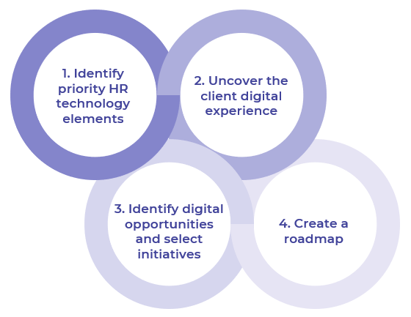
Use McLean & Company’s process to create a digital HR strategy that meets client and organizational needs

Get to Action
1. Create the vision for the change and understand the impact | - Document the project team, key responsibilities, and time commitments.  - Gather high-level feedback from clients.  - Review organizational goals to identify digital HR strategy connections.  - Prioritize HR technology elements.  - Define scope and establish a purpose statement.  - Select metrics and goals to measure success of the digital HR strategy.  Deliverables:  - HR Technology Primer  - Digital HR Strategy Workbook  - Strategy Exploration Guide  - HR Metrics Library  - Case Studies: Develop a Holistic Digital HR Strategy
2. Communicate the change | - Document HR processes and systems in prioritized HR technology elements.  - Map HR processes and identified organizational expectations and key deliverables for each.  - Visualize the degree of systems integration.  - Create client personas.  - Complete interviews with personas to inform empathy maps.  - Complete journey maps for personas.  Deliverables:  - Digital HR Strategy Workbook  - Digital HR Strategy Interview Guide  - Digital HR Strategy Persona Template  - Empathy Map Template
3. Involve the managers and develop the change action plan | - Uncover and categorize digital opportunities.  - Identify and prioritize initiatives to address uncovered opportunities.  - Select goals and metrics to assess improvements in each prioritized HR technology element.  Deliverables:  - Digital HR Strategy Workbook
4. Implement the change | - Identify organizational change type and impact.  - Establish initiatives owners, dependencies, and timelines to build a digital HR strategy roadmap.  - Communicate the digital HR strategy with affected stakeholders and the organization.  - Start planning for the next phase of the digital HR strategy.  Deliverables:  - Change Assessment Tool  - Project Roadmap Tool  - Internal Communications Guide  - Standard Focus Group Guide  - Workshop: Develop a Holistic Digital HR Strategy

__________________________________________________

For acceptable use of this template, refer to McLean & Company's Terms of Use. These documents are intended to supply general information only, not specific professional, personal, legal, or accounting advice, and are not intended to be used as a substitute for any kind of professional advice. Use this document either in whole or in part as a basis and guide for document creation. To customize this document with corporate marks and titles, simply replace the McLean & Company information in the Header and Footer fields of this document.

