Get Started With HR Analytics Executive Briefing

Summary
Organizations are eager to leverage the value of HR analytics solutions and take advantage of the advancements in the HR analytics space. In fact, in a 2020 LinkedIn survey, 85% of organizations identified HR analytics as critical for the future of HR. However, analytics without a clear purpose and link to business challenges will fail to drive action.

Our Recommendation
- The best use of HR analytics depends on each organization’s business challenges and context and requires significant investment into four foundational building blocks: ethical guidelines, data governance, technology, and analytics team skillsets.
- With a cross-functional stakeholder team, identify the gaps in the organization’s ethical guidelines, data governance processes, technology, and analytics team skillsets that are required to deliver on the analytics agenda.
- Plan to address gaps in the foundational building blocks required to deliver on the analytics agenda. Leverage the successes of early projects and stakeholder feedback to scale the use of analytics to optimize business decisions across the organization.

Client Challenge
- Building a successful HR analytics capability in-house requires significant time and resources, and organizations are often challenged with knowing where to start.
- HR analytics has not historically been an area of HR expertise, with few HR professionals being trained to perform analytics.

Critical Insight
- Tapping into the potential of HR analytics isn’t about the most complex or innovative solution. It starts with defining the purpose of HR analytics, asking the right questions to solve business challenges, and investing in the infrastructure, skillsets, and technology required to identify appropriate solutions.

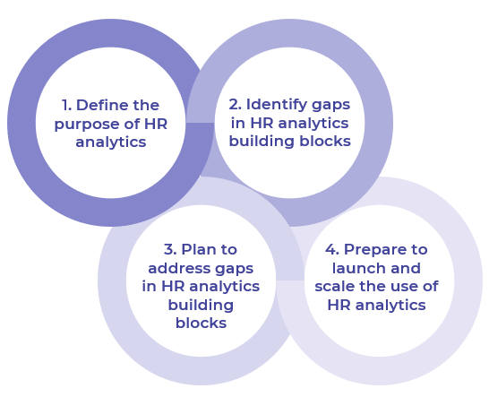
Use McLean & Company’s four-step process to get started with HR analytics

Get to Action
1. Create the vision for the change and understand the impact | - Identify the HR analytics team and key stakeholders.  - Define the purpose of HR analytics.  - Review strategic documents to identify and prioritize HR analytics needs.  - Identify goals and metrics.  - Draft an initial analytics agenda.  Deliverables:  - Standard Project Charter  - HR Analytics Workbook  - Talent Implications Checklist  - Case Studies: Get Started With HR Analytics
2. Communicate the change | - Confirm available data sources.  - Identify gaps in each HR analytics building block:  - Ethical guidelines  - Data governance  - Technology  - Analytics skillset  - Prioritize gaps to address.  Deliverables:  - HR Analytics Gap Analysis Tool  - HR Analytics Workbook
3. Involve the managers and develop the change action plan | - Plan to close gaps in each HR analytics building block:  - Ethical guidelines  - Data governance  - Technology  - Analytics skillset  - Prioritize actions to address gaps.  Deliverables:  - HR Analytics Workbook
4. Implement the change | - Create a business case to address HR analytics gaps.  - Develop an action plan.  - Create a communication plan for key stakeholders.  - Plan an evaluation and iteration process for HR analytics.  Deliverables:  - HR Action and Communication Plan  - Online Workshop: Get Started With HR Analytics

__________________________________________________

For acceptable use of this template, refer to McLean & Company's Terms of Use. These documents are intended to supply general information only, not specific professional, personal, legal, or accounting advice, and are not intended to be used as a substitute for any kind of professional advice. Use this document either in whole or in part as a basis and guide for document creation. To customize this document with corporate marks and titles, simply replace the McLean & Company information in the Header and Footer fields of this document.

