Develop an Internship Program Executive Briefing

Summary
Organizations need to build a strong talent pipeline to address future skills gaps and support long-term strategic objectives. Internship programs create an opportunity to build the talent pipeline by providing early access to emerging talent, including new perspectives, ideas, and skill sets, and increasing talent retention. However, internship programs have traditionally received little thought, which limits the opportunity for organizations to leverage emerging talent to address future needs.

Our Recommendation
- Invest in creating a structured internship program with a strong foundation that can be scaled up over time.
- Design a program that supports organizational goals and talent needs through a strong program structure, recruiting diverse intern talent, and emphasizing intern integration within the organization. Leverage the program to not just build the talent pipeline but also support intern professional development.

Client Challenge
- Internship programs require significant time and resources to develop and implement, and programs that lack structure provide limited return on investment.
- Ineffective internship programs have a negative impact on both interns and organizations and run the risk of damaging the employer brand externally.

Critical Insight
- A well-thought-through, structured internship program expands the talent pipeline and supports organizational goals through meaningful work that benefits both interns and the organization.

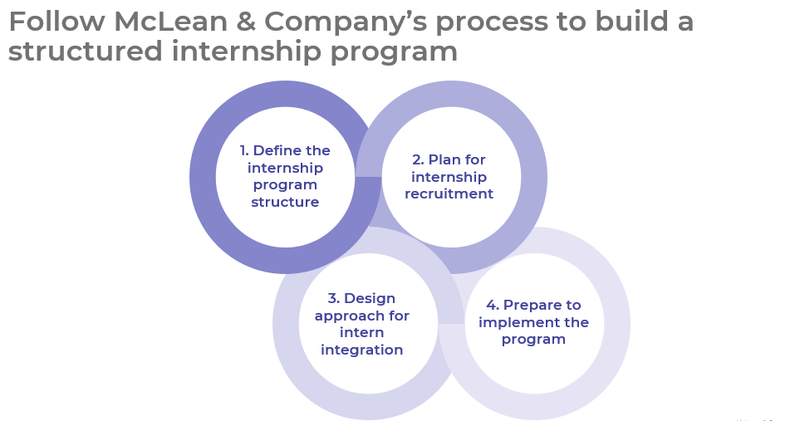
Get to Action
1. Define the Internship Program Structure | - Reviewed organizational information.  - Identified talent needs.  - Determined the most appropriate internship program format.  - Defined program goals and metrics.  - Determined the degree of program centralization.  - Assigned accountabilities to stakeholders.  - Prioritized intern requests to determine intern placements.  - Determined the program budget.  Deliverables:  - Case Studies: Develop an Internship Program  - Internship Program Workbook  - Intern Request Form Template  - HR Metrics Library
2. Plan for Internship Recruitment | - Selected intern managers.  - Outlined intern role requirements.  - Selected external partners.  - Created audience profiles.  - Customized sourcing methods and the TA process for the intern audience.  Deliverables:  - Job Description Template  - Sourcing Plan Template  - Internship Program Workbook
3. Design Approach for Intern Integration | - Prepared for the intern’s first day.  - Planned socialization and professional development opportunities.  - Assigned mentors to interns.  - Determined the intern performance evaluation process.  - Planned to offboard interns.  - Updated relevant policies.  Deliverables:  - Internship Program Workbook
4. Prepare to Implement the Program | - Developed an action plan.  - Created an intern recruitment calendar.  - Developed a communication plan.  - Identified training needs for relevant stakeholders.  - Planned a program evaluation and iteration process.  Deliverables:  - HR Action and Communication Plan  - Campus Recruitment Calendar
__________________________________________________

For acceptable use of this template, refer to McLean & Company's Terms of Use. These documents are intended to supply general information only, not specific professional, personal, legal, or accounting advice, and are not intended to be used as a substitute for any kind of professional advice. Use this document either in whole or in part as a basis and guide for document creation. To customize this document with corporate marks and titles, simply replace the McLean & Company information in the Header and Footer fields of this document.

