Exit Survey Guide Executive Briefing

Summary
McLean & Company’s exit survey data offers insight into the top drivers of turnover at your organization and provides departing employees with the opportunity to provide feedback on factors that affect employee engagement and retention. ​

Our Recommendation
- Tap into the perspective of departing employees to identify overall trends behind departure.
- Focus on the insights the data reveals to make organizational improvements and resolve issues that cause premature departure.
- Source qualitative data to understand the context behind the results and action plan with greater impact.

Client Challenge
- Exit surveys often have low response rates due to a failure to send surveys as soon as departing employees submit their resignations and employee beliefs that feedback will not be acted upon.
- Actions may focus on addressing immediate issues rather than following up with respondents to clarify feedback and conducting a full analysis of the results.
- Exit survey data analysis is often done in a silo, without examining other employee survey data such as new hire or engagement surveys for consistent themes or insights.

Critical Insight
- Demonstrate that the organization values and leverages feedback from departing employees to improve the employee experience.

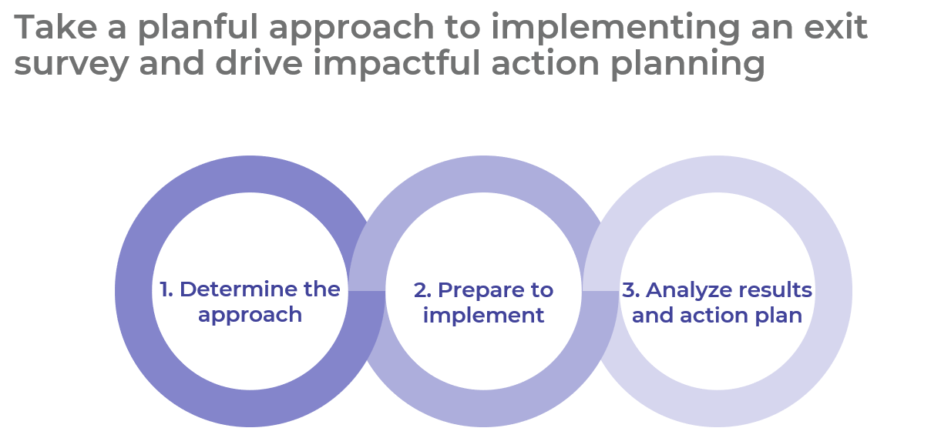

Get to Action
1. Determine the approach | - Establish the purpose and goals for the exit survey.  - Identify stakeholder roles and accountabilities.  - Review the employee survey landscape.  - Identify where exit data offers insight into key HR programs.  - Establish timing for exit survey activities.  Deliverables:  - Exit Survey Program Workbook  - HR Metrics Library
2. Prepare to implement | - Gain an understanding of emotional responses to change.  - Establish communication principles.  - Create key messages and branding for the change.  - Gain advice for announcing the upcoming change to the organization.  Deliverables:  - Exit Survey Scoping Checklist  - Guide to Navigating the McLean Connect Dashboard – Exit Survey  - Guide to Interpreting Your Exit Survey Report
3. Analyze results and action plan | - Analyze survey data and prepare for action.  - Act on individual feedback and serious issues.  - Meet with HR program owners to review data insights and identify action plan initiatives.  - Communicate action initiatives, establish timelines, and track progress.  Deliverables:  - Exit Interview Template  - Exit Survey Program Workbook

__________________________________________________

For acceptable use of this template, refer to McLean & Company's Terms of Use. These documents are intended to supply general information only, not specific professional, personal, legal, or accounting advice, and are not intended to be used as a substitute for any kind of professional advice. Use this document either in whole or in part as a basis and guide for document creation. To customize this document with corporate marks and titles, simply replace the McLean & Company information in the Header and Footer fields of this document.

