Build a Resilient HR Team Executive Briefing

Summary
HR’s role is complex and emotionally draining, and the rapidly changing world of work continues to increase the pressure and stress experienced by HR professionals. This can create negative experiences and chronic work stress, which leads to burnout and turnover. Lack of resilience in HR professionals doesn’t only impact the individuals, it also has significant impacts on departmental outcomes, organizational success, and the bottom line.

Our Recommendation
- Focus on the three key behaviors that are connected to workplace resilience: activate networks, learn to learn, and be flexible.
- Develop a collection of resilience techniques that HR team members can access to develop and practice resilient behaviors in the workplace.

Client Challenge
- Building resilience is incredibly complex. It involves the intersection of individual mindsets and behaviors that are impacted by work factors and personal factors. Many of these factors are outside the organization’s control.
- Mindsets, a key aspect of resilience, are very difficult for the organization to directly impact. To add to this complexity, it's very hard to separate resilience and wellbeing.

Critical Insight
- Work resilience is not just something you’re born with, it takes awareness and effort to develop. HR teams must recognize the importance of building their own resilience and ensure they are actively practicing resilient behaviors to help meet the many demands of the role and the organization.

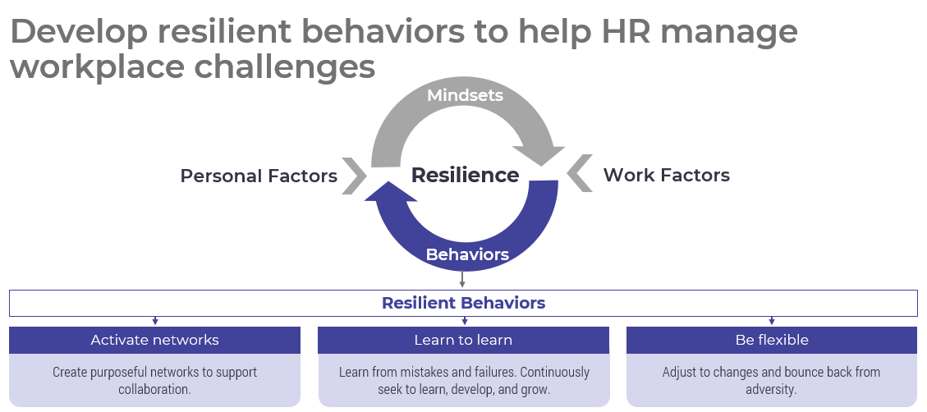

Get to Action
1. Define the HR department’s resilience needs | - Determine the HR team members who will be involved in this initiative.  - Gather data to define the current state of resilient behaviors among HR.  - Turn data insights into HR resilience needs.  Deliverables:  - HR Resilience Workbook  - Standard Focus Group Guide
2. Select resilience techniques | - Identify goals and metrics for the HR resilience project.  - Select resilience techniques and validate them with stakeholders.  Deliverables:  - HR Metrics Library  - Resilience Techniques Catalog  - HR Resilience Workbook
3. Prepare to launch | - Decide how to roll out the resilience techniques to the HR team.  - Build a communication plan.  - Plan to monitor and iterate on the techniques.  Deliverables:  - HR Action and Communication Plan  - Internal Communications Guide

__________________________________________________

For acceptable use of this template, refer to McLean & Company's Terms of Use. These documents are intended to supply general information only, not specific professional, personal, legal, or accounting advice, and are not intended to be used as a substitute for any kind of professional advice. Use this document either in whole or in part as a basis and guide for document creation. To customize this document with corporate marks and titles, simply replace the McLean & Company information in the Header and Footer fields of this document.

