Succeed as a CHRO With a Leadership Development Program Executive Briefing

Summary
Industry disruption, organizational complexity, technological changes, and external risks are continuing to change the world of work and, as a result, the role of the CHRO. CHROs are being met with increased expectations and are playing a larger strategic role to help their organizations successfully navigate the ever-changing environment.

Our Recommendation
- Adopt a planful approach to creating a development plan to overcome common barriers. Scheduling time for development, aligning with organizational strategy, and owning personal growth are key to prioritizing and following through on your development.
- Build a customized plan to focus your development on key competencies that will support your success and maximize impact on your organization.

Client Challenge
- Many CHROs are unprepared for the increasing demands and complexity of the role. If CHROs don’t prioritize their own development to meet expectations and support their organization, they risk falling behind.
- However, it is often difficult for CHROs to find time in their busy schedules, overcome feelings of vulnerability, and/or adopt a dynamic learning mindset. These barriers often prevent CHROs from prioritizing their own development.

Critical Insight
- In an environment of constant disruption, CHROs require key competencies to support their organizations. A planful approach is required to keep personal development off the backburner and help the organization navigate change and succeed.

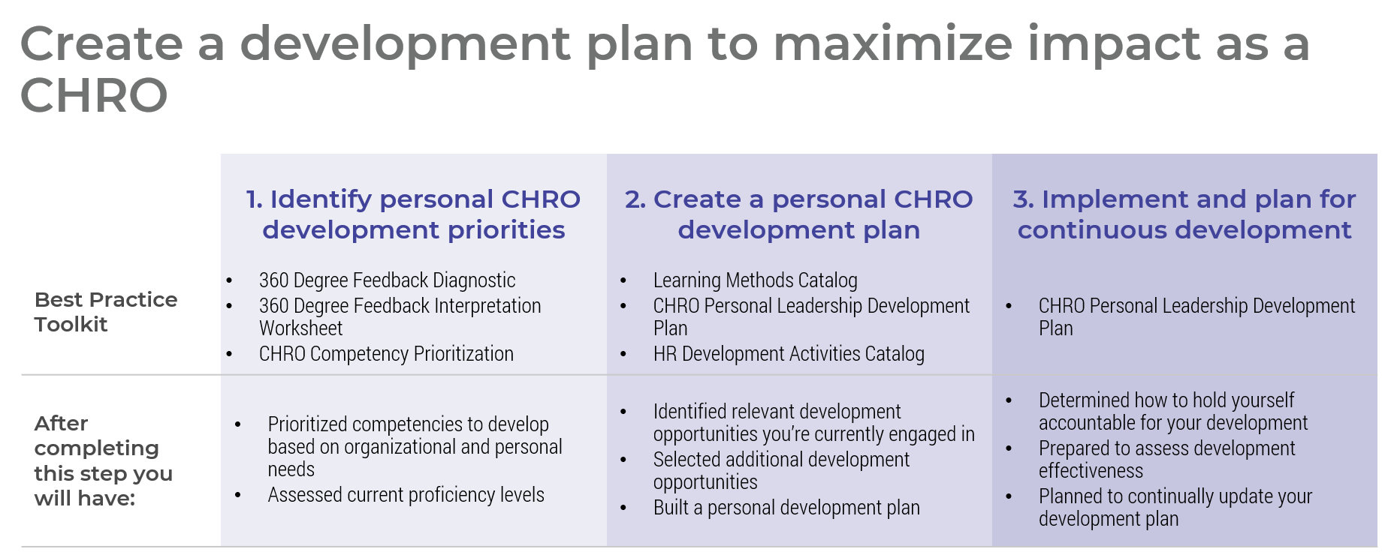

Get to Action
1. Identify your development priorities | - Prioritize competencies to develop based on organizational and personal needs  - Assess current proficiency levels  Deliverables:  - CHRO Competency Prioritization  - CHRO 360 Feedback Interpretation Worksheet  - CHRO Personal Leadership Development Plan  - Case Studies: Accelerate Your Impact as a CHRO
2. Create your personal CHRO development plan | - Identify relevant development opportunities you’re currently engaged in  - Select additional development opportunities  - Build your development plan  Deliverables:  - Learning Methods Catalog  - CHRO Personal Leadership Development Plan  - HR Development Activities Catalog
3. Implement and plan for continuous development | - Determine how to hold yourself accountable for your development  - Prepare to assess development effectiveness  - Plan to continually update your development plan

__________________________________________________

For acceptable use of this template, refer to McLean & Company's Terms of Use. These documents are intended to supply general information only, not specific professional, personal, legal, or accounting advice, and are not intended to be used as a substitute for any kind of professional advice. Use this document either in whole or in part as a basis and guide for document creation. To customize this document with corporate marks and titles, simply replace the McLean & Company information in the Header and Footer fields of this document.

