Adapt the Talent Acquisition Process to a Virtual Environment Executive Briefing

Summary
COVID-19 pushed organizations to shift to a remote environment, requiring TA to adjust their process to accommodate this change. Although some TA activities are easily transferable to a virtual environment, others require more significant workarounds to continue essential operations.

Our Recommendation
- Identify TA activity priorities that must be shifted to more sustainable virtual solutions. Assess virtual options available, including existing technology, to not only support operations during the pandemic but also enhance the overall TA process in the long term by improving process efficiencies, candidate experience, and quality of hire.

Client Challenge
- Although TA is among the most diverse and mature markets in HR technology, the function still has difficulty with using virtual solutions to their advantage. This resulted in many TA functions scrambling to find band-aid solutions to continue operations in the short term at the beginning of the pandemic. However, due to the fact the pandemic will impact the way organizations work for the foreseeable future, temporary solutions will not be sufficient.

Critical Insight
- Effective virtual TA solutions drive success in multiple priorities, including process efficiency, candidate experience, and quality of hire. This was true before the pandemic, is still true during it, and will continue to be true into the new normal. Use the shift to a remote environment as an opportunity to enhance the TA process with virtual solutions.

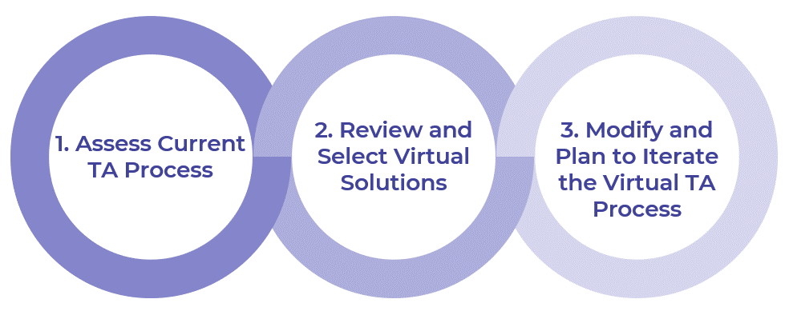
Get to Action

1. Assess current  TA process | - Map out the current TA process.  - Gather relevant data and review implications to inform the shift to a virtual TA process.  - Identify and prioritize TA activities that need to shift to virtual.  - Build an inventory of current tools and technologies available to leverage for the virtual TA process.  - Review the project’s constraints to select realistic solutions.  - Use current metrics to track the impact of the shift to virtual solutions.  Deliverables:  - Process Mapping Guide  - Virtual TA Workbook  - HR Metrics Library  - Case Studies: Adapt the Talent Acquisition Process to a Virtual Environment
2. Review and select virtual solutions | - Shortlist virtual solutions for prioritized TA activities.  - Evaluate whether to include an HRIS, ATS, and/or CRM in the shortlist.  - Identify gaps where TA activities have not been addressed by an overall virtual solution.  - Review additional virtual solutions at each stage of the TA process.  - Evaluate the effort and impact of shortlisted solutions.  - Identify potential risks of adopting virtual TA solutions.  Deliverables:  - Virtual TA Workbook  - Idea Catalog: Adapt the Talent Acquisition Process to a Virtual Environment
3. Modify and plan  to iterate the virtual TA process | - Finalize the selection of virtual TA solutions with key stakeholders.  - Prepare to engage with vendors for selected solutions.  - Confirm and document virtual TA process.  - Clarify the roles of all stakeholders involved in the virtual TA process post implementation.  - Create an action plan to integrate virtual solutions into the TA process.  - Sustain and support the change to virtual TA activities.  - Communicate the virtual TA process internally and externally.  - Evaluate and iterate the virtual TA process.  Deliverables:  - Virtual TA Workbook  - SLA Template  - Candidate Experience SLA Template  - Action & Communication Plan

__________________________________________________

For acceptable use of this template, refer to McLean & Company's Terms of Use. These documents are intended to supply general information only, not specific professional, personal, legal, or accounting advice, and are not intended to be used as a substitute for any kind of professional advice. Use this document either in whole or in part as a basis and guide for document creation. To customize this document with corporate marks and titles, simply replace the McLean & Company information in the Header and Footer fields of this document.

