Sustain Work-From-Home Executive Briefing

Summary
The COVID-19 pandemic pushed organizations that were previously resistant to work-from-home (WFH) into an immediate WFH experiment. The success of these programs signaled an opportunity for a shift in mindset regarding remote work as a more permanent option for employees.

Our Recommendation

Sustain WFH opportunities for employees by creating a planned, integrated, and supported program that maximizes the benefits of flexibility while supporting both organizational and employee needs. Using an in-depth analysis of work duties, processes, and operational outcomes, along with the development of clearly defined program parameters, transition into a successful and unbiased long-term WFH program.

Client Challenge
Not all roles are suitable for WFH. Organizations need a clearly defined, unbiased approach to determine who can WFH on an ongoing basis and who needs to work onsite. In addition, some employees want to work onsite regardless of whether their role can WFH. Successful WFH programs require support (e.g. tools, training, and logistics) and integration into organizational and HR programs.

Critical Insight
WFH programs won't sustain themselves: they require the right long-term options for your organization and ongoing efforts through supporting programs and change management.

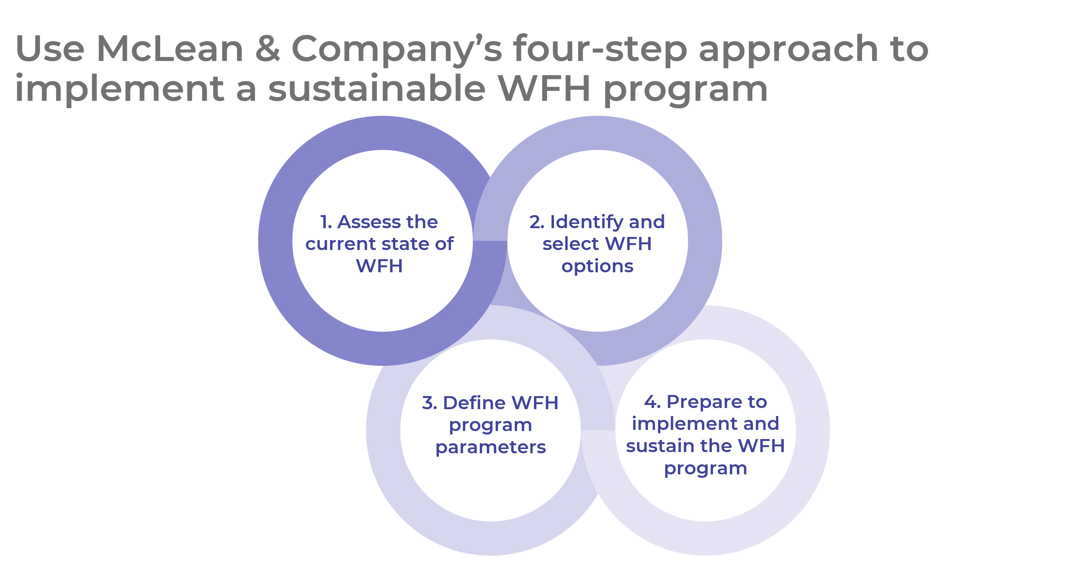

Get to Action
1. Assess the current state of WFH | - Involve key players in the planning committee.  - Identify current WFH work units and roles.  - Assess the current state of WFH for each applicable work unit.  - Determine the suitability of each work unit to WFH.  - Determine program goals and metrics to track success.  Deliverables:  - Sustained WFH Workbook  - HR Metrics Library
2. Identify and select WFH options | - Review the different WFH options.  - Choose the WFH option for each work unit that best aligns with the organizational context.  - Ensure consistency where possible by consolidating varied WFH options across work units.  - Solicit feedback to validate the choice of the selected WFH options from employees and leaders.  Deliverables:  - Sustained WFH Workbook
3. Define WFH program parameters | - Define employee eligibility parameters for the WFH program.  - Define time parameters for the WFH program.  - Create a WFH policy outlining the program parameters.  - Update related guidelines and policies to support the WFH program.  - Determine the resources and support required to enable the program.  - Plan modifications to identified organizational programs.  Deliverables:  - Sustained WFH Workbook  - Idea Catalog: Sustain Work-From-Home  - Job Aid: Work-From-Anywhere  - Work-From-Home (WFH) Policy
4. Prepare to implement and sustain the WFH program | - Solicit required approvals on the WFH program.  - Create a program rollout schedule.  - Use change management tactics to support transition to the WFH program.  - Communicate the WFH program internally and externally.  - Evaluate and iterate the program on an ongoing basis.  Deliverables:  - Internal Communications Guide Template  - HR Action and Communication Plan
__________________________________________________

For acceptable use of this template, refer to McLean & Company's Terms of Use. These documents are intended to supply general information only, not specific professional, personal, legal, or accounting advice, and are not intended to be used as a substitute for any kind of professional advice. Use this document either in whole or in part as a basis and guide for document creation. To customize this document with corporate marks and titles, simply replace the McLean & Company information in the Header and Footer fields of this document.

