Nudges: A Paradigm for HR to Influence Employee Behavior Executive Briefing

Summary
Employees are often unaware of the impact that biases and heuristics have on their decisions, leading to decision-making pressures and bottlenecks that have a significant impact on organizational outcomes. Map out the decision-making process of employees and develop ethical nudges that address the pressures and bottlenecks they face.

Our Recommendation
- Map out the decision-making process of employees’ suboptimal behaviors to determine any pressures or bottlenecks that are inhibiting employees from making better decisions.
- Develop ethical nudges that address the pressures and bottlenecks faced by employees.

Client Challenge
- Every decision we make is informed by biases and heuristics, but they are a double-edged sword. They enable people to make quick and intuitive decisions but also lead to rash and misinformed choices.
- Biases and heuristics are of particular concern in an organizational context since misinformed or suboptimal decisions made by employees can have a significant impact on organizational outcomes.

Critical Insight
- Nudges are not new: HR professionals have been applying the concept in practice for decades without having a formal name for it. But by taking an informed, measurable approach, HR can stop guessing and start reporting on the effectiveness of their nudge interventions.

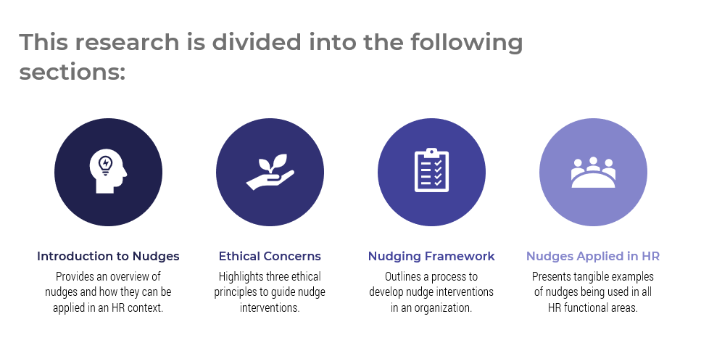

Get to Action

1. Integrate nudge interventions into your HR practices to influence employee behavior and drive organizational results. | - Learn about the theory and applications of nudges  - Use the ethical principles and ethics matrix to determine what constitutes an ethical nudge  - Follow McLean & Company’s nudge framework to apply nudges to HR  - Learn how different organizations have applied nudge theory to solve HR challenges and drive organizational results  Deliverables:  - Nudges: A Paradigm for HR to Influence Employee Behavior Storyboard  - Biases and Heuristics Catalog  - Process Mapping Guide  - Design Thinking Primer

__________________________________________________

For acceptable use of this template, refer to McLean & Company's Terms of Use. These documents are intended to supply general information only, not specific professional, personal, legal, or accounting advice, and are not intended to be used as a substitute for any kind of professional advice. Use this document either in whole or in part as a basis and guide for document creation. To customize this document with corporate marks and titles, simply replace the McLean & Company information in the Header and Footer fields of this document.

