Navigate the Pandemic With a Flexible Talent Strategy Executive Briefing

Summary

The COVID-19 pandemic has resulted in unparalleled disruption for business, government, and society. HR leaders continue to be at the forefront of the crisis response, enabling organizations to swiftly address the talent implications of the evolving situation. Now is the time for HR to transition to a proactive role and enable the organization to achieve its near-term strategies as it navigates through initial crisis response to the new normal.

Our Recommendation

HR should integrate scenario planning into the strategic planning process to prepare for a diverse set of possible pandemic outcomes. Identify the talent implications of the organization’s near-term strategies in each possible scenario and build a flexible talent strategy.

Client Challenge

The near term is still unclear and will be shaped by a complex interplay of epidemiological factors, economic factors, governmental responses, and shifts in societal and consumer behavior. Organizations and HR departments need to be prepared for multiple possible scenarios.

Critical Insight
Uncertainty is a problem to overcome, not an excuse to avoid planning. Now more than ever HR needs to develop a flexible talent strategy that enables the organization to survive and thrive in any possible future.

McLean & Company’s process to create an agile talent strategy

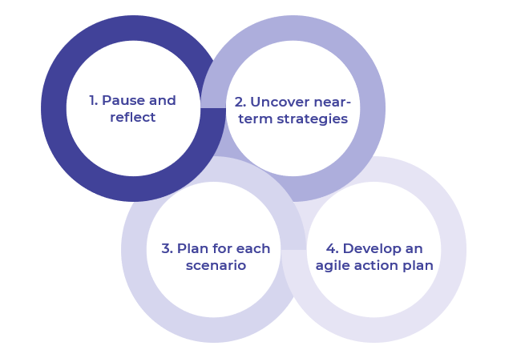
Get to Action
1. Pause and reflect | - Solicit quick feedback from key stakeholders on the impact of the crisis.  - Briefly evaluate HR’s crisis response actions.  Deliverables:  - Navigate the Pandemic With a Flexible Talent Strategy Workbook
2. Uncover near-term strategies | - Identify the organization’s guiding principles.  - Uncover near-term organizational strategies for each scenario.  Deliverables:  - Navigate the Pandemic With a Flexible Talent Strategy Workbook
3. Plan for each scenario | - Identify talent implications for each scenario.  - Review current talent strategy for alignment with talent implications in each scenario.  - Determine HR initiatives to address remaining talent implications for each scenario.  - Assess HR’s ability to support identified HR initiatives.  - Prioritize HR initiatives and validate them with stakeholders.  Deliverables:  - Navigate the Pandemic With a Flexible Talent Strategy Workbook  - Talent Implications Checklist
4. Develop an agile action plan | - Develop an agile action plan to deliver on HR strategic initiatives.  - Plan to iterate the agile action plan on an ongoing basis.  - Communicate the agile action plan to stakeholders.  Deliverables:  - Navigate the Pandemic With a Flexible Talent Strategy Workbook

__________________________________________________

For acceptable use of this template, refer to McLean & Company's Terms of Use. These documents are intended to supply general information only, not specific professional, personal, legal, or accounting advice, and are not intended to be used as a substitute for any kind of professional advice. Use this document either in whole or in part as a basis and guide for document creation. To customize this document with corporate marks and titles, simply replace the McLean & Company information in the Header and Footer fields of this document.

