Return-to-the-Workplace Playbook Executive Briefing

Summary
The onset of the pandemic dispersed employees from the workplace, some working from home, others laid-off/furloughed, and some brought back to the workplace only to be sent home again. However, as vaccines roll out and countries around the world pass the peak of the pandemic, organizations are anxious to determine when and how to bring employees back to the workplace.

Our Recommendation
- Review key factors and determine how to bring employees back to the workplace, prioritizing first by work units and then by employee segments. Maintain awareness of public health requirements and legislation when designing return-to-the-workplace (RTW) protocols, including actions to address employee-specific challenges. Finally, create a plan with key triggers and be prepared to iterate.

Client Challenge
- There are currently multiple vaccines for COVID-19, but uptake around the world varies. Balancing the protection of employees in a workplace with employees’ privacy and rights poses an issue.
- Organizations need to put protocols in place to ensure the health and safety of anyone accessing the workplace and to prevent outbreaks. Protocols require organizations to assess and modify current operations and workplace layouts.
- Organizations operating in different regions may have different federal and local public health restrictions and COVID-19 guidelines and be in different stages of the pandemic.
- This disruption may be greater or lesser across work units within an organization, requiring different work units to operate in different ways or at different times.

Critical Insight
- Workplace changes spurred by the realities of the pandemic have been so seismic it is highly unlikely things will go back to the way they were before.

Use McLean & Company’s Roadmap to Returning to the Workplace

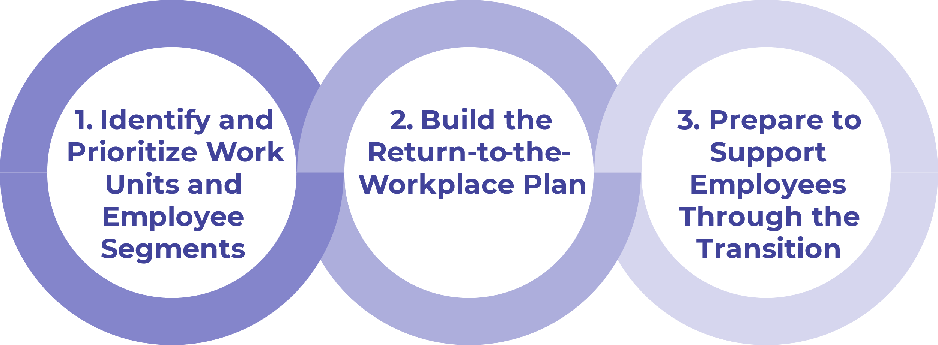
Get to Action

1. Identify and prioritize work units and employee segments. | - Identify work units within the organization.  - Assess employee sentiment on returning to the workplace and determine if a work-from-home program is needed.  - Analyze data and prioritize work units to return to the workplace.  - Identify and prioritize employee segments to return to the workplace.  Deliverables:  - Return-to-the-Workplace Workbook  - Case Study: Return-to-the-Workplace Playbook
2. Build the RTW plan. | - Select the approach you will use to return employees to the workplace.  - Tailor organizational programs and policies and update existing COVID-19 protocols.  Deliverables:  - Return-to-the-Workplace Plan Summary Tool  - Idea Catalog: Return-to-the-Workplace Playbook  - Return-to-the-Workplace Workbook
3. Prepare to support employees through the transition. | - Create a detailed RTW action plan.  - Review communication best practices and leverage McLean & Company’s resources.  - Plan internal and external communications.  - Establish an approach for monitoring the success of the deployment plan.  Deliverables:  - HR Action and Communication Plan  - Return-to-the-Workplace FAQ Template

__________________________________________________

For acceptable use of this template, refer to McLean & Company's Terms of Use. These documents are intended to supply general information only, not specific professional, personal, legal, or accounting advice, and are not intended to be used as a substitute for any kind of professional advice. Use this document either in whole or in part as a basis and guide for document creation. To customize this document with corporate marks and titles, simply replace the McLean & Company information in the Header and Footer fields of this document.

