The Complete Manual for Layoffs Executive Briefing

Summary
When the economy is negatively influenced by factors beyond any organization’s control, the impact can be felt almost immediately on the bottom line. This decline in revenue as a result of a weakening economy will force organizations to reconsider every dollar they spend.

Our Recommendation
By following our process, we can provide your organization with the direction, tools, and best practices to lay off employees. This will need to be done with careful consideration into your organization’s short- and longer-term strategic goals.

Client Challenge
In an effort to determine where costs can be reduced, or if an organization is being put into a forced closure, the costs associated with your workforce will have to be considered. Laying off employees may be the only option.

Critical Insight
The remote work environment many organizations find themselves in adds a layer of complexity to the already sensitive process of laying off employees. Carrying out layoffs must be done with keeping personal contact as your first priority. That personal contact should be the basis for all subsequent communication with laid-off and retained employees, even after layoffs have occurred.

Roadmap

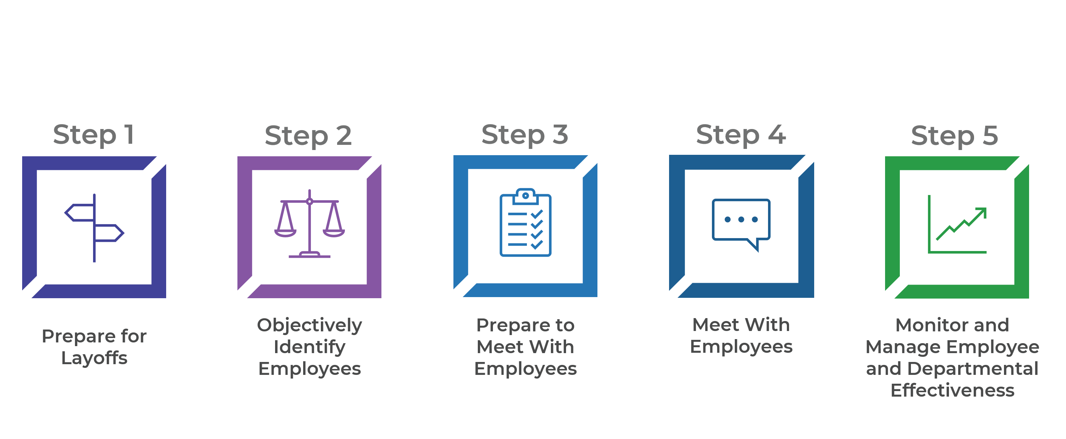
Get to Action
1. Prepare for Layoffs | - Identified appropriate cost-cutting strategies, including redeployment and layoffs.  - Gathered information to guide layoff decision making and employee support.  Deliverables:  - Standard SWOT Analysis Template  - Redeployment & Layoff Strategy Workbook  - Sample Layoffs Policy  - Cost-Cutting Planning Tool  - Termination Costing Tool
2. Objectively Identify Employees | - Set objective criteria to select roles/departments and employees for layoff.  - Identified which skills and responsibilities are critical to the organization.  - Confirmed the transfer of essential responsibilities to retained employees.  Deliverables:  - Workforce Planning Workbook  - Employee Layoff Selection Tool
3. Prepare to Meet With Employees | - Planned logistics.  - Trained managers.  - Planned for knowledge transfer.  - Prepared communications and layoff notices.  - Planned for reactions.  - Built communications plan for post-layoff.  Deliverables:  - Termination Logistics Tool  - Knowledge Transfer Risk Assessment Tool  - Knowledge Transfer Template  - Knowledge Identification Interview Guide Template  - Knowledge Transfer Job Aid  - Layoff Communications Package
4. Meet With Employees | - Delivered the layoffs notices.  - Established collaborations with necessary departments.  Deliverables:  - Employee Departure Checklist Tool
5. Monitor and Manage Employee and Departmental Effectiveness | - Identified key communication methods for staying connected to employees.  - Built a communication plan for all groups of affected employees.  - Completed organization performance monitoring plan.

__________________________________________________

For acceptable use of this template, refer to McLean & Company's Terms of Use. These documents are intended to supply general information only, not specific professional, personal, legal, or accounting advice, and are not intended to be used as a substitute for any kind of professional advice. Use this document either in whole or in part as a basis and guide for document creation. To customize this document with corporate marks and titles, simply replace the McLean & Company information in the Header and Footer fields of this document.

