Reimagine Learning in the Face of Crisis Executive Briefing

Summary
The impact of VUCA (volatile, uncertain, complex, and ambiguous) times on organizations is well known, but the current COVID-19 pandemic is a crisis like no other. The economic impacts and labor disruptions are keeping HR leaders focused on damage control and workforce planning, with long-term priorities put on hold. The knee-jerk reaction may be to suspend all learning & development (L&D) activities to cut costs and mitigate risk.

Our Recommendation
L&D teams should focus on how to support employees and managers to develop the critical competencies they need to successfully perform through the crisis, enabling organizations to survive and thrive during and beyond the crisis. Ensure learning needs align closely with evolving organizational priorities, collaborate cross-functionally, and curate content to provide the learning employees and leaders need most, when they need it.

Client Challenge
As organizations re-evaluate their priorities and shift to new ways of working, leaders and employees are challenged to navigate unchartered territory and to adjust quickly to ever-evolving priorities. Learning how to perform effectively through the crisis and deliver on new priorities is crucial to the success of all employees and the organization.

Critical Insight
The most successful organizations recognize that learning is critical to adjusting quickly and effectively to their new reality. This requires L&D to reimagine their approach to deliver learning that enables the organization’s immediate and evolving priorities.

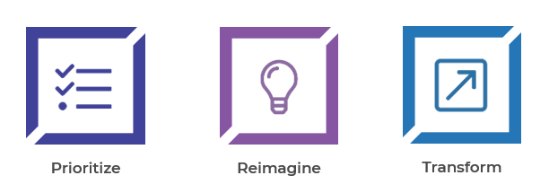
Get to Action
1. Prioritize | - Identify and involve key stakeholders.  - Identify immediate priorities.  - Conduct high-level triage of L&D and identify immediate learning priorities.  Deliverables:  - Reimagine Learning in the Face of Crisis Workbook
2. Reimagine | - Identify the audience impacted by each priority to determine their learning needs.  - Translate immediate priorities into learning needs.  - Evaluate ability to realistically deliver learning.  - Uncover existing internal content across the organization that supports learning needs.  - Curate external content that will be used to support learning needs.  Deliverables:  - Reimagine Learning in the Face of Crisis Workbook
3. Transform | - Identify technical requirements for the chosen delivery method.  - Draft a four- to six-week action plan.  Deliverables:  - How to Curate Guide  - Tips for Building an Online Learning Community  - Ten Tips for Adapting In-Person Training During a Crisis  - Tips for Remote Learning in the Face of Crisis  - Reimagine Learning in the Face of Crisis Workbook

__________________________________________________

For acceptable use of this template, refer to McLean & Company's Terms of Use. These documents are intended to supply general information only, not specific professional, personal, legal, or accounting advice, and are not intended to be used as a substitute for any kind of professional advice. Use this document either in whole or in part as a basis and guide for document creation. To customize this document with corporate marks and titles, simply replace the McLean & Company information in the Header and Footer fields of this document.

