Adapt Your Onboarding Process to a Virtual Environment Executive Briefing

Summary
The COVID-19 pandemic has forced many organizations to make sudden changes to the way they conduct work. Many organizations that don’t normally work remotely had to shift their workforce to a work-from-home (WFH) arrangement and leverage virtual meetings to remain connected. This has impacted the new hire onboarding process, requiring organizations to quickly pivot to a virtual approach.

Our Recommendation
- Organizations need to assess their existing onboarding process and identify the parts that are critical.
- Using the technology currently available, organizations must adapt onboarding to a virtual environment.
- Develop a plan to re-assess and update the onboarding program according to the duration of the situation.

Client Challenge
- For many, the WFH arrangement will be temporary, however, the uncertainty around the length of the pandemic makes it hard for organizations to plan long term.
- As onboarding plans traditionally carry a six- to twelve-month outlook, the uncertainty around how long employees will be working remotely makes it challenging to determine how much of the current onboarding program needs to change.
- In addition, introducing new technologies to a remote workforce and planning training on how to access and effectively use these technologies is difficult.

Critical Insight
- The COVID-19 pandemic has led to a virtual environment many organizations were not prepared for.
- Focusing on critical parts of the onboarding process and leveraging current technology allows organizations to quickly adapt to the uncertainty and constant change.

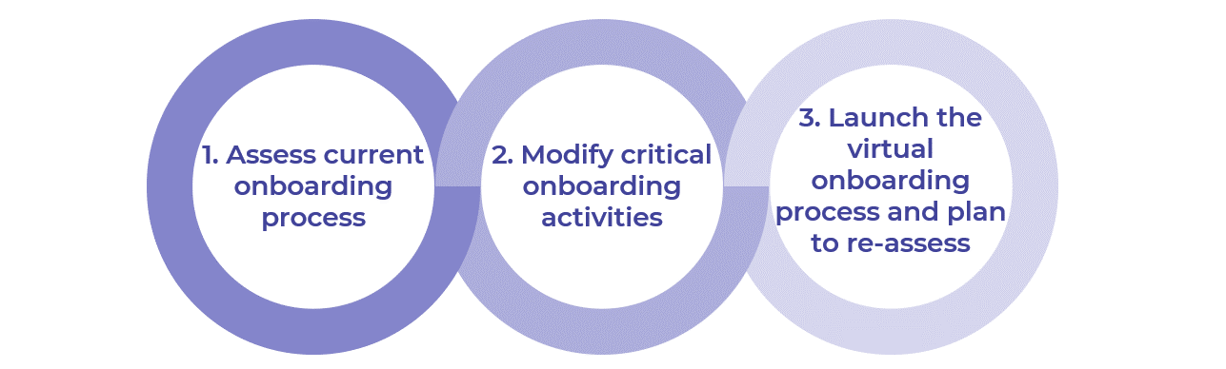
Get to Action
1. Assess current onboarding processes | - Map the current onboarding process  - Identify challenges to going virtual  Deliverables:  - Virtual Onboarding Workbook  - Process Mapping Guide
2. Modify onboarding activities | - Determine how the “Acclimate” stage of onboarding can be modified for a virtual environment  - Brainstorm solutions in the “Guide” stage of onboarding  - Address virtual training roadblocks in the “Develop” stage of onboarding  Deliverables:  - Virtual Onboarding Ideas Catalog  - Virtual Onboarding Workbook  - Network Activation Action Plan  - Performance Management for Emergency Work-From-Home  - In-Person to Online: Delivering Training While Social Distancing Note
3. Launch the virtual onboarding process and plan to re-assess | - Modify the onboarding process  - Create an action plan  - Re-assess and iterate  Deliverables:  - Virtual Onboarding Workbook  - Virtual Onboarding Guide for HR  - Virtual Onboarding Guide for Managers  - HR Action and Communication Plan  - Virtual Onboarding Schedule

__________________________________________________

For acceptable use of this template, refer to McLean & Company's Terms of Use. These documents are intended to supply general information only, not specific professional, personal, legal, or accounting advice, and are not intended to be used as a substitute for any kind of professional advice. Use this document either in whole or in part as a basis and guide for document creation. To customize this document with corporate marks and titles, simply replace the McLean & Company information in the Header and Footer fields of this document.

