Redeploy Your Workforce During a Crisis

Summary
Layoffs are often the first cost-cutting option organizations resort to in times of crisis. However, during a crisis, many parts of an organization change frequently and rapidly, and all areas aren’t impacted in the same way. This presents an opportunity to redeploy employees to areas of need instead of laying them off, which will better position the organization to get back to normal once no longer in crisis mode.

Our Recommendation
Make the most of your workforce in a time of crisis by following McLean & Company’s process to initiate employee redeployment efforts and reduce costs.

Client Challenge
When the economy is negatively influenced by factors beyond any organization’s control, the impact can be felt almost immediately on the bottom line. This decline in revenue as a result of a weakening economy will force organizations to reconsider every dollar they spend to help secure the long-term viability of their organization.

Critical Insight
Employees are an organization’s greatest asset. When faced with cost-cutting pressures, look for redeployment opportunities that use talent as a resource to get through hard times before resorting to difficult layoff decisions.

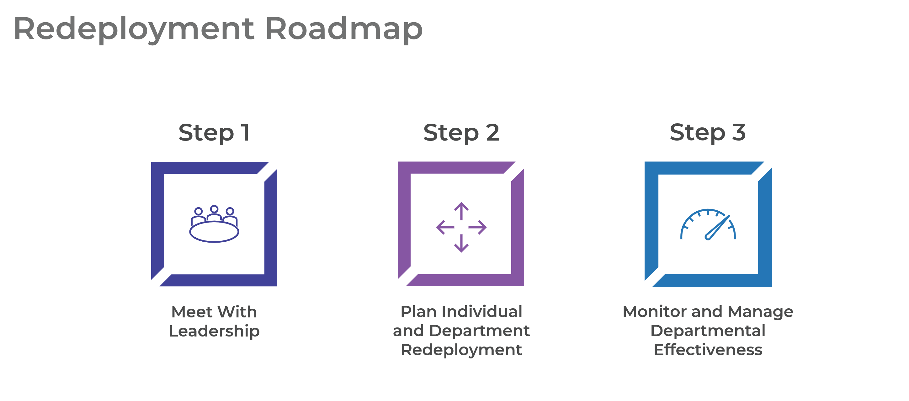
Get to Action
1. Meet With Leadership | - Set strategy with senior leadership.  - Brainstorm underused and understaffed employee segments and departments.  - Determine an approach to redeployments and layoffs.  Deliverables:  - Standard SWOT Analysis Template  - Redeployment and Layoff Strategy Workbook  - Cost-Cutting Planning Tool  - Termination Costing Tool
2. Plan Individual and Department Redeployment | - Identify employees that need to be redeployed.  - Create a high-level action plan to redeploy employees.  - Prepare communication, training, and support for redeployment initiatives.  Deliverables:  - Short-Term Survival Segment Evaluation Tool  - Skills Inventory for Redeployment Tool  - Redeployment Action and Communication Plan  - Redeployment Communication Roll-Up Template  - Crisis Communication Guides
3. Monitor and Manage Departmental Effectiveness | - Monitor departmental performance.  - Review organizational performance.  - Determine next steps.

__________________________________________________

For acceptable use of this template, refer to McLean & Company's Terms of Use. These documents are intended to supply general information only, not specific professional, personal, legal, or accounting advice, and are not intended to be used as a substitute for any kind of professional advice. Use this document either in whole or in part as a basis and guide for document creation. To customize this document with corporate marks and titles, simply replace the McLean & Company information in the Header and Footer fields of this document.

