Prepare for External Risks Executive Briefing

Summary
In today’s volatile, uncertain, complex, and ambiguous (VUCA) environment, organizations face frequent vulnerability to external risks. Although talent is increasingly recognized as a crucial asset to organizations, the talent implications of external risks are rarely assessed. Moreover, organizations tend to be reactive to external risks, which often leads to disproportionate consequences for talent.

Our Recommendation
- Conduct an environmental scan to identify and prioritize external risks according to their likelihood, impact, and HR relevance.
- Create scenarios to anticipate the talent implications of the prioritized risks.
- Identify HR initiatives that enable organizations to survive and thrive in a VUCA world with the use of three principles: proactive implementation, plan now for the future, and opportunity for growth.

Client Challenge
- Organizations focus on finding operational and financial solutions to external risks without evaluating how talent can be part of the solution. When HR is not involved early on, by the time the talent implications are apparent, the damage is already done.
- This is further complicated by a VUCA climate where there is less time to rectify errors before organizational survival is threatened.

Critical Insight
- Managing risks must go beyond maintaining the status quo. HR departments that anticipate and proactively plan for the talent implications of external risks not only survive but thrive through challenging times.

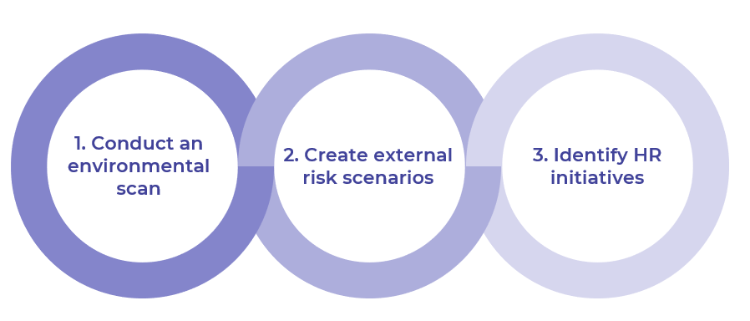
Get to Action
1. Conduct an environmental scan | - Gather information on the organization’s context.  - Conduct an environmental scan.  - Prioritize external risks.  Deliverables:  - Standard Project Charter  - External Risks Workbook  - Strategy Exploration Guide  - Case Studies: Prepare for External Risks
2. Create external risk scenarios | - Determine the scope of scenario planning.  - Identify assumptions and uncertainties about each prioritized risk.  - Build scenarios for each prioritized risk.  Deliverables:  - External Risks Workbook
3. Identify HR initiatives | - Define talent implications from each risk scenario.  - Determine HR initiatives to address the talent implications.  - Prioritize HR initiatives against existing programs.  - Present recommendations to the board.  Deliverables:  - External Risks Workbook  - Prepare for External Risks: HR Initiatives Catalog  - HR Action and Communication Plan  - HR Metrics Library  - Prepare for External Risks Presentation Template

__________________________________________________

For acceptable use of this template, refer to McLean & Company's Terms of Use. These documents are intended to supply general information only, not specific professional, personal, legal, or accounting advice, and are not intended to be used as a substitute for any kind of professional advice. Use this document either in whole or in part as a basis and guide for document creation. To customize this document with corporate marks and titles, simply replace the McLean & Company information in the Header and Footer fields of this document.

