Design an Employee Volunteer Program Executive Briefing

Summary

People want to work for socially responsible organizations, and candidates evaluate employers based on their community involvement. Employees want to give back by volunteering, but busy schedules and workplace constraints (e.g. accessibility barriers, unsupportive managers, job requirements) make finding the time difficult. Employee volunteer programs present employers with many benefits, including decreased turnover and increased talent attraction, employee engagement, innovation, and revenue.

Our Recommendation
- Involve senior leaders, middle managers, and employees in program design from the beginning to gain support and buy-in at every level.
- Design an employee-powered volunteer program aligned with organizational goals. It should measure success and empower employees to champion events and causes they are passionate about.
- Build long-term partnerships with existing and new community partners to ensure shared value.

Client Challenge

A lack of leadership support, especially among middle managers support, derails participation in employee volunteer programs.

It is difficult to measure an employee volunteer program’s social impact, as it is an abstract concept. As a result, organizations often avoid measuring impact altogether. This is a missed opportunity to demonstrate the value and benefits of such programs to fellow employees and senior leaders.

Critical Insight
- Employee or corporate volunteer programs are best positioned to maximize shared value when they align with the organization’s priorities and harness the power of employees to drive community impact. It’s a win-win-win.

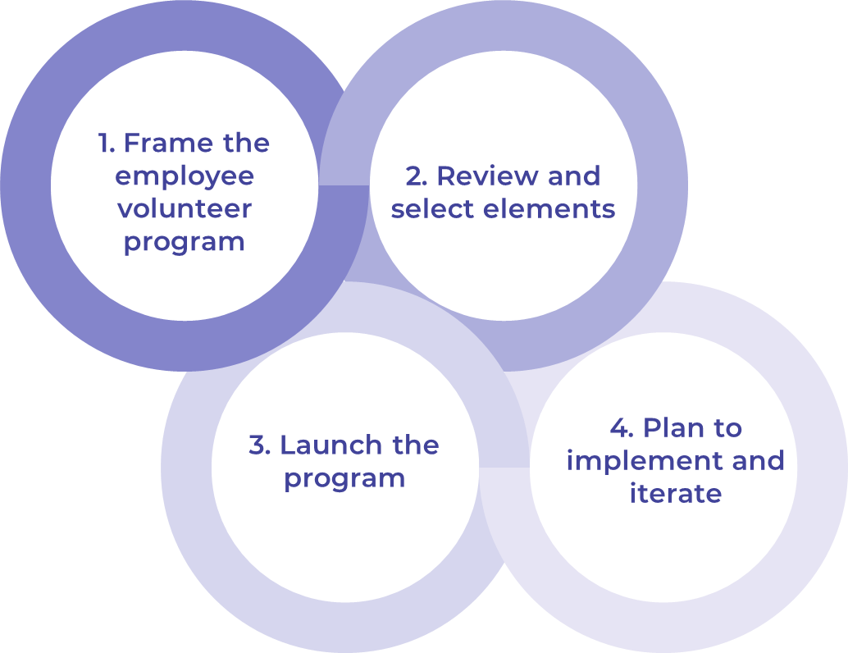
Get to Action

1. Frame the employee volunteer program | - Identify key individuals to consult and include on the design committee.  - Determine the program scope.  - Assess the current state of volunteerism in the organization.  - Review internal data for organizational needs.  - Identify the level of employee interest.  - Set the program goals and metrics.  Deliverables:  - Employee Volunteer Program Workbook  - Case Studies: Design an Employee Volunteer Program
2. Review and select elements | - Review and select elements for program inclusion.  - Assess the feasibility of each selected element.  Deliverables:  - Employee Volunteer Program Workbook  - Employee Volunteering Policy
3. Launch the program | - Decide if a proportion of initiatives will be devoted to a strategic cause.  - Identify potential community partners.  - Decide if a dedicated program manager is required.  - Decide if a technology solution will be used.  - Present selected elements and decision points to executive sponsors.  Deliverables:  - Employee Volunteer Program Workbook
4. Plan to implement and iterate | - Plan the program launch.  - Identify HR integration points.  - Create policies, guidelines, and procedures to set program parameters.  - Develop a communication plan.  - Promote opportunities internally.  - Incorporate volunteer recognition practices.  - Track and share impact.  - Solicit and review feedback.  - Evaluate and iterate the program.  Deliverables:  - HR Action and Communication Plan  - Employee Volunteering Policy

__________________________________________________

For acceptable use of this template, refer to McLean & Company's Terms of Use. These documents are intended to supply general information only, not specific professional, personal, legal, or accounting advice, and are not intended to be used as a substitute for any kind of professional advice. Use this document either in whole or in part as a basis and guide for document creation. To customize this document with corporate marks and titles, simply replace the McLean & Company information in the Header and Footer fields of this document.

