Create an HR Budget Executive Briefing

Summary
HR budgets change year over year, yet HR often lacks a well-defined budget process.

Our Recommendation

Examine and forecast HR strategic initiatives and operational costs.

Reduce HR budgetary gaps by assessing which strategic initiatives and operational costs can be eliminated and appeal for additional resources as needed.

Client Challenge
- HR is often not included in budget conversations, as they are viewed as overhead rather than as a business partner.
- A lack of time and knowledge makes creating an effective budget process an intimidating task.
- There is a struggle to demonstrate the value of HR investment.

Critical Insight
- A clear budget process will make the case for HR’s proposed budget to key stakeholders and assist in tightening the gap between the proposed and approved budget for prioritized HR initiatives.

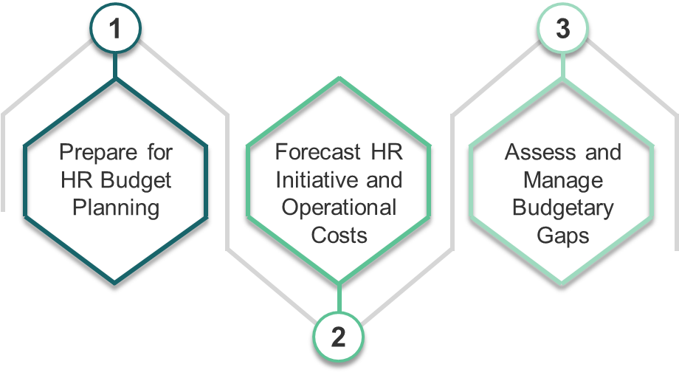
Get to Action

1. Prepare for HR Budget Planning | - Partner with your finance department to obtain support.  - Familiarize yourself with budgeting basics.  - Create a timeline to document milestones and deadlines for the HR budget.  Deliverables:  - HR Metrics Library  - Case Studies: Create an HR Budget
2. Forecast HR Initiative and Operational Costs | - Categorize initiatives to identify surplus resources.  - Prioritize strategic initiatives and forecast their costs.  - Examine and forecast HR operational costs.  Deliverables:  - HR Budget Planning Tool
3. Assess and Manage Budgetary Gaps | - Assess the existence of any budgetary gaps.  - Reduce HR operational costs to limit the size of any budgetary gaps.  - Appeal for additional resources to close the budgetary gaps.  Deliverables:  - HR Budget Planning Tool

__________________________________________________

For acceptable use of this template, refer to McLean & Company's Terms of Use. These documents are intended to supply general information only, not specific professional, personal, legal, or accounting advice, and are not intended to be used as a substitute for any kind of professional advice. Use this document either in whole or in part as a basis and guide for document creation. To customize this document with corporate marks and titles, simply replace the McLean & Company information in the Header and Footer fields of this document.

