Build an Employee Referral Program Executive Briefing

Summary
Concerned about acquiring and retaining talent, organizations are looking to employee referrals as an untapped candidate source. Employee referrals have many advantages, from acquiring talent faster, to better quality hires, to lower recruitment costs.

Our Recommendation
- Set program goals aligned to talent acquisition pain points and strategic talent goals to ensure you achieve the desired impact.
- Align the program design to your culture; employer brand; diversity, equity, and inclusion efforts; and employee and candidate experience efforts.
- Market, collect feedback, and iterate your program like a product.

Client Challenge
- Organizations often underestimate what it takes to build a successful employee referral program, suffering unintended consequences such as lack of diversity.
- Many employees find current employee referral programs to be cumbersome and unclear, leading to a poor employee experience and lack of participation.

Critical Insight
- Employee referral programs don't need to be complicated, but they do need to be planful. Design the program to encourage diversity, equity, and inclusion; align to your culture and brand; and provide a great employee and candidate experience.

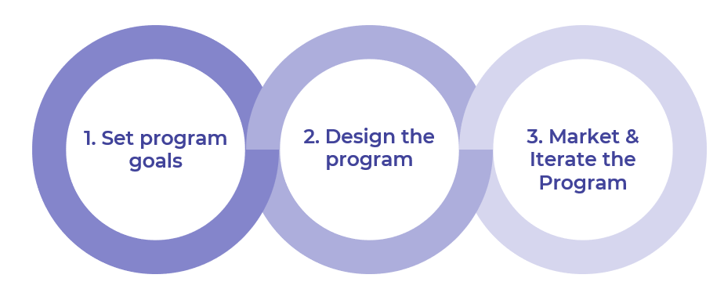
Get to Action

1. Set program goals | - Identify talent acquisition pain points and strategic talent goals the program will address.  - Set program goals, metrics, and design criteria.  - Acquire approval from senior leaders for building the program.  Deliverables:  - Employee Referral Program Playbook  - HR Metrics Library  - Case Studies: Build an Employee Referral Program
2. Design the program | - Align the program to culture and employer brand efforts, as well as DEI goals.  - Set program eligibility and other parameters.  - Determine program rewards and recognition.  - Integrate the referral program into the talent acquisition process.  Deliverables:  - Employee Referral Program Playbook  - Standard Focus Group Guide
3. Market and iterate the program | - Create a policy or guidelines for the program.  - Develop a marketing and communications plan.  Deliverables:  - Employee Referral Policy Template  - Standard Internal Communications Plan  - Employee Referral Program Playbook

__________________________________________________

For acceptable use of this template, refer to McLean & Company's Terms of Use. These documents are intended to supply general information only, not specific professional, personal, legal, or accounting advice, and are not intended to be used as a substitute for any kind of professional advice. Use this document either in whole or in part as a basis and guide for document creation. To customize this document with corporate marks and titles, simply replace the McLean & Company information in the Header and Footer fields of this document.

