Plan for High-Volume Recruiting Executive Briefing

Summary
Few organizations have plans to decrease their workforce. In fact, over 90% of employers are hiring for new roles (iCIMS, 2021). The demand for talent is high, and organizations are struggling to fill roles. High-volume recruitment (HVR) is the process of filling an above average number of roles within a short period of time. Depending on the organization, the volume of roles can range from a dozen to a thousand. Examples of HVR situations include seasonal hiring, opening a new location, and winning new business.

Our Recommendation

Be proactive and leverage project management principles to meet the clear timelines typical of an HVR project.

An HVR plan will help balance the need for an efficient process and a good candidate experience with hiring manager needs.

Client Challenge

A tight labor market already makes regular cycle recruitment challenging. An HVR project not only increases the amount of requisitions a team will have to fill but also amplifies the impact of regular recruitment challenges (e.g. poor candidate experience, inconsistent hiring results, inefficient talent acquisition process).

Critical Insight
- Balancing the candidate experience and hiring manager needs with process efficiency may seem impossible. Use project management principles to make it achievable.

Follow McLean & Company’s Three-Step Process to Plan for High-Volume Recruiting
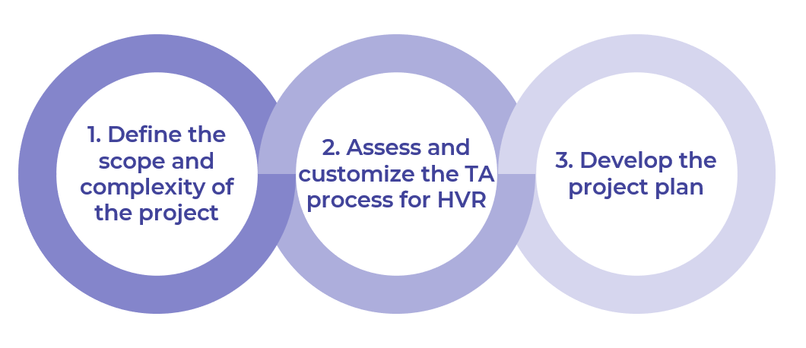

Get to Action
- Define the Scope and Complexity of the Project | - Determine the breadth of the HVR project.  - Define the complexity of the HVR project.  - Identify HVR project constraints.  - Select goals and metrics for the project.  Deliverables:  - High-Volume Recruiting Project Plan  - Intake Meeting Guide  - Candidate Audience Profile Template  - HR Metrics Library  - Case Studies: Plan for High-Volume Recruiting
- Assess and Customize the TA Process for HVR | - Customize the TA process to address HVR needs.  - Identify external communication needs and additional materials required for the project.  Deliverables:  - High-Volume Recruiting Project Plan  - Job Ad Guide  - Candidate Audience Profile Template
- Develop the Project Plan | - Prepare a business case for key players.  - Clarify project team roles.  - Determine project team communication methods.  - Hold a kick-off meeting to prepare project team members.  Deliverables:  - High-Volume Recruiting Project Plan

_____________________________________________________

For acceptable use of this template, refer to McLean & Company's Terms of Use. These documents are intended to supply general information only, not specific professional, personal, legal, or accounting advice, and are not intended to be used as a substitute for any kind of professional advice. Use this document either in whole or in part as a basis and guide for document creation. To customize this document with corporate marks and titles, simply replace the McLean & Company information in the Header and Footer fields of this document.

