Develop a Resilient Workforce Executive Briefing

Summary
The world of work is changing rapidly, and employees are not always able to keep up. This impacts turnover, physical health, negative feelings at work, and chronic work stress. Lack of employee resilience doesn’t only impact the individual; it also has significant impacts on organizational measures and the bottom line.

Our Recommendation
- Focus on the three key behaviors that are connected to workplace resilience: activate networks, learn to learn, and be flexible.
- Develop a portfolio of resilience techniques that employees can access to develop and practice resilient behaviors in the workplace.

Client Challenge
- Building resilience is incredibly complex. It involves the intersection of individual mindsets and behaviors that are impacted by work factors as well as personal factors. These factors are outside the control of the organization.
- The mindset, a key aspect of resilience, can be very difficult for the organization to directly impact.

Critical Insight
- Work resilience is not just something you’re born with. It has to be developed by actively practicing resilient behaviors and through support from the organization.

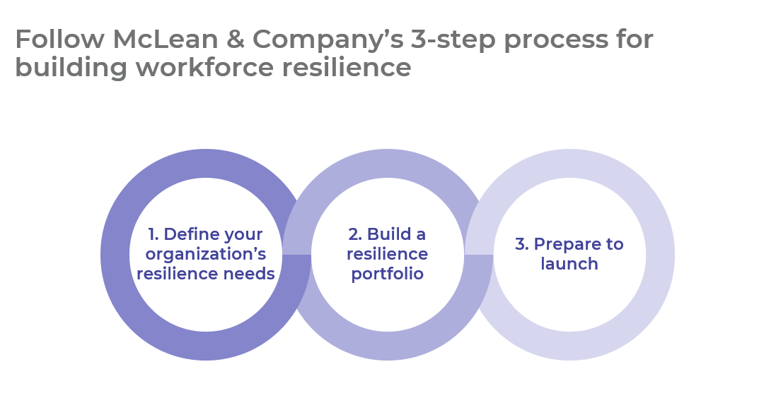
Get to Action
1. Define your organization’s resilience needs | - Align organizational goals with resilience benefits.  - Gather data to define the current state of resilient behaviors.  - Turn data insights into resilience needs.  Deliverables:  - Employee Resilience Workbook  - HR Metrics Library  - Engagement Survey Diagnostic  - Employee Resilience Questions  - Standard Focus Group Guide  - HR Resilience Interview Guide  - Case Studies: Develop a Resilient Workforce
2. Build a resilience portfolio | - Identify goals and metrics for your resilience project.  - Clarify HR’s role in building resilience.  - Select resilience techniques and validate them with stakeholders.  Deliverables:  - HR Metrics Library  - Employee Resilience Workbook  - Resilience Techniques Catalog
3. Prepare to launch | - Decide how to roll out the resilience techniques.  - Build a communication plan.  - Plan to monitor and iterate on the techniques.  Deliverables:  - HR Action and Communication Plan  - Internal Communications Guide

__________________________________________________

For acceptable use of this template, refer to McLean & Company's Terms of Use. These documents are intended to supply general information only, not specific professional, personal, legal, or accounting advice, and are not intended to be used as a substitute for any kind of professional advice. Use this document either in whole or in part as a basis and guide for document creation. To customize this document with corporate marks and titles, simply replace the McLean & Company information in the Header and Footer fields of this document.

