Enable Innovation Through Culture Executive Briefing

Summary
Not innovating is not an option – organizations need to do it to survive and thrive. Spending money on innovation does not necessarily result in success. HR can play a strong role in aligning culture to drive innovation.

Our Recommendation

Engage stakeholders to understand the organization’s innovation goals and type(s) and gain buy-in for HR’s involvement.

Identify the drivers that need to be improved and maintained to enable the organization’s innovation type(s).

Plan to align HR programs to reinforce prioritized drivers.

Client Challenge

Few HR departments enable their organization’s innovation efforts, resulting in a missed opportunity to be a strategic partner and accelerate results.

There are different types of innovation, and different cultural drivers are critical for each one. Understanding the type(s) of innovation an organization is using allows HR to determine where to focus their efforts.

Critical Insight

Enabling innovation is a balancing act. Take the time to understand the type(s) your organization is using to focus HR’s resources where they will have the biggest impact.

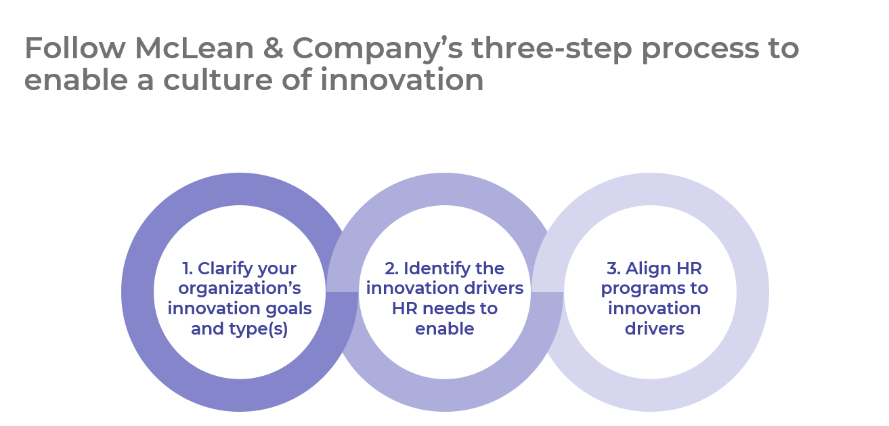

Get to Action

1. Clarify your organization’s innovation goals and type(s) | - Familiarize yourself with the four types of innovation.  - Engage stakeholders and clarify the organization’s innovation goals.  - Identify the innovation type(s) HR needs to enable.  Deliverables:  - Innovation Assessment Tool  - Case Studies: Enable Innovation Through Culture
2. Identify the innovation drivers HR needs to enable | - Familiarize yourself with the drivers of a culture of innovation.  - Assess the organization and HR’s alignment to the drivers.  - Prioritize drivers to improve and to maintain.  Deliverables:  - Innovation Assessment Tool
3. Align HR programs to innovation drivers | - Define behaviors for prioritized innovation drivers.  - Create a high-level action plan to align HR programs to prioritized drivers.  - Establish metrics to measure success.  Deliverables:  - Innovation Assessment Tool  - Comprehensive Competency Library  - HR Action & Communication Plan  - HR Metrics Library  - Workshop: Enable Innovation Through Culture

__________________________________________________

For acceptable use of this template, refer to McLean & Company's Terms of Use. These documents are intended to supply general information only, not specific professional, personal, legal, or accounting advice, and are not intended to be used as a substitute for any kind of professional advice. Use this document either in whole or in part as a basis and guide for document creation. To customize this document with corporate marks and titles, simply replace the McLean & Company information in the Header and Footer fields of this document.

