Build a Change Sustainment Plan Executive Briefing

Situation
Organizations invest a lot of time and resources into change initiatives but do not see the return on investment due to a lack of focus on sustainment. Many organizations do not plan for change sustainment beyond the launch of the change.

Complication
- Leaders often are not actively involved in creating sustainable change, signaling to employees that the change isn’t important.
- Lack of planning for sustaining change in the workplace impacts the ability to obtain the appropriate support and resources needed to sustain the change on an ongoing basis.

Solution
- Don’t leave sustainment to chance.
- Involve key leaders in planning to build ownership from the start.
- Create a plan to sustain the change until the change becomes business as usual.
- Review and incorporate the appropriate sustainment components into your change sustainment plan.

Critical Insight
- Sustainment cannot be done well ad hoc. The creation and implementation of a targeted sustainment plan is an integral part of the change process and key to long-term change adoption.

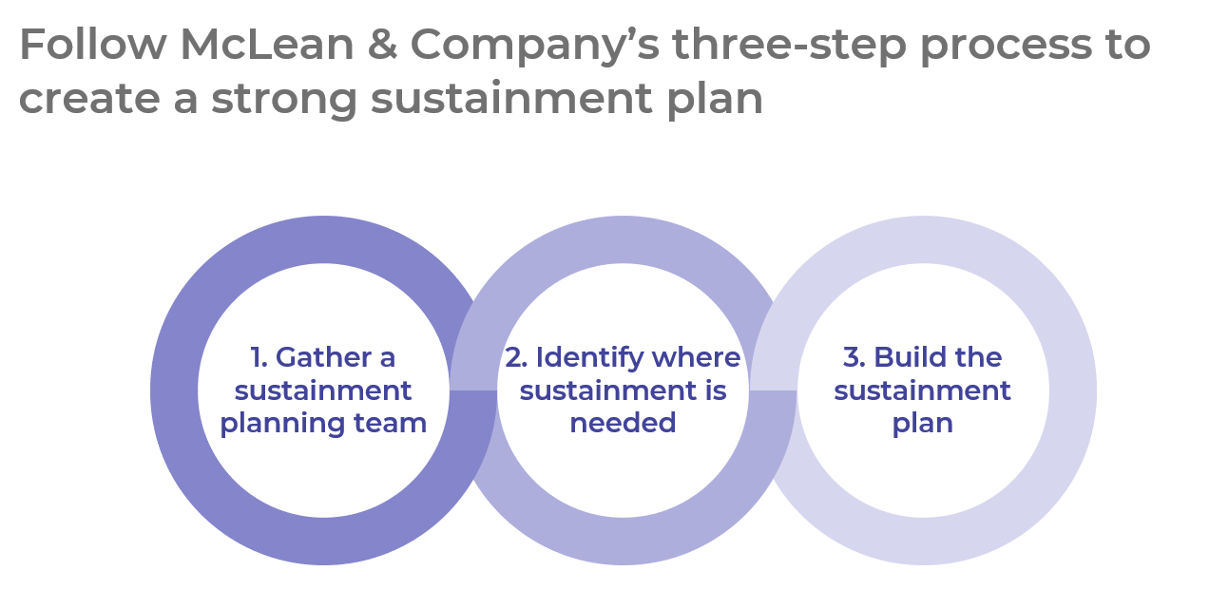

Get to Action

1. Gather a sustainment planning team | - Identify and gain buy-in from your sustainment planning team.  - Review the project and change plans with the sustainment planning team in preparation for plan design.  - Establish how you will measure sustainment success.  Deliverables:  - Sustainment Plan Workbook  - Change Assessment Tool  - Case Studies: Build a Change Sustainment Plan
2. Identify where sustainment is needed | - Prioritize project and change actions for sustainment.  - Identify the current status of the five core sustainment components.  - Identify which supplementary sustainment components are needed.  Deliverables:  - Sustainment Components Catalog
3. Build the sustainment plan | - Create a plan for each sustainment component for prioritized project/change actions.  - Identify sustainment component implementation owners and other stakeholder roles.  - Secure required resources and budget.  - Establish a timeline for implementation of the plan.  Deliverables:  - Sustainment Owner Planning Template  - Standard Focus Group Guide

_____________________________________________________

For acceptable use of this template, refer to McLean & Company's Terms of Use. These documents are intended to supply general information only, not specific professional, personal, legal, or accounting advice, and are not intended to be used as a substitute for any kind of professional advice. Use this document either in whole or in part as a basis and guide for document creation. To customize this document with corporate marks and titles, simply replace the McLean & Company information in the Header and Footer fields of this document.

