Build a Customized Campus Recruitment Program Executive Briefing

Summary
Campuses are a great source of talent, but organizations don’t effectively engage with schools to target the right talent. Organizations continue to use traditional recruitment sourcing methods, which are not the most effective way to attract new graduates.

Our Recommendation
- Use research and school relationships to build a planful and targeted campus recruitment program.
- Build relationships with targeted schools to identify the best sourcing methods for growing your talent pipeline.
- Modify your talent acquisition (TA) process to create a candidate experience that resonates with new graduates.

Client Challenge
- The campus recruitment environment is complex. Most future graduates are new to job seeking, and they must balance their academic responsibilities with their job-seeking interests.
- Many organizations believe some work experience is required even for entry-level roles, leading to the impression that new graduates lack the skills needed for these jobs.

Critical Insight
With organizations’ pressing workforce needs, new graduates are a great source of talent. However, because they approach the labor market differently from experienced job seekers, organizations need a tailored approach to recruit them successfully.

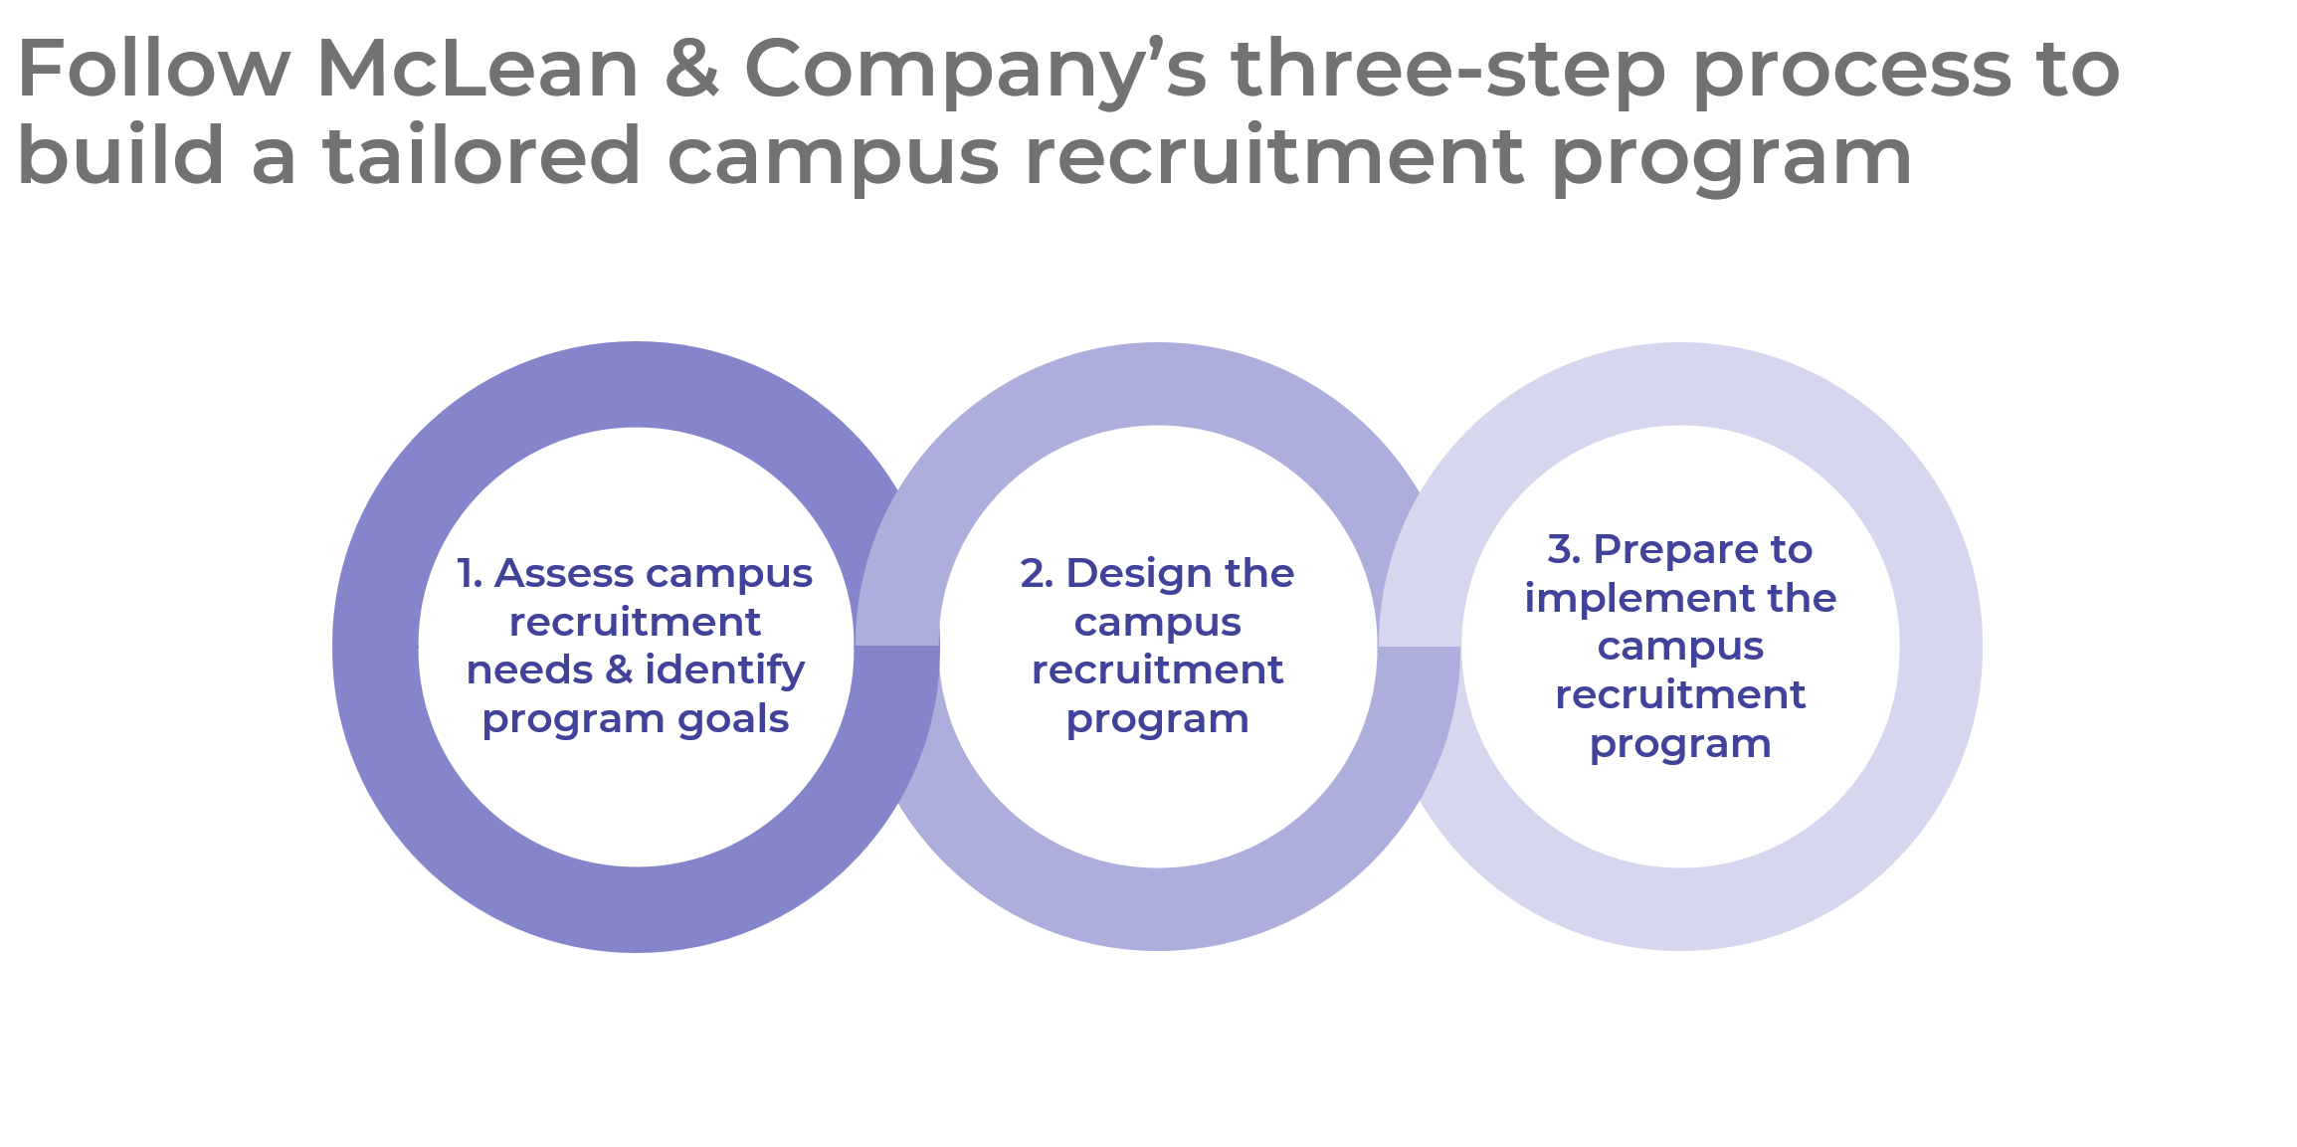

Get to Action

1. Assess campus recruitment needs and identify program goals | - Identify organizational goals and roles that could be filled by new graduates.  - Set program-level goals for campus recruitment and identify associated metrics.  - Build a business case for stakeholder support and commitment.  Deliverables:  - Campus Recruitment Program Workbook  - HR Metrics Library  - Case Studies: Build a Customized Campus Recruitment Program
2. Design the campus recruitment program | - Develop job descriptions and audience profiles for priority roles.  - Tailor employer brand messaging to target new graduates.  - Select sourcing methods for the campus recruitment program.  - Identify changes to current TA process for campus recruitment.  Deliverables:  - Sourcing Plan Template  - Job Description Template  - Job Ad Guide  - New Graduate Audience Profile Template  - EVP and Employer Brand Promotion Plan  - Campus Recruitment Sourcing Methods Catalog
3. Prepare to implement the campus recruitment program | - Identify an action plan for implementing the campus recruitment program.  - Create an annual campus recruitment calendar.  - Develop communications content and collateral for marketing the employer brand.  - Determine an annual evaluation and planning process.  Deliverables:  - HR Action and Communication Plan  - Campus Recruitment Calendar  - Campus Recruitment Readiness Checklist  - Workshop: Build a Customized Campus Recruitment Program

__________________________________________________

For acceptable use of this template, refer to McLean & Company's Terms of Use. These documents are intended to supply general information only, not specific professional, personal, legal, or accounting advice, and are not intended to be used as a substitute for any kind of professional advice. Use this document either in whole or in part as a basis and guide for document creation. To customize this document with corporate marks and titles, simply replace the McLean & Company information in the Header and Footer fields of this document.

