Determine the Right HR Outsourcing Solution Executive Briefing

Summary

HR departments are trying to engage in more strategic, value-add work for the organization and decrease time spent on non-core administrative tasks. Organizations are looking for cost savings and to help HR improve performance levels.

Our Recommendation
- Investigate pain points in the current HR processes and requirements to determine what is driving the need to outsource.
- Use a defined vendor selection process including a request for proposal (RFP) process to solicit proposals for HR outsourcing, and form a proposal evaluation committee to objectively evaluate vendor RFP responses.
- Proactively prepare the vendor for a successful and collaborative relationship by being clear about expectations and providing them with essential organizational information required to customize service delivery.

Client Challenge
- HR departments are often faced with limited time, money, and skills; outsourcing is an option to help HR best use resources and improve service levels.
- HR outsourcing is challenging in itself and needs careful management to ensure that expectations are met and the investment is a valuable one.
- HR outsourcing can result in employee demoralization and negatively impact the organizational culture and productivity.

Critical Insight
- The performance of the HR department can be elevated by outsourcing tactical activities to an HRO provider, freeing up resources to focus on strategic projects and in-house upskilling as required.

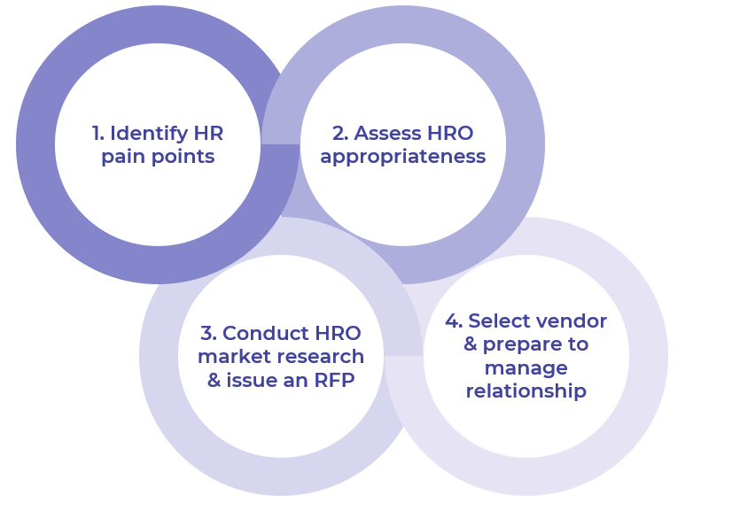

Get to Action

1. Identify HR pain points | - Identify key stakeholders to involve in determining HRO appropriateness.  - Use the HR Outsourcing Assessment Tool to assess current and target HR performance levels.  - Calculate costs of operating HR functions in-house.  Deliverables:  - HR Outsourcing Assessment Tool  - Case Studies: Determine the Right HR Outsourcing Solution
2. Assess HRO appropriateness | - Review and compare current state against target state for each HR function, including:  - Performance levels  - Degree of strategic importance  - Current level of capability  - Identify which activities to keep in-house, which to outsource, and when to hire a consultant.  - Determine the right type of HRO solution.  - Set goals and metrics to be achieved through the HRO solution.  Deliverables:  - HR Outsourcing Assessment Tool  - HR Metrics Library
3. Conduct HRO market research and issue an RFP | - Create an HRO vendor evaluation committee.  - Outline the customized vendor selection process.  - Generate a list of HRO vendors to contact.  - Issue an RFI (optional).  - Set vendor evaluation criteria in alignment with HRO needs.  - Issue an RFP.  Deliverables:  - Standard Project Charter  - Request for Information Template  - Request for Proposal Evaluation Grid  - Request for Proposal Template
4. Select a vendor and prepare to manage relationship | - Select the right HRO vendor to meet your needs.  - Gain executive sign-off on the final vendor decision.  - Negotiate the contract with the selected vendor.  - Prepare internally for the vendor relationship.  - Equip the vendor with the information it needs to succeed in delivering the HRO solution.  Deliverables:  - Request for Proposal Evaluation Grid  - HR Outsourcing Assessment Tool  - Service-Level Agreement Template  - HR Metrics Library  - Standard Project Charter  - HR Action & Communication Plan  - Guide for Vendors

__________________________________________________

For acceptable use of this template, refer to McLean & Company's Terms of Use. These documents are intended to supply general information only, not specific professional, personal, legal, or accounting advice, and are not intended to be used as a substitute for any kind of professional advice. Use this document either in whole or in part as a basis and guide for document creation. To customize this document with corporate marks and titles, simply replace the McLean & Company information in the Header and Footer fields of this document.

