Determine the Right Recruitment Process Outsourcing Solution Executive Briefing

Summary
Recruitment process outsourcing (RPO) is a widely adopted solution to improve Talent Acquisition (TA) effectiveness. There are many reasons for RPO’s rise, including limited in-house capabilities and the struggle to balance process efficiency, hire quality, and candidate experience.

Our Recommendation
- Investigate the pain points of current TA processes and requirements to determine what is driving the need to outsource.
- Conduct market research either informally or through a request for information (RFI) to get an understanding of the vendor landscape and determine which vendors could meet the organization’s TA needs.
- Use a defined request for proposal (RFP) process to solicit proposals for RPO and form a proposal evaluation committee to objectively evaluate vendor RFP responses.
- Prepare the vendor for a successful and collaborative relationship by stating expectations and providing them with essential organizational information to customize service delivery.

Client Challenge
- There are several RPO vendors in the market; finding one that is best suited for the organization and its specific needs can be daunting.
- An RPO solution is not always the best fit. An organization must determine whether outsourcing is right for them and which model of outsourcing is most appropriate.
- A vendor relationship must be nurtured to ensure the RPO solution succeeds in meeting its objectives.

Critical Insight
- The performance of the TA process can be elevated by outsourcing tactical activities to an RPO provider, freeing up resources to focus on strategic projects and in-house upskilling.

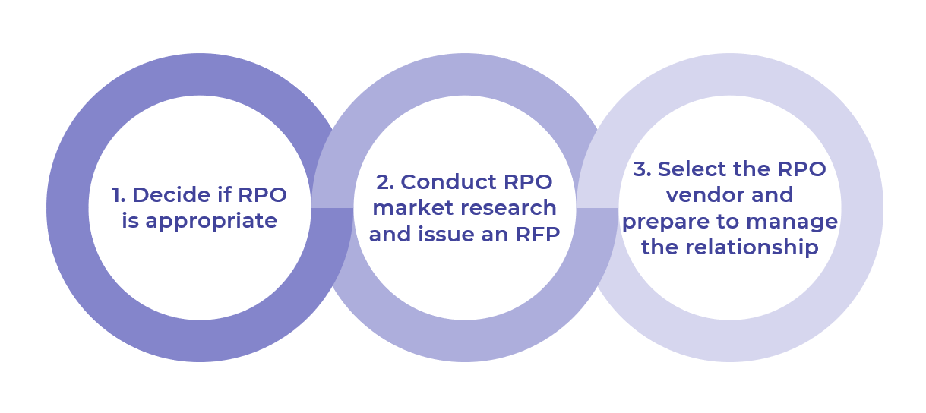

Get to Action

- Decide if RPO is appropriate | - Identify key stakeholders to involve in determining RPO appropriateness.  - Decide if RPO is suitable to address your TA needs.  - Outline goals and metrics for an RPO solution  Deliverables:  - Talent Acquisition Pain Points Assessment Workbook  - HR Metrics Library  - Standard Project Charter
- Conduct RPO market research and issue an RFP | - Create an RPO vendor evaluation committee.  - Outline your customized vendor selection process.  - Generate a list of RPO vendors to contact.  - Issue an RFI (optional).  - Align vendor evaluation criteria with RPO needs.  - Issue an RFP.  Deliverables:  - Standard Project Charter  - Request for Information Template  - Request for Proposal Evaluation Grid  - Request for Proposal Template
- Select RPO vendor and prepare to manage the relationship | - Select the right RPO vendor to meet your needs.  - Gain executive sign-off on your final vendor decision.  - Negotiate the contract with your selected vendor.  - Prepare internally for the vendor relationship.  - Equip vendor with the information required to successfully deliver the RPO solution.  Deliverables:  - Request for Proposal Evaluation Grid  - Talent Acquisition Pain Points Assessment Workbook  - Service-Level Agreement Template  - Post-Hire Survey – Hiring Manager  - HR Metrics Library  - Standard Project Charter  - HR Action & Communication Plan  - Guide for Vendors

__________________________________________________

For acceptable use of this template, refer to McLean & Company's Terms of Use. These documents are intended to supply general information only, not specific professional, personal, legal, or accounting advice, and are not intended to be used as a substitute for any kind of professional advice. Use this document either in whole or in part as a basis and guide for document creation. To customize this document with corporate marks and titles, simply replace the McLean & Company information in the Header and Footer fields of this document.

