Design In-House Assessments That Improve Hiring Success Executive Briefing

Summary

The majority of organizations conduct at least one assessment (usually an interview). However, according to CareerBuilder, one in five survey respondents stated they lacked the skills to interview and hire people effectively, meaning that bad hires are making their way into the organization.

Bias can also affect assessors’ ability to bring in the right talent when they are poorly trained on how to evaluate candidates or are put in an unstructured assessment situation.

Our Recommendation

Create an in-house assessment to accompany an interview in order to better assess the on-the-job competencies of your candidates.

Create a scoring rubric for the assessment to improve objectivity of hires and to mitigate bias.

Test the assessment to ensure it is valid and reliable before integrating the assessment into your talent acquisition process.

Client Challenge

The cost of making a bad hire is high, even for entry-level positions.

Lack of skilled interviewing is intensified by the fact that over half of job applicants don’t meet the basic requirements of the role.

Critical Insight
- Increasing the quality of pre-hire assessments beyond an interview improves objectivity and the quality of hiring decisions. Designing them in-house allows for greater alignment with the organization’s unique needs.

Get to Action

1. Determine priority areas | - Identify priority roles.  - Set goals and metrics.  - Pinpoint top competencies.  - Identify pain points.  Deliverables:  - Bad Hire Cost Calculator  - Pre-Hire Assessment Workbook  - HR Metrics Library  - Case Studies: Design In-House Assessments That Improve Hiring Success
2. Design your in-house assessments | - Review and choose your assessment method.  - Develop the assessment.  - Determine resourcing required to run the assessment.  - Create scoring for the assessment.  Deliverables:  - Assessment Design Template
3. Ensure assessments are valid and reliable | - Verify that the assessment design is connected to the role.  - Identify and mitigate areas for bias.  - Test the assessment design.  - Analyze the results for validity and reliability.  Deliverables:  - Pre-Hire Assessment Workbook
4. Create an action plan for implementation | - Determine your action plan to integrate the assessment into the TA process.  - Develop your communications.  - Customize guidelines for running the assessment.  - Determine how to measure and gather feedback.  Deliverables:  - HR Action and Communication Plan  - Internal Communications Guide  - Assessment Administration Guide  - Workshops: Design In-House Assessments That Improve Hiring Success

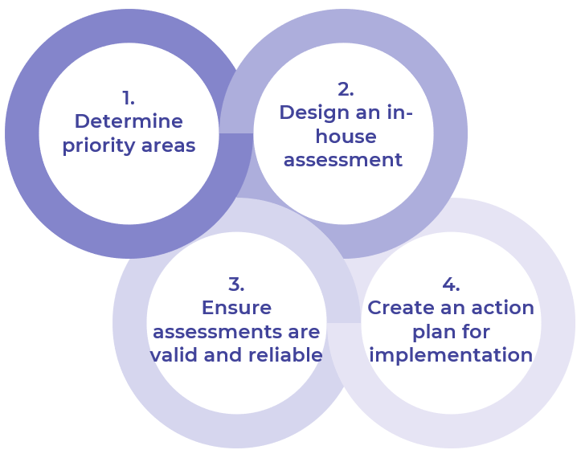
__________________________________________________

For acceptable use of this template, refer to McLean & Company's Terms of Use. These documents are intended to supply general information only, not specific professional, personal, legal, or accounting advice, and are not intended to be used as a substitute for any kind of professional advice. Use this document either in whole or in part as a basis and guide for document creation. To customize this document with corporate marks and titles, simply replace the McLean & Company information in the Header and Footer fields of this document.

