Develop a Targeted Flexible Work Program Executive Briefing

Summary
Workplace flexibility continues to be top priority for employees; as a result, organizations who fail to offer flexibility will have a difficult time attracting, recruiting, and retaining talent. Use this research to identify and select flexible work options that meet the needs of both employees and the organization.

Our Recommendation
- Uncover the needs of unique employee segments to shortlist flexible work options that employees want and will use.
- Assess the feasibility of various flexible work options and select ones that meet employee needs and are feasible for the organization.
- Equip the organization with the information and tools needed to implement and sustain a flexible work program.

Client Challenge
- A one-size-fits-all approach to selecting and implementing flexible work options fails to consider unique employee needs and will not reap the benefits of offering a flexible work program (e.g. higher engagement, enhanced employer brand).
- Improper structure and implementation of flexible work programs exacerbates existing challenges (e.g. high turnover) or creates new ones.

Critical Insight
- Flexible work is more than flexible location. Organizations must understand the needs of unique employee groups to uncover the options that will attract and retain talent.
- Provide greater inclusivity to employees by broadening the scope to include flex location, flex time, and flex time-off.

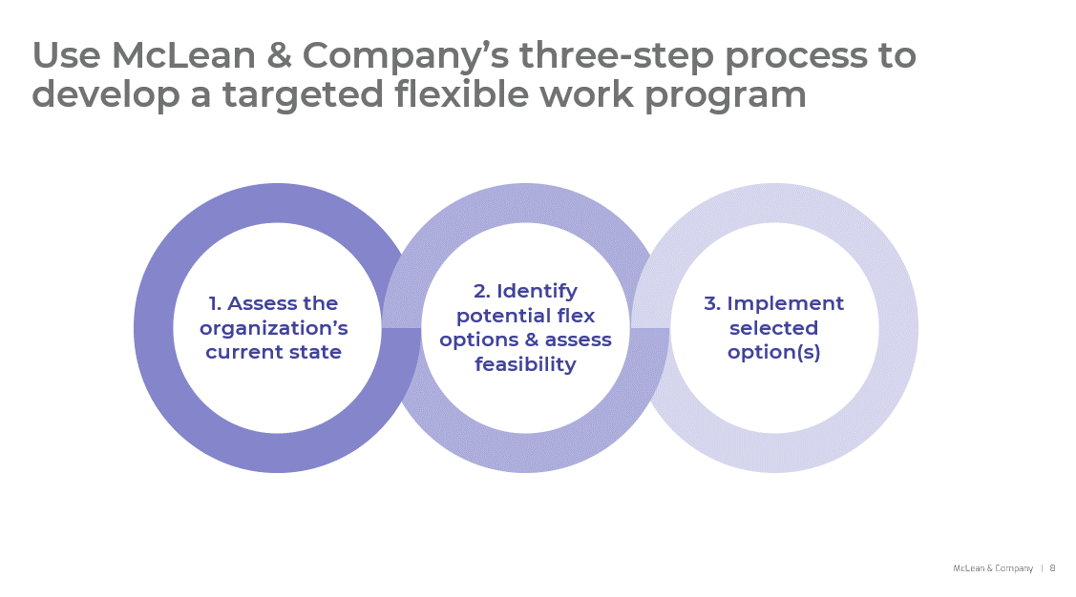
Get to Action
- Assess the organization’s current state | - Identify key stakeholders and their responsibilities  - Uncover the current and desired state of the organization  - Analyze feedback to identify flexibility challenges  - Identify and prioritized employee segments  - Determine the program goals  - Identify the degree of flexibility for work location, timing, and deliverables  Deliverables:  - Storyboard  - Workbook  - Case Studies
- Identify potential flex options and assess feasibility | - Create a shortlist of potential options for each prioritized employee segment  - Evaluate the feasibility of each potential option  - Determine the cost and benefit of each potential option  - Gather employee sentiment on potential options  - Finalize options with senior leadership  Deliverables:  - Flexible Work Options Catalog  - Four-Day Work Week Guide (if selected as an option)  - Tactics Catalog: Supporting Working Caregivers  - Dependent Care Flexibility Employee Guide  - Dependent Care Flexibility Manager Guide.
- Implement selected option(s) | - Address implementation issues and cultural barriers.  - Equip the organization to adopt flexible work options successfully.  - Pilot the program and assessed its success.  - Develop a plan for program rollout and communication.  - Establish a program evaluation plan.  - Align HR programs to support the program.  Deliverables:  - Guide to Flexible Work for Managers and Employees  - Flex Time-Off Policy  - Work-from-home (WFH) policy  - Flex Time Policy  - Flexible Work Arrangement Agreement Template

__________________________________________________

For acceptable use of this template, refer to McLean & Company's Terms of Use. These documents are intended to supply general information only, not specific professional, personal, legal, or accounting advice, and are not intended to be used as a substitute for any kind of professional advice. Use this document either in whole or in part as a basis and guide for document creation. To customize this document with corporate marks and titles, simply replace the McLean & Company information in the Header and Footer fields of this document.

