Equip Managers to Improve Poor Performance Executive Briefing

Summary
Low performance has detrimental effects on the organization, both reducing team engagement and morale and stifling productivity and innovation. HR can combat this by implementing a process for performance improvement and training managers on how to properly, and confidently, assess and address low performance.

Our Recommendation
- HR must implement a process for performance improvement and ensure managers address low performance consistently and fairly across the organization.
- HR needs to train mangers on how to assess the root causes of low performance so that they are better equipped to address low performance and support an employee through the process.

Client Challenge
- Many managers are not trained on addressing low performance and do not have a process for performance improvement in place to help them understand.
- Managers will often resort to implementing a performance improvement plan (PIP) first, before coaching the employee. As a result, PIPs have been misused as the only way for managers to deal with low performance or even manage someone out of the company.

Critical Insight
- There is no “silver bullet” for improving low performance as each case is different. Giving managers a clearly defined process allows them to systematically assess and address low performance.

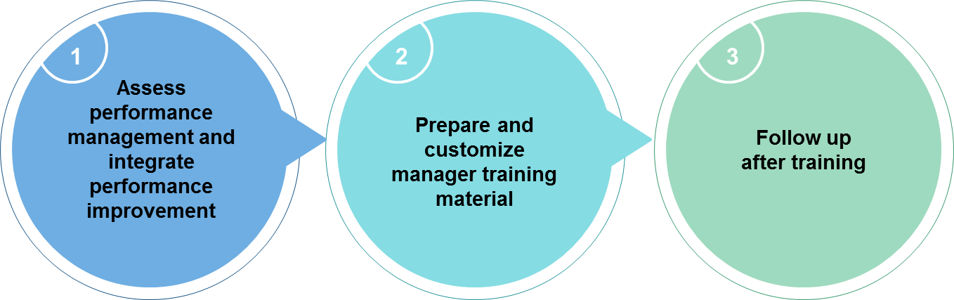
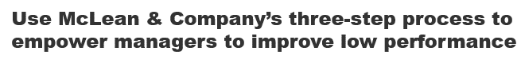
Get to Action
1. Assess performance management and integrate performance improvement | - Determine how performance management can address low performance  - Customize the process for performance improvement  - Customize the PIP template  Deliverables:  - Modern Performance Management Worksheet  - Performance Improvement Plan Template  - Standard HR Scorecard  - HR Metrics Library
2. Prepare and customize manager training material | - Review and customize the manager training deck  - Evaluate how this training fits in with other organizational offerings  - Prepare to deliver training  Deliverables:  - Training Deck: Improving Employee Performance  - Improve Employee Performance Participant Handbook  - Diagnosing Root Cause Role Play Scenarios  - PIP Conversation Role Play Scenarios  - Participant Training Session Evaluation Template
3. Follow up after training | - Measure training effectiveness  - Ensure sustainment beyond the training session  - Review HR accountabilities and address any gaps  Deliverables:  - Participant Training Session Evaluation Template  - Feedback and Coaching Guide  - Identify and Reengage Disengaged Employees – Manager Guide

__________________________________________________

For acceptable use of this template, refer to McLean & Company's Terms of Use. These documents are intended to supply general information only, not specific professional, personal, legal, or accounting advice, and are not intended to be used as a substitute for any kind of professional advice. Use this document either in whole or in part as a basis and guide for document creation. To customize this document with corporate marks and titles, simply replace the McLean & Company information in the Header and Footer fields of this document.

