Design an Impactful Employee Development Program Executive Briefing

Summary

Organizations spend a lot on employee development, but it has been ineffective because it is not informed by what the organization needs. There is a growing gap between the competencies organizations have been focused on developing and what is needed in the future. The pace of change in today’s operating environment demands new competencies while making others obsolete, and L&D is challenged with keeping up with upskilling employees.

Our Recommendation

Design an employee development program that builds the competencies the organization needs both today and in the future.

Connect the right development opportunity to the right employee through an effective development-planning process.

Equip managers and build program support to foster continuous learning and development.

Client Challenge

Leaders have left employees to drive their own development without providing direction or support, and without aligning development to the organization’s needs.

Organizations position development as employee owned, yet employees still feel like their needs aren’t being met, and many leave as a result.

Organizations often have a lot of development opportunities but don’t connect the right opportunity to the right employee.

Critical Insight

Development needs to be not only employee owned and manager supported, but also organization informed to ensure that it meets the organization’s needs.

Today, operating environments change quickly, and organizations need to develop the competencies employees need both for today and in the future.

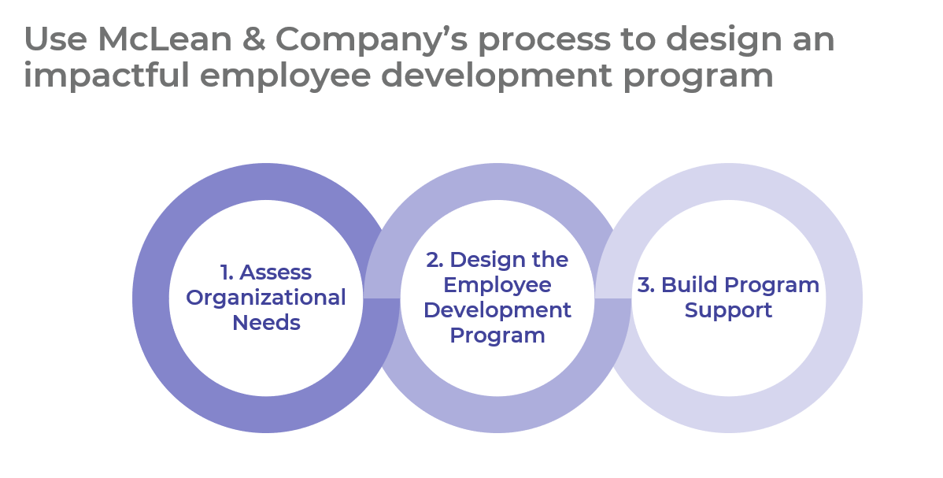

Get to Action

1. Assess organizational needs | - Conduct an organizational needs analysis.  - Compile a list of priority competencies to develop.  - Identify employee segments to develop (if applicable).  Deliverables:  - Employee Development Needs Analysis Workbook
2. Design the employee development program | - Determine the employee assessment method.  - Review current and new development programs and activities.  - Design a custom development planning process.  - Identify manager and employee follow-up accountabilities.  Deliverables:  - Employee Development Program Design Playbook  - Learning Methods Catalog  - Process Mapping Guide  - Individual Competency Development Plan Template  - Employee Career Development Workbook  - Manager Career Conversation Guide
3. Build program support | - Review the elements of a dynamic learning mindset.  - Integrate employee development with other HR programs.  - Identify the tools required to equip managers and employees.  - Plan to mitigate barriers, maintain the program, and measure progress.  - Create an action and communication plan.  Deliverables:  - Manager Job Aid: Employee Development  - Employee Job Aid: Employee Development  - Employee Development Program Design Workbook  - HR Action & Communication Plan  - HR Metrics Library

__________________________________________________

For acceptable use of this template, refer to McLean & Company's Terms of Use. These documents are intended to supply general information only, not specific professional, personal, legal, or accounting advice, and are not intended to be used as a substitute for any kind of professional advice. Use this document either in whole or in part as a basis and guide for document creation. To customize this document with corporate marks and titles, simply replace the McLean & Company information in the Header and Footer fields of this document.

