Use Dashboards to Become a Data-Driven HR Function Executive Briefing

Summary
Data and metrics are a must-have for HR teams because data-driven decisions are a top priority for organizations and data can provide insights and recommendations for many HR functions, including succession planning, retention, engagement, and more. Data-driven organizations experience benefits for both employees and the organization. They are more effective at providing insights to leaders, better able to act on employee needs in real time, and more likely to enable innovation. Create dashboards that tell a story and present data in an effective way, leading to insights, recommendations, and decisions that benefit employees and the organization.

Our Recommendation
- Select metrics that matter to generate insights and provide data-driven recommendations to various audiences across the organization.
- Many organizational leaders find dashboards to be an effective way to present HR data, so create these valuable tools for HR to monitor the current state and provide insights to meet audience needs.
- Keep the audience behind the data top of mind when creating dashboards by telling a story that leads to insights and recommendations and ensuring data and metrics are used to make decisions that benefit employees and the organization.
Client Challenge
- Many organizations are not investing in developing HR teams’ competencies related to data and metrics, and as a result, HR professionals often lack the training required to become data driven and leverage strategic data to their advantage.
- There is a disconnect between how often organizations report metrics and analytics as a top priority and the investment being made in developing HR’s data-driven competencies.

Critical Insight
- Becoming data driven doesn’t mean losing focus on the people behind the data. Data and metrics must be used to make decisions that benefit employees and the organization overall.

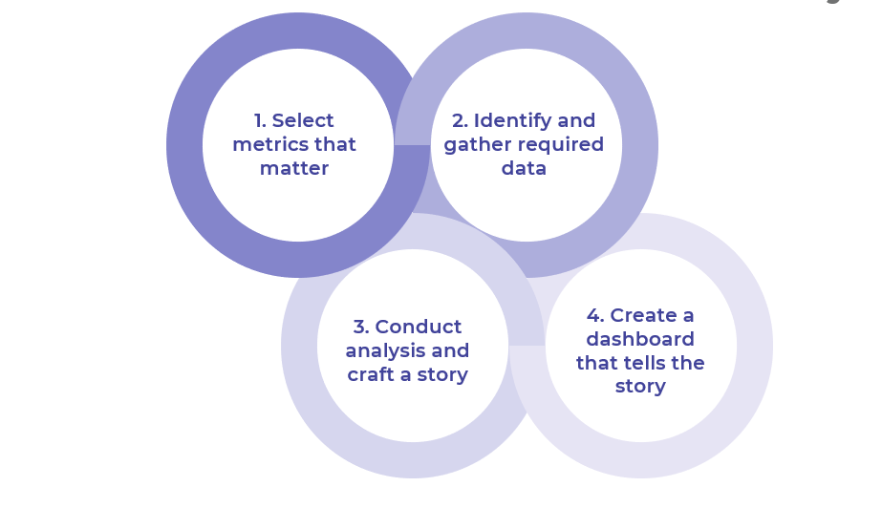

Get to Action

1. Select metrics that matter | - Understand the target audience for the dashboard.  - Uncover and prioritize audience needs.  - Translate needs into metrics that matter.  Deliverables:  - Metrics Workbook  - Case Studies: Use Dashboards to Become a Data-Driven HR Function
2. Identify and gather required data | - Recognize DEI considerations.  - Identify required data for selected metrics.  - Determine the quality of required data.  - Collect additional data, as necessary.  - Determine the frequency of measurement and reporting for selected metrics.  Deliverables:  - Metrics Workbook
3. Conduct analysis and craft a story | - Combine and prepare data.  - Calculate selected metrics.  - Understand the stages of the storytelling model.  - Develop insights and recommendations based off identified trends.  Deliverables:  - Metrics Workbook  - Metrics Calculation Sample
4. Create a dashboard that tells the story | - Understand dashboard best practices.  - Choose appropriate visuals to display data.  - Plan to launch the dashboard.  - Launch the dashboard and deliver recommendations.  - Gather feedback and follow up on recommendations.  Deliverables:  - Metrics Workbook

________________________________________________

For acceptable use of this template, refer to McLean & Company's Terms of Use. These documents are intended to supply general information only, not specific professional, personal, legal, or accounting advice, and are not intended to be used as a substitute for any kind of professional advice. Use this document either in whole or in part as a basis and guide for document creation. To customize this document with corporate marks and titles, simply replace the McLean & Company information in the Header and Footer fields of this document.

