Design and Build a Strategic Workforce Planning Toolkit Executive Briefing

Summary
Today’s rapidly changing operating environment is making it increasingly difficult to get the talent needed to execute organizational strategies using traditional reactive talent management practices. Eighty percent of executives expect changes to organizational operations or value creation, which will further impact the skills needed in the future (PwC, 2021), and workforce planning is the solution: organizations who conduct any form of workforce planning see more positive talent, HR, and business outcomes than those who do not (Sapient Insights Group).

Our Recommendation
- Start the workforce planning journey by designing the process and planning for the different people and analyses that will be involved.
- Implement a clear and straightforward workforce planning process aligned with organizational capabilities and maturity to make workforce planning achievable and attain the benefits of this strategic planning process.

Client Challenge
- Organizations often struggle to implement workforce planning. While headcount planning is a process most organizations are comfortable with, workforce planning is a more complex undertaking that involves more people, more quantitative and qualitative data, and longer planning horizons.
- A lack of suitable data and internal expertise on designing and applying workforce planning means that many organizations apply it infrequently, improperly, or not at all.

Critical Insight
- It is common practice to continually reassess customers, markets, and products in today’s volatile, uncertain, complex, and ambiguous (VUCA) environment, but there is often no parallel assessment of workforce composition. Leaders need to be planful and develop a strategy that positions their organization to take advantage of change rather than fall victim to it.
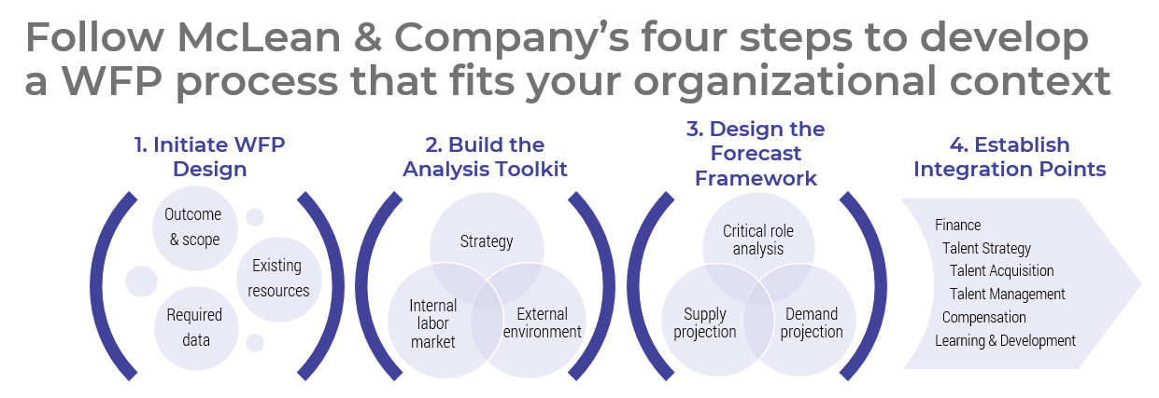

Get to Action
1. Initiate workforce planning design | - Define the scope.  - Set clear goals.  - Review the current state.  - Complete part 1 of the Workforce Planning Process Worksheet.  Deliverables:  - Standard Project Charter  - HR Metrics Library  - Workforce Planning Process Worksheet  - Workforce Planning Workbook  - Case Studies: Design and Build a Strategic Workforce Planning Toolkit
2. Build the analysis toolkit | - Create a toolkit that enables leaders to effectively identify the needs of their workforce.  - Customize the Workforce Planning Discussion Guide and Workforce Planning Discussion Notebook.  - Complete part 2 of the Workforce Planning Process Worksheet.  Deliverables:  - Workforce Planning Discussion Notebook  - Workforce Planning Process Worksheet  - Workforce Planning Discussion Guide  - Strategy Exploration Guide
3. Design the forecast framework | - Determine the approach to critical roles.  - Create a framework for creating supply and demand projections.  - Determine whether workforce plans will apply across the entire organization or for each function.  - Complete part 3 of the Workforce Planning Process Worksheet.  Deliverables:  - Workforce Planning Workbook  - Supply and Demand Forecasting Job Aid  - Workforce Planning Process Worksheet  - Critical Role Identifier
4. Establish integration points | - Decide how results will connect to related programs and processes.  - Create a project plan.  - Communicate the process to key stakeholders.  Deliverables:  - Process Mapping Guide  - Project Roadmap Tool  - HR Metrics Library

__________________________________________________

For acceptable use of this template, refer to McLean & Company's Terms of Use. These documents are intended to supply general information only, not specific professional, personal, legal, or accounting advice, and are not intended to be used as a substitute for any kind of professional advice. Use this document either in whole or in part as a basis and guide for document creation. To customize this document with corporate marks and titles, simply replace the McLean & Company information in the Header and Footer fields of this document.

