Create a Talent Acquisition Strategy Executive Briefing

Summary
There is growing recognition of the critical role Talent Acquisition (TA) plays in achieving organizational success. As a result, TA is being challenged to act strategically and align its approach with the organization’s talent needs. However, stakeholders are often dissatisfied with the TA function.

Our Recommendation
- Use a defined framework to create a TA strategy that identifies TA strategic objectives and the projects needed to support and drive the organization’s priorities. Holistically assess and optimize the foundational strategic elements of TA – candidate awareness & experience, TA process & accountability, TA technology, and TA competency – to elevate TA as a strategic function.

Client Challenge
- TA functions face many demands and competing priorities. TA needs to not only fill roles quickly but also fill them with the right talent. Managing current demands while planning for future talent needs means TA is simultaneously fighting fires and trying to prevent new ones.
- TA’s attempts to manage these competing pressures often focus on improving TA processes. Although process is a key element of TA, a more holistic examination is required to identify and close strategic gaps that are preventing a stronger contribution to organizational success.

Critical Insight
- A TA strategy has the greatest impact on organizational success when it optimizes foundational TA elements to deliver on current and future talent needs.

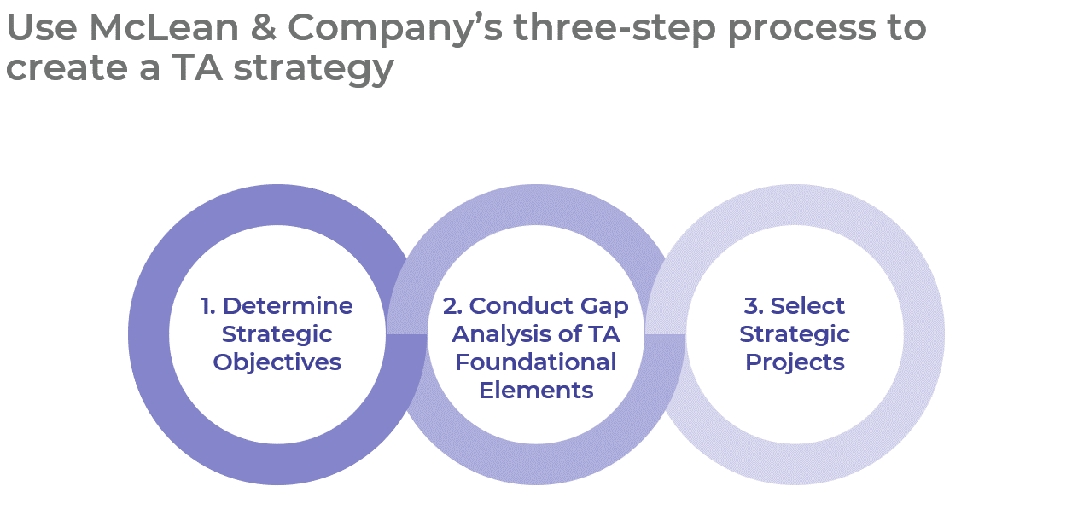

Get to Action

1. Determine Strategic Objectives | - Determine talent implications.  - Identify and prioritize talent implications relevant to the TA function.  - Determine TA strategic objectives and define metrics.  Deliverables:  - TA Strategy Workbook  - HR Metrics Library  - Case Studies: Create a Talent Acquisition Strategy
2. Conduct Gap Analysis of TA Foundational Elements | - Conduct a gap analysis of candidate awareness & experience strategic practices.  - Conduct a gap analysis of TA process & accountability strategic practices.  - Conduct a gap analysis of TA technology strategic practices.  - Conduct a gap analysis of TA team competencies.  - Prioritize gaps based on their size and importance.  Deliverables:  - TA Strategy Gap Analysis Tool  - Job Aid: Diversity, Equity, and Inclusion in Talent Acquisition  - Post-Hire Survey: Hiring Manager  - HR Competency Library  - TA Strategy Workbook
3. Select Strategic Projects | - Review candidate awareness & experience gaps to identify strategic projects.  - Review TA process & accountability gaps to identify strategic projects.  - Review TA technology gaps to identify strategic projects.  - Review TA team competency gaps to identify strategic projects.  - Select strategic projects and communicate them to relevant stakeholders.  Deliverables:  - TA Strategy Workbook  - TA Strategy Presentation Template

__________________________________________________

For acceptable use of this template, refer to McLean & Company's Terms of Use. These documents are intended to supply general information only, not specific professional, personal, legal, or accounting advice, and are not intended to be used as a substitute for any kind of professional advice. Use this document either in whole or in part as a basis and guide for document creation. To customize this document with corporate marks and titles, simply replace the McLean & Company information in the Header and Footer fields of this document.

