Train Managers to Communicate Effectively Executive Briefing

Summary
A one-size-fits-all communication strategy is no longer sufficient to meet the demands of today’s complex communications environment. Employees of managers who communicate effectively are up to four times more likely to be engaged than employees of those who don't. Improving communication has a positive impact on productivity, efficiency, organizational reputation, and financial performance.

Our Recommendation
- Identify where these complexities exist in your organization.
- Establish clear guidelines on effective and appropriate use of communication channels.
- Increase awareness and train managers to successfully navigate these increased complexities. Training components include:
  - Effective communication and why it matters.
  - Changing workplace and impact on communication.
  - Model communication culture and values.

Client Challenge
- The rapid rate of communication and the increase in verbal and written channels puts increased pressure on managers to consider the communication process.
- Direct reports are often dispersed across domestic and international sites, representing multiple cultures and generations. This adds to the strain on communications.

Critical Insight
- Communication context considerations are more complex in the workplaces of today, challenging managers to “think before they speak” like never before.
- Context frames the purpose of communication. It is intent, word choice, speed of speech, body language, and intonation. Context is always present but often overlooked. Effective communication takes context into account.

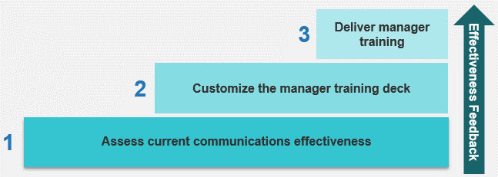
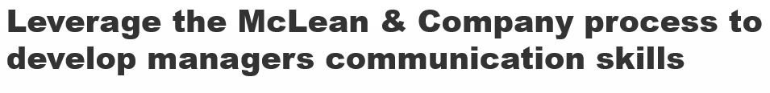
Get to Action

1. Assess Current Communication Techniques | - Understand of the organizational, team, and individual barriers that impede communication.  - Assess overall effectiveness of manager communication.  - Conduct focus groups with managers and employees.  - Identify areas of strength and opportunities for improvement.  Deliverables:  - Communication Effectiveness Analysis Tool  - Standard Focus Group Guide  - Case Studies: Train Managers to Communicate Effectively
2. Customize the Manager Training Deck | - Define the role of HR in manager communication.  - Identify the five elements of effective communication.  - Customize the manager training deck for your organization  - Customize the training deck to align with your communication culture and employee value proposition (EVP).  Deliverables:  - Training Deck: Train Managers to Communicate Effectively
3. Deliver Manager Training | - Select how training will be delivered in your organization.  - Plan out logistics for the training session.  - Develop a communication plan.  - Identify training effectiveness metrics.  - Design a communication competency framework.  Deliverables:  - Effective Manager Communication Participant Handbook  - Effective Manager Communication Quiz  - Effective Manager Communication Session Feedback Template

__________________________________________________

For acceptable use of this template, refer to McLean & Company's Terms of Use. These documents are intended to supply general information only, not specific professional, personal, legal, or accounting advice, and are not intended to be used as a substitute for any kind of professional advice. Use this document either in whole or in part as a basis and guide for document creation. To customize this document with corporate marks and titles, simply replace the McLean & Company information in the Header and Footer fields of this document.

