Build an Employee Mentoring Program Executive Briefing

Summary
Many organizations have jumped on the mentoring bandwagon by introducing an employee mentoring program without clearly defining the need and goal of the program. Consequently, employee mentoring programs are often applied incorrectly to an issue in the organization, automatically setting the program up for failure (e.g. lack of manager coaching).

Our Recommendation
- Prior to establishing an employee mentoring program, take the time to ensure that a mentoring program is the right learning method.
- Identify high-priority employee segments and create a custom mentoring program plan tailored to their needs.
- Create the appropriate resources and training to ensure that mentors and mentees are set up for success.
- Evaluate and continuously improve the mentoring program to ensure it drives impact in the organization.

Client Challenge
- Different groups of employees have different mentoring needs, making a universal approach to mentoring ineffective.
- Traditional mentoring in the workplace can be a resource-intensive process, and often there are more employees looking to be mentored than mentors available.

Critical Insight
- All too often employee mentoring programs are inaccurately implemented as a solution to a problem. It is important to remember that an employee mentoring program is simply another learning method that must be applied and customized to the audience at the appropriate time to be impactful.

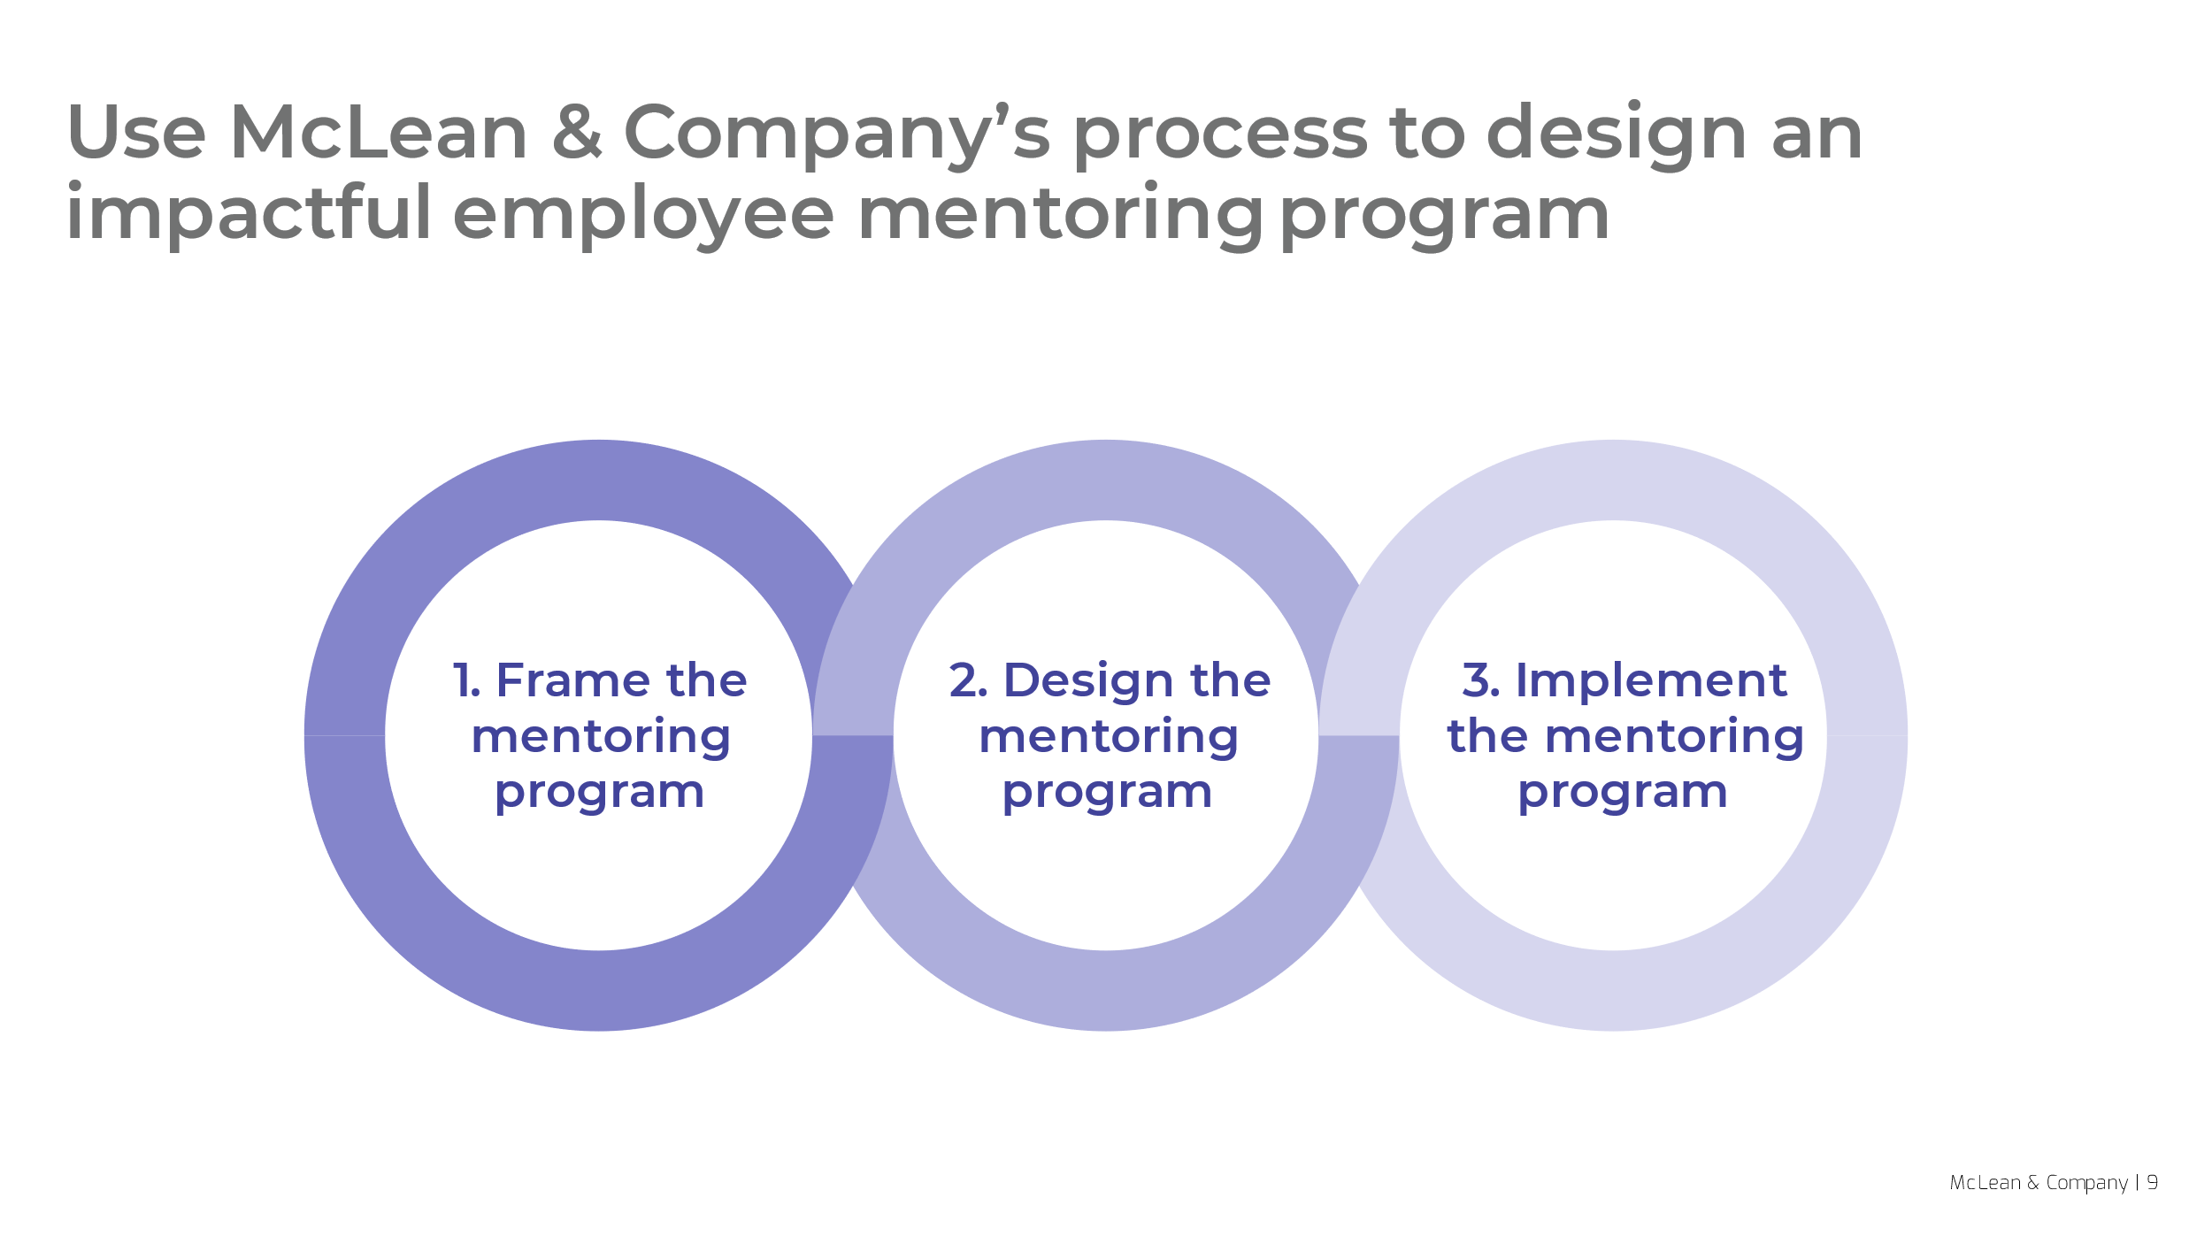
Get to Action

1. Frame the mentoring program | - Determine if mentoring is the appropriate learning method.  - Identify organizational and employee needs.  - Select mentoring goals and key metrics.  Deliverables:  - Mentoring Project Plan
2. Design the mentoring program | - Prioritize employee segments.  - Create a customized program for each employee segment.  - Estimate mentoring resource requirements.  Deliverables:  - Mentoring Project Plan
3. Implement the mentoring program | - Select mentors and mentees.  - Match mentoring pairs.  - Create mentoring resources.  Deliverables:  - Mentoring Project Plan  - Mentoring Tip Sheet  - Mentoring Agreement Template  - Mentee Preparation Checklist  - Manager Training: Build an Effective Mentoring Relationship

__________________________________________________

For acceptable use of this template, refer to McLean & Company's Terms of Use. These documents are intended to supply general information only, not specific professional, personal, legal, or accounting advice, and are not intended to be used as a substitute for any kind of professional advice. Use this document either in whole or in part as a basis and guide for document creation. To customize this document with corporate marks and titles, simply replace the McLean & Company information in the Header and Footer fields of this document.

